|  |  |  |  |
| --- | --- | --- | --- |
| **Logo_FPT_University_doc** | | **MINISTRY OF EDUCATION AND TRAINING** | |
| **FPT UNIVERSITY** | |
| Capstone Project Document | |
| Library Management System | |
|  | |
| |  |  | | --- | --- | | **Group 4** | | | **Group Members** | Lê Minh Quân – 60209  Nguyễn Hùng Phú – 60177  Trịnh Ngọc Điệp – 60128  Trần Hồ Quốc Bảo – 60006 | | **Supervisor** | TAINT | | **Ext Supervisor** |  | | **CP code** | LIB | | |
| |  | | --- | | - Ho Chi Minh City, 01/2012 - | | |

# table of Contents

[Report No.1: Introduction 9](#_Toc322579249)

[1.1. FPT university capstone project 9](#_Toc322579250)

[1.2. Background 9](#_Toc322579251)

[1.3. Introduction 9](#_Toc322579252)

[1.4. Aims and objectives 10](#_Toc322579253)

[1.5. How LIB works 10](#_Toc322579254)

[1.6. Project program and management 10](#_Toc322579255)

[1.7. Project members 11](#_Toc322579256)

[1.8. LIB - Why is it needed? 11](#_Toc322579257)

[1.9. Conclusion 11](#_Toc322579258)

[Report No.2: Project Management Plan 13](#_Toc322579259)

[2.1. Project Overview 13](#_Toc322579260)

[2.1.1. Project description 13](#_Toc322579261)

[2.1.2. Assumptions and constraints 14](#_Toc322579262)

[2.1.3. Project Risk 15](#_Toc322579263)

[2.1.4. References 15](#_Toc322579264)

[2.2. Project deliverables and dependencies 15](#_Toc322579265)

[2.2.1. Deliverables 15](#_Toc322579266)

[2.2.2. Critical Dependencies 16](#_Toc322579267)

[2.3. Project Lifecycle 16](#_Toc322579268)

[2.3.1. Stage description 16](#_Toc322579269)

[2.3.2. Iteration objectives 18](#_Toc322579270)

[2.3.3. Project schedule 21](#_Toc322579271)

[2.4. Process tailoring/deviation 21](#_Toc322579272)

[2.5. Resource plan 21](#_Toc322579273)

[2.5.1. Project Organization 22](#_Toc322579274)

[2.5.2. External interfaces 23](#_Toc322579275)

[2.5.3. Project communication 23](#_Toc322579276)

[2.5.4. Training plan 24](#_Toc322579277)

[2.5.5. Tools and Infrastructure 24](#_Toc322579278)

[2.5.6. Project Finance 25](#_Toc322579279)

[2.6. Quality Management 26](#_Toc322579280)

[2.6.1. Quality objectives 26](#_Toc322579281)

[2.6.2. Quality activities 26](#_Toc322579282)

[2.7. Configuration management 28](#_Toc322579283)

[2.7.1. Introduction 28](#_Toc322579284)

[2.7.2. Configuration management Process 28](#_Toc322579285)

[Report No.3: Software Requirement Specification 37](#_Toc322579286)

[3.1. User Requirement Specification 37](#_Toc322579287)

[3.1.1. Overview 37](#_Toc322579288)

[3.1.2. Project Scope 37](#_Toc322579289)

[3.2. System Requirement Specification (Specific Requirements) 37](#_Toc322579290)

[3.2.1. External Interface Requirements 38](#_Toc322579291)

[3.2.2. System Overview: 39](#_Toc322579292)

[3.2.3. System Features 42](#_Toc322579293)

[3.2.4. Software System Attributes 100](#_Toc322579294)

[3.3. Entity Relationship Diagram or Data Structures 101](#_Toc322579295)

[3.4. Other material (if any) 102](#_Toc322579296)

[Report No.4: Software Detail Design 103](#_Toc322579297)

[4.1. Design Overview 103](#_Toc322579298)

[4.2. System Architectural Design 104](#_Toc322579299)

[4.2.1. Choice of System Architecture 104](#_Toc322579300)

[4.2.2. Discussion of Alternative Designs 104](#_Toc322579301)

[4.2.3. Description of System Interface 105](#_Toc322579302)

[4.3. Component Diagram 105](#_Toc322579303)

[4.4. Detailed Description of Components 105](#_Toc322579304)

[4.4.1. CRC Cards (Class-Responsibility-Collaborators) 105](#_Toc322579305)

[4.4.2. Class Diagram 106](#_Toc322579306)

[4.4.3. Class Diagram Explanation 108](#_Toc322579307)

[4.4.4. System Layers Overview 109](#_Toc322579308)

[4.4.5. System Layers Explanation 109](#_Toc322579309)

[4.5. Sequence Diagram 110](#_Toc322579310)

[4.6. User Interface Design 118](#_Toc322579311)

[4.6.1. Description of the User Interface 118](#_Toc322579312)

[4.7. Database Design or Data Structures 122](#_Toc322579313)

[4.8. Other material (if any) 126](#_Toc322579314)

[Report No.5: Software Test Documentation 127](#_Toc322579315)

[5.1. Introduction 127](#_Toc322579316)

[5.1.1. System Overview 127](#_Toc322579317)

[5.1.2. Test Approach 127](#_Toc322579318)

[5.2. Test Plan 127](#_Toc322579319)

[5.2.1. Features to be tested 127](#_Toc322579320)

[5.2.2. Features not to be tested 127](#_Toc322579321)

[5.2.3. Testing Tools and Environment 127](#_Toc322579322)

[5.3. Test Cases 127](#_Toc322579323)

[5.3.1. Case 1: Insert Author 128](#_Toc322579324)

[5.3.2. Case 2: Edit Author 129](#_Toc322579325)

[5.3.3. Case 3: Insert Category 131](#_Toc322579326)

[5.3.4. Case 4: Edit Category 132](#_Toc322579327)

[5.3.5. Case 5: Insert Publisher 134](#_Toc322579328)

[5.3.6. Case 6: Edit Publisher 135](#_Toc322579329)

[5.3.7. Case 7: Insert Catalogue 137](#_Toc322579330)

[5.3.8. Case 8: Edit Catalogue 139](#_Toc322579331)

[5.3.9. Case 9: Insert Copy 141](#_Toc322579332)

[5.3.10. Case 10: Delete Copy 142](#_Toc322579333)

[5.3.11. Case 11: Insert Rental 143](#_Toc322579334)

[5.3.12. Case 12: Expand Rental 144](#_Toc322579335)

[5.3.13. Case 13: Finish Rental 145](#_Toc322579336)

[5.3.14. Case 14: Insert User 146](#_Toc322579337)

[5.3.15. Case 15: Edit User 149](#_Toc322579338)

[5.4. Checklists 151](#_Toc322579339)

[5.4.1. Checklist of Validation 151](#_Toc322579340)

[5.4.2. Submission Checklist 154](#_Toc322579341)

[5.5. Other material (if any) 154](#_Toc322579342)

[5.5.1. Test log 154](#_Toc322579343)

[Report No.6: Software User’s Manual 155](#_Toc322579344)

[6.1. Catalogue management 155](#_Toc322579345)

[6.1.1. Insert catalogue 155](#_Toc322579346)

[6.1.2. Edit a catalogue’s information 157](#_Toc322579347)

[6.1.3. Delete a catalogue 158](#_Toc322579348)

[6.2. Author management 159](#_Toc322579349)

[6.2.1. Insert an author 159](#_Toc322579350)

[6.2.2. Edit an author’s information 159](#_Toc322579351)

[6.2.3. Delete an author 160](#_Toc322579352)

[6.3. Publisher management 161](#_Toc322579353)

[6.3.1. Insert a publisher 161](#_Toc322579354)

[6.3.2. Edit a publisher’s information 162](#_Toc322579355)

[6.3.3. Delete a publisher 163](#_Toc322579356)

[6.4. Category management 164](#_Toc322579357)

[6.4.1. Insert a category 164](#_Toc322579358)

[6.4.2. Edit a category’s information 165](#_Toc322579359)

[6.4.3. Delete a category 166](#_Toc322579360)

[6.5. Copies management 167](#_Toc322579361)

[6.5.1. Insert copies 167](#_Toc322579362)

[6.5.2. Delete copy 168](#_Toc322579363)

[6.6. Book register and rental management 169](#_Toc322579364)

[6.6.1. Purpose 170](#_Toc322579365)

[6.6.2. Usage 170](#_Toc322579366)

[6.6.3. Main Interface 170](#_Toc322579367)

[6.6.4. Main Functions 172](#_Toc322579368)

[6.7. User management 179](#_Toc322579369)

[6.7.1. Purpose 179](#_Toc322579370)

[6.7.2. Usage 179](#_Toc322579371)

[6.7.3. Main Interface 179](#_Toc322579372)

[6.7.4. Main Functions 179](#_Toc322579373)

[6.8. Search functions 181](#_Toc322579374)

[6.8.1. Search of Catalogue: 181](#_Toc322579375)

[6.8.2. List of Result: 185](#_Toc322579376)

[6.8.3. Rental Register Search Function: 186](#_Toc322579377)

[6.8.4. Rental Detail Search Function: 187](#_Toc322579378)

[6.8.5. Users Search Function: 188](#_Toc322579379)

[6.9. LIB’s reports: 188](#_Toc322579380)

[6.10. Deployment Guide 192](#_Toc322579381)

[6.10.1. INSTALL SQL SERVER AND Run SQL Server ScriptS: 192](#_Toc322579382)

[6.10.2. Install LIB Desktop Application 194](#_Toc322579383)

[6.10.3. Install the LIB OPAC System 196](#_Toc322579384)

# Introduction

## FPT university capstone project

This introduction presents the aims and objectives of The LIB Capstone Project. It contains information about what kind of data we are trying to collect, how we go about this process of data collection, the kind of analysis which will take place and the results we hope to have achieved at the culmination of the project in 2012.

## Background

This project is created based on the need of FPT University for the students of 2008 – 2012 year graduation.

Today, it’s a need for everyone to access knowledge from any kind of system. There are many people that prefer to get to the library and check the books that they think can satisfy them with their problems. So, libraries are one of the developed countries’ concerns. According to that, for the sake of managing the knowledge system, Library Management Systems are created thanks to the developing of Libraries.

FPT University that has recently built a library, need software that can help their librarians to manage the books efficiently.

From those reasons, the LIB project is created.

## Introduction

There are over 200 public libraries in the world, which contain more than 430.000 titles of books all over the world. And one library has its own way of knowledge management. This will make the other users hard to access to the knowledge system of an unknown world.

The LIB is the Library Management System that provides a very efficient way to manage knowledge of any library. From one small library to a thousands of large libraries, to make the world of knowledge seem easy to others than the old way of storing book.

## Aims and objectives

The defined aims of the LIB project are to:

* Provide the efficient way for library for storing knowledge.
* Make users feel at ease when access to the storage of books.
* Provide the creators a way to achieve the graduation certification from FPT University.

The project scope is focus on 3 main features:

* Book Transaction Management
* Book Management
* Client Management

## How LIB works

LIB will be used by the libraries all over the network of information. Every library has its own knowledge database. All will be connected to the main database system, in here, data will collected and filtered for the sake of users in the specific area and knowledge.

It will perform as a manager of local area library on manage books and user, also the state borrow and return. Also, it connects to world library to update the information of the new titles over the world and provide new information based on specific program or area of the local library.

## Project program and management

The LIB Project has been arranged in a series of 8 Capstone projects of FPT University in 2012, and be divided in to 3 main phrases, takes place from Jan 2012 to May 2012.

The sponsor of the project is one of the university professors: Mr. TaiTN.

LIB will be performed as a formal software engineering project from the start of the project. Every document will be created as of the need of the project and request from users and sponsors, and created based on the templates of FPT Software, except this document.

LIB will use SCRUM, one of the agile software management processes, as the project software process.

## Project members

This project will consist of 4 students from SE0425 class of 2008 of FPT University:

* Lê Minh Quân – QUANLM – 60209 – Team Leader
* Nguyễn Hùng Phú – PHUNH – 60177 – Team Member
* Trịnh Ngọc Điệp – DIEPTN – 60128 – Team Member
* Trần Hồ Quốc Bảo – BaoTHQ – 60177 – Team Member

## LIB - Why is it needed?

* To help the government or board of study making use of the library management system.
* To help the users to access the knowledge database.
* To digitalize the librarian’s jobs.

## Conclusion

All we have declared above is basic information of the LIB project. But the main purpose of this project is to summarize knowledge that we have learnt over 4 years in university. Further information will be provided in the next documents.

# Project Management Plan

## Project Overview

### Project description

|  |  |  |  |  |  |  |
| --- | --- | --- | --- | --- | --- | --- |
| Project name : | FPT LIBRARY SYSTEM | | | | | |
| Project Code: | LIB | | | | | |
| Contract Type: | -- | | | | | |
| Customer: | FPT University | | | | | |
| 2nd Customer: | -- | | | | | |
| Project level: | 🞎 Company | | 🞎 Branch | | | 🗹 Group |
| Project rank: | Not rank | | | | | |
| Group: | Group 4 | | | | | |
| Division: | SE0425 | | | | | |
| Project type: | 🞎 External | | | 🗹 Internal | | |
| Project manager: | TaiNT | | | | | |
| Project category: | 🗹 New development | | 🞎 Maintenance | | | 🞎 Other |
| Business domain: | Library Management System | | | | | |
| Application type: | Winform and webform application | | | | | |
| Scope and Objective | * Aim of the project is to create software that has a capability to manage a large amount of data (books) in a library. * The output from the project will have 2 interfaces:   + The interface for the librarians to manage the library information.   + The interface for the user from the outside to access the library system and perform transactions or requests. * The main scopes of the project are:   + The capability to manage books by cataloging and titling. (compromise to some standards that been applied for library)   + The capability to manage users and the transactions made by users, the books has been borrowed…   + The capability to manage requests and new books transactions that has been imported to library or transported from library. | | | | | |
| Committed billable effort |  | | | | | |
| Committed calendar effort |  | | | | | |
| Committed effort usage (man-month[[1]](#footnote-1)): | 16 | | | | | |
| In which:  Management activities (%) | 19.41% | | | | | |
| Development activities (%) | 57.65% | | | | | |
| For Quality activities (%) | 22.94% | | | | | |
| Project start date: | 03/01/2012 | Expected end date: | | | 29/04/2012 | |
| Planned duration: | 4 months |  | | |  | |

### Assumptions and constraints

#### Constraints

Table : Constraints

|  |  |  |
| --- | --- | --- |
| No | Description | Type[[2]](#footnote-2) |
| 1 | This application has been developed specialized for FPT University Library (HCM Branch) | Business |
| 2 | Every activity will have to meet the schedule | Schedule |
| 3 | All of the requirements will have to be provided and interpreted clearly from the project sponsor | Requirement |

#### Assumptions

Table : Assumptions

|  |  |  |
| --- | --- | --- |
| No | Description | Type[[3]](#footnote-3) |
| 1 | The FPT University Library will provide all needed business process information to the project team | Business |
| 2 | The project sponsor & customer will attend to all stages of the development process and provide help on the project requirement | Business & Requirement |

### Project Risk

### References

Table : Document’s References

|  |  |  |  |  |
| --- | --- | --- | --- | --- |
| No | Document | Issued date | Source | Note |
|  |  |  |  |  |
|  |  |  |  |  |

## Project deliverables and dependencies

### Deliverables

[[4]](#footnote-4)Table : Project deliverables to customer

|  |  |  |  |  |
| --- | --- | --- | --- | --- |
| No | Deliverable | Delivery date | Delivery location | Note |
| 1 | Introduction Document | January 9th, 2012 | FU – CMS | Soft version  Final version |
| 2 | Software Project Management Plan | January 30th, 2012 | FU – CMS | Soft version  Beta version |
| 3 | Software Requirements Specification | February 11th, 2012 | FU – CMS | Soft version  Beta version |
| 4 | Software Design Description | February 20th, 2012 | FU – CMS | Soft version  Beta version |
| 5 | Software System Database Design | February 24th, 2012 | Google – SVN | Soft version  Beta version |
| 6 | Release Document and Test Document for R1 | March 2nd, 2012 | Google – SVN | Soft version  Final version |
| 7 | Release Document and Test Document for R2 | March 9th, 2012 | Google – SVN | Soft version  Final version |
| 8 | Release Document and Test Document for R3 | March 16th, 2012 | FU – CMS  Google – SVN | Soft version  Final version |
| 9 | Software Test Documentation | March 19th, 2012 | FU – CMS | Soft version  Final version |
| 10 | Software User’s Manual and Training Document | March 31st, 2012 | FU – CMS | Soft version  Hard version  Hard-cover version  Final version |

### Critical Dependencies

Table : Critical dependencies

|  |  |  |  |
| --- | --- | --- | --- |
| No | Critical dependency | Expected Delivery Date | Note |
|  |  |  |  |

## Project Lifecycle

### Stage description

Table : Project stage summary

|  |  |  |  |  |
| --- | --- | --- | --- | --- |
| Stage | No. of iterations | Start | End | Elapsed time |
| Initiation Stage |  | Week 1 | Week 1 | 6 days |
| Definition Stage | 1 | Week 2 | Week 3 | 12 days |
| Solution Stage | 1 | Week 4 | Week 5 | 12 days |
| Construction Stage | 3 | Week 6 | Week 12 | 42 days |
| Transition Stage | 2 | Week 13 | Week 14 | 12 days |
| Termination Stage |  | Week 14 | Week 14 | 6 days |

Table : Project stage and milestones

| Stage | Description | Milestone |
| --- | --- | --- |
| Initiation Stage | The Initiation stage will intend to get project requirements and review those, estimate project size and effort, creates the internal work order and team building. | Kick-of meeting |
| Definition Stage | The Definition stage will develop the product requirements and establish the business case for the LIB System. The major use cases will be developed as well as the high level Project Plan. | Business Case Review Milestone.  In this stage, the LIB project plan document will also be created.  In this stage, the LIB SRS document will also be created. |
| Solution Stage | The Solution Stage will analyze the requirements and will develop the architectural prototype. At the completion of the Solution Stage all use cases selected for Release 1.0 will have completed analysis and design. In addition, high risk use cases for Release 2.0 will have been analyzed and designed. The architectural prototype will test the feasibility and performance of the architecture that is required for Release 1.0.  A User-Interface Prototype will also be developed. | The Architectural Prototype Milestone marks the end of the Solution Stage. This prototype signifies verification of the major architectural components which comprise the R1.0 Release.  The User-Interface Prototype Milestone enables early user feedback on the user interface.  In this stage Project SDD document will be released. |
| Construction Stage | During the Construction Stage, remaining use cases will be analyzed and designed. The Beta version for Release 1.0 will be developed and distributed for evaluation. The implementation and test activities to support the R1.0 and R2.0 releases will be completed. | The R2.0 Operational Capability Milestone marks the end of the Construction Stage. Release 2.0 software is ready for packaging. |
| Transition Stage | The Transition Stage will prepare the R1.0 and R2.0 releases for distribution. It provides the required support to ensure a smooth installation including user training. | The R2.0 Release Milestone marks the end of the Transition Stage. At this point all capabilities, as defined in the SRS, are installed and available for the users. |
| Termination Stage | The Termination Stage has objectives to summarize and evaluate project results, and closure the project. | Post mortem meeting |

### Iteration objectives

Table : Project iterations objectives

| Stage | Iteration | Description | Associated Milestones | Risks Addressed |
| --- | --- | --- | --- | --- |
| Definition Stage | Preliminary Iteration | Defines business model, product requirements, project plan, and business case. | Business Case Review  Project Plan Review  SRS Review | Clarifies user requirements up front.  Develops realistic project plans and scope.  Determines feasibility of project from a business point of view. |
| Solution Stage | E1 Iteration – Develop Architectural Prototype | Completes analysis & design for all R1 use cases. Develops the architectural prototype for R1.  Complete Analysis and Design for all high risk R2 use cases. | Architectural Prototype  SDD Review | Architectural issues clarified.  Technical risks mitigated.  Early prototype for user review. |
| Construction Stage | C1 Iteration – Develop R1 Beta | Implement and test R1 use cases to provide the R1 Beta Version.  This stage will implement all the basic functionalities of the project.  Database will be revised and reconstructed to be compromised with the need of the project. | R1 Beta  DB Review | All key features from a user and architectural prospective implemented in the Beta.  User feedback prior to release of R1.  User feedback prior to the release of the system database version. |
|  | C2 Iteration – Develop R1 Release | Implement and test remaining R1 use cases, fix defects from Beta, and incorporate feedback from Beta.  Develops the R1 system.  Revises all the early stage R1 system, the functionality of the management feature will be implemented according to the need of managing DB for testing and reviewing. | R1 Software  DB Test data reviewed  Unit Test document review | R1 fully reviewed by user community.  Product quality should be high.  Defects minimized.  Cost of quality reduced.  Effort for maintaining the documents from the project. |
|  | C3 Iteration – Develop R2 Release | Design, implement, and test R2 use cases.  Incorporate enhancements and defects from R1.  Develops the R2 system.  Improves the R2 stage of the software, the ability to communicate with the other system will be implemented in R2 to make R3. | R2 Software  Unit Test document Review  Integration Test Review  System Test Review | Quick release of R2 addresses customer satisfaction.  All key functionality provided in System by R2 Release.  Effort for maintaining and creating new documents will reduced the time for coding. |
| Transition Stage | T1 Iteration – R1 Release | Package, distribute, and install R1 Release. | R1 Released | Two stages release minimizes defects.  A two stages release provides easier transition for users. |
|  | T2 Iteration – R2 Release | Package, distribute, and install R2 Release. | R2 Released  User Manual Review | Two stages release minimizes defects.  Two stages release provides easier transition for users.  Training section for user will need to be planned. |

### Project schedule

Prefer to initial MS Project plan of the project that been attached to this document.

## Process tailoring/deviation

The operational process for the project is based on the development process model defined in the FPT Software Process Handbook and F-soft guidelines.

Table : Process tailoring/deviation

|  |  |  |  |  |
| --- | --- | --- | --- | --- |
| No. | Tailoring/deviation | Added/Modified/Deleted | Reason for tailoring/deviation | Tailoring or Deviation? |
|  |  |  |  |  |

## Resource plan

### Project Organization

#### Organizational structure



#### Project team

Table : Project team

| No. | Name | Position | Start Date | End Date | Working time[[5]](#footnote-5) |
| --- | --- | --- | --- | --- | --- |
| Management team | | | | | |
| 1 | Nguyễn Trọng Tài | PM | January 3rd , 2012 | April 28th , 2012 | 5 hours/week |
| Project team | | Has the responsibility to complete all phases of the project | | | |
| 2 | Lê Minh Quân | TL | January 3rd , 2012 | April 28th , 2012 | 20 hours/week |
| 3 | Trần Hồ Quốc Bảo | TM | January 3rd , 2012 | April 28th , 2012 | 20 hours/week |
| 4 | Trịnh Ngọc Điệp | TM | January 3rd , 2012 | April 28th , 2012 | 20 hours/week |
| 5 | Nguyễn Hùng Phú | TM | January 3rd , 2012 | April 28th , 2012 | 20 hours/week |

### External interfaces

#### FPT interfaces

Table : FPT interfaces

|  |  |  |  |  |
| --- | --- | --- | --- | --- |
| No. | Name | Position | Responsibilities[[6]](#footnote-6) | Tel, Fax, Email |
| 1 | TaiNT | PI | Process control and audit, support on process related issues | [taint@fpt.edu.vn](mailto:taint@fpt.edu.vn) |
| 2 | FPT Lib | PS | Business process related issues supporter |  |
|  |  |  |  |  |

#### Customer’s interfaces

Table: Customer’s interfaces

|  |  |  |  |  |
| --- | --- | --- | --- | --- |
| No. | Name | Position | Responsibilities[[7]](#footnote-7) | Tel, Fax, Email |
| 1 | TaiNT | Instructor | University’s representative |  |

#### Subcontract

Table: Subcontract plan

| No. | Job | Deliverable | Delivery date | Note |
| --- | --- | --- | --- | --- |
|  | <NA if it’s not available> |  |  |  |

### Project communication

#### Internal project communication

Every week, the project team has two regular meetings (face to face) at FPT University with project manager for reporting the progressing of the project, Q&A, reviewing … Beside that, the project team also can contact with the project manager via mobile phone or email for Q&A. And if needed, project team can book some meetings outside FPT University with the project manager.

Every week, the project team also has two regular meetings (face to face) for solving project’s problem, discussing about the project … From the developing phase, project team members have to write daily report about the project progressing to the project leader. Beside the regular meetings, the project team also has some other face to face meetings or online meetings; it’s up to the needs of the project.

#### Communication with management board of department

N/A.

#### Communication with customer

Project manager also plays the role as customer.

#### Others

Contacts with the FPT University’s librarians for some information about the business scope of the project.

### Training plan

Table : Training plan

| No. | Topic | Description | Participants | Time | Waiver criteria |
| --- | --- | --- | --- | --- | --- |
| 1 | Training about ADO dot NET | Review all the technical knowledge that is needed for the project | All project team | 1 days at February 11th 2012 |  |
|  |  |  |  |  |  |

### Tools and Infrastructure

#### Software

For developing phases:

* Microsoft Visual Studio 2008
* Microsoft Office 2007
* Microsoft SQL Server 2008
* Tortoise SVN (for managing resource)

For communications:

* Mail system of FPT University
* Mavenlink
* Skype chat system

#### Hardware

Four laptops for project team with the processor is Intel Core 2 duo 1.8 GHz to higher, RAM for 2 GB to higher, VGA from 128 MB to higher, HDD from 160 GB to higher (these information up to the configuration of team members’ laptops)

#### Others infrastructures

### Project Finance

#### Invoice schedule

Table : Invoice schedule

| No. | Item | Target date for Invoicing | Amount | % of total revenue | Conditions are required to raise an invoice |
| --- | --- | --- | --- | --- | --- |
|  | <N/A if it’s not available> |  |  |  |  |

#### Project cost

Table : Project costing

|  |  |  |  |  |  |
| --- | --- | --- | --- | --- | --- |
| Labor |  |  |  |  |  |
|  | Activities |  | EFFORT (md) |  | Cost |
|  |  |  |  |  |  |
|  |  | Total Effort: |  |  |  |
|  |  |  | TOTAL LABOR: |  |  |
|  |  |  |  |  |  |
| NonLabor | (attach supporting details) |  |  |  |  |
|  |  |  |  |  |  |
|  |  |  | TOTAL NONLABOR: |  |  |
|  |  |  | TOTAL BUDGET: |  |  |

## Quality Management

### Quality objectives

Table : Quality objectives

| No | Quality objectives | Unit | Norm | Target | Notes |
| --- | --- | --- | --- | --- | --- |
| 1 | CMMI Level 5 | -- | -- | Quality Management process |  |
| 2 | C# Coding Convention | -- | -- | Coding process | <http://msdn.microsoft.com/en-us/library/ff926074.aspx> |

### Quality activities

#### Strategy to achieve the quality objectives

* Defect Prevention: Defect prevention by using the standard process from the guideline of the QMS.
  + For the spec before coding stage: Make everything clear to improve the productivity in the coding stage.
  + For the coding before release: Double checks or reviews the code beforehand, takes the pair programming as the main coding process.
* Defect Compromising:
  + For the defect from the unclearness of the spec: if the defect has been state as not importance one, we can leave the defect as one of the system originator.
  + For the defect from the coding skill: This defect may lower the system performance, but for the future development may need this to make the system more functionality.

#### Review and inspection

Table: Reviews and inspection

| No | Items under Review/Inspection | Conductor | Date | Approved by | Note |
| --- | --- | --- | --- | --- | --- |
| 1 | Project Plan | Team |  | TaiNT |  |
| 2 | SRS | Team |  | TaiNT |  |
| 3 | Design | Team |  | TaiNT |  |
| 4 | Code | Team |  | TaiNT |  |
| 5 | Test Document | Team |  | TaiNT |  |
| 6 | Test Result | Team |  | TaiNT |  |
| 7 | Documents in advance | Team |  | TaiNT |  |
| 8 | Release Package | Team |  | TaiNT |  |

#### Other activities

Table: Others quality activities

| No. | Activity | Date/ frequency | Responsibility | Note |
| --- | --- | --- | --- | --- |
| 1 | Metric collection | At the end of Iteration (Development stage) | TL | LOC |
| 2 | Internal audits | Every Week (Development stage) | TL | To raise and close issues |
| 3 | Quality objective tracking | At the end of Working day | TM | To neatly follow the process as planed |

#### Metrics Plan

|  |  |  |
| --- | --- | --- |
| Metric to be collected | Unit of Measurement | Tools used if any |
| Size | LOC | SVN |
| Effort | Person-days | Mavenlink project management system |
| Defects | Number of Defects | MS Excel |
| Schedule | Elapsed time | MS Project & Mavenlink project management system |

## Configuration management

### Introduction

The purpose of this document is to identify and describe configuration management (CM) process implementing in the project LIB

#### Role & Responsibility

Refer to Project Organization section in Project Plan

### Configuration management Process

#### CI Identification & Naming convention

Refer to sheet CI Identification in CM Report

#### Movement of CIs through their storage

##### For Document

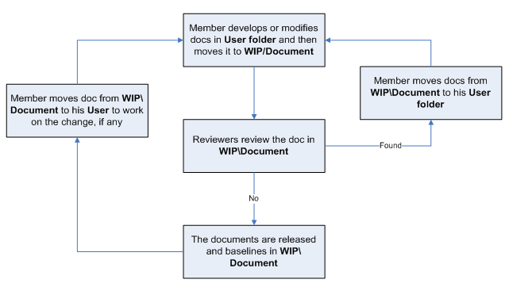

##### For Source code:

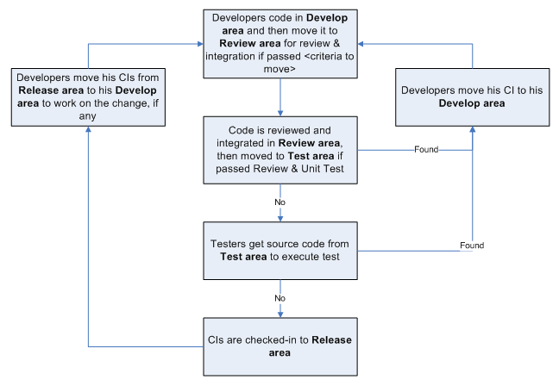

#### Directory structure & Access right

##### Promotion Areas

| Area | Purpose |
| --- | --- |
|
| Develop Area | Area for different users to store his/her owned items |
| Review Area | To store items that is ready for review.  Reviewer get to be-reviewed items from this area |
| Test Area | Just applicable for Source items.  To store items passed Unit Test and Code Review |
| Release Area | To store the items ready for release and all released versions of items  Users get the most recent items for their usage from this area |
| Archive Area | To archive all released versions of each CI |

##### Directory structure

| Main Folder | Sub Folder | Purpose | Map to Area | Access right |
| --- | --- | --- | --- | --- |
| **Project Directory :** <https://se0425-capstone-project-lib.googlecode.com/svn/trunk/> | | | | |
| WIP | Deliverables | Store all CIs that are delivered to customer, be possible to add date to folder name | Release | Full: PM, CC  Modify: None  Read: All |
| Documents | Documents of Requiements, Design, Test, … | Release + Review | Full: PM, CC  Modify: PIC  Read: All |
| Meeting minutes | Store project meeting minutes, including meeting minutes with customer | NA | Full: PM, CC  Modify: All |
| Plan | Store Proposal, Estimation, Project Plans, Project schedule, Task list | Review + Release | Full: PM, CC  Modify: PTL  Read: All |
| Report | Store Project Reports: Weekly , Milestone, Post-mortem, Acceptance note, other Event-driven reports | NA | Full: PM, CC  Modify: PTL  Read: All |
| Record | Store project records, divided into  Review: include Review, Test and Inspection records  Change request  Acceptance  Mails  ... | NA | Full: PM, CC  Modify: All |
| Source | Store VSS file of Source code | Archive | Refer to VSS directory |
| User | User’s working area, store user’s owned items | Develop | Full: PM, CC  Modify: User  Read: All |
| Reference | Customer supplied | store Documents and Other materials/data supplied by customer or those support software development and production operation in the project… | Release | Full: PM, CC  Modify: PIC  Read: All |
| Process Template | Store Guidelines/Standards/Forms/Templates/Checklist specified for the project usage | Release |  |
| Audit |  | Store QA work products  Process review  Final inspection  Work product review | NA | Full right: Project QAs  Read right: All |
| Archive | Baseline Name | To released versions of CIs at baselines | Archive | Full: PM, CC  Read: All |
| **VSS Directory:** N/A | | | | |
| N/A | | | | |

###### For physically stored items

|  |  |  |  |
| --- | --- | --- | --- |
| Items | Location | Person in charge | Usage rule |
| N/A | | | |

###### Access right control

Access right of non-project team members (ex: auditor, external reviewer, etc) must be get permission of PM and granted in the pre-defined duration, then revoked at expiry date by CC. As soon as a member is out of the project, his or her access right is revoked also.

The access right is reviewed frequently and updated by CC at <baseline point and project closure time>.

After project asset is approved by QA at project closure time, PM informs to IT Department to revoke the access right of all project team members. If some one has a request for data reference, audit, etc, he or she must get the approval of authorized person, normally Group Leader or Division Leader, and then send the request to IT Department. IT Department is responsible for implementing such kind of requests.

#### Version numbering rule

##### For Documents:

The version level is maintained as numbered identifier with two components

1.1

Revision

Version

The original version will be numbered 0.1. Subsequent revisions will be numbered 0.2, 0.3. The release version will be 1.0.

**Version number**, which appears to the left of the decimal. It changes only when the core architecture of the item changes. For example: when an item is completely overhauled, with substantial internal changes, the version 1.0 would become version 2.0

**Revision number**, which appears to the right of the decimal. It changes when existing content is changed, but the overall structure and flow of the item remains the same. The normal sequence of revision is 1.1, 1.2 and so on.

##### For Software Source Files:

Software executables and support files are generally identified by name and version number, such as “Main DB v1.1.a”. The scratch edition will be 1.0. The version numbering scheme consists of three components:

1.1a

Revision

Version

Update

view

**Version number**, which appears to the left of the decimal. It changes only when the core architecture of the software item changes, as when moving from one area of the development tool to another, when an application is completely overhauled, or the user interface changes fundamentally. In this case, version 1.1a would become version 2.0.

**Revision number**, which appears to the right of the decimal. It changes when new features, functionality or other content are added or significantly changed. In normal case, the core architecture or user interface have been extended or limited in some manner. The most common reason for changing the revision number is when adding a new module or other functionality to the software. The normal sequence of revision is 1.0, 1.1, and 1.2 and so on.

**Update level** is appended or incremented when the only change to the software item is to correct one or more defects, without the addition of any new functionality. Version 1.1 would become v1.1a, v1.1b and so on. This updating is over ridden when a combination revision, involving bug fixes and new feature additions, is performed. In such a case, the software revision number is incremented and any update indicator is dropped, as in v1.1b to v1.2

#### Change control

Refer to Requirement Change Management section in Project Plan and Change Control Report sheet in CM Report.

#### Baseline plan

| No. | Baseline Name | When Baselined | PIC |
| --- | --- | --- | --- |
| 1 | Project Plan | After finishing Introduction |  |
| 2 | Startup & Construction | Within 4 days |  |
| 3 | Software Requirement Specification | After finishing Project plan |  |
| 4 | Startup & Construction | Within 4 days |  |
| 5 | Software Design Description | After finishing Software Requirement Specification |  |
| 6 | Startup & Construction | Within 4 days |  |
| 7 | Software Test Documentation  Guide Implementation | After finishing Software Design Description |  |
| 8 | Unit Test Plan | Within 3 days |  |
| 9 | Coding | Within 30 days from Unit Test Plan |  |
| 10 | Review Code | Within 3 days from Coding |  |
| 11 | Fix bugs | Within 11 days from Review Code |  |
| 12 | Perform Integration | Within 5 days from Fix bugs |  |
| 13 | System Test | Within 5 days from Perform Integration |  |
| 14 | Deployment | After Software Test Documentation Guide Implementation |  |
| 15 | User manual | Within 2 days |  |
| 16 | Release note | Within 2 days from user manual |  |
| 17 | Review and Acceptant Test | Within 4 days Release note |  |
| 18 | Complete Construction and Transition Stage | After finishing Deployment |  |
| 19 | Survey Customer Satisfaction | Within 1 day |  |

#### Backup strategy

|  |  |  |  |  |  |
| --- | --- | --- | --- | --- | --- |
| Storage Area to be Backed up | Items to be Backed up | Backup To | Backup Type | Backup Frequency | PIC |
| <https://se0425-capstone-project-lib.googlecode.com/svn/trunk/> | All | <https://se0425-capstone-project-lib.googlecode.com/svn/trunk/Backup> | Full backup | Once a week | TL – CM |

# Software Requirement Specification

## User Requirement Specification

### Overview

The system described in this document is one type of the library management system application. The features of the system consist of managing books, users, the transactions of borrowing and returning books… and the ability to generate required reports for the managers.

### Project Scope

The LIB system allows users to perform the following actions:

* Manage Catalogue (Titles and Copies): add, edit or remove one of the titles and copies in the system.
* Manage User Information: add, edit or remove users from the system.
* Manage Borrowing and Returning Transaction: approve and modify the transaction between users and library.
* Generate Reports: generate reports bases on the information from the library.

## System Requirement Specification (Specific Requirements)

### External Interface Requirements

#### User Interfaces

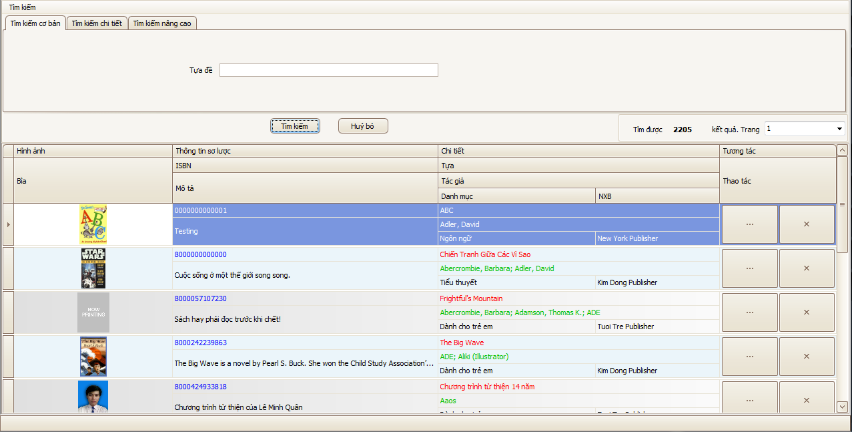

Figure : Sample of Basic Search feature

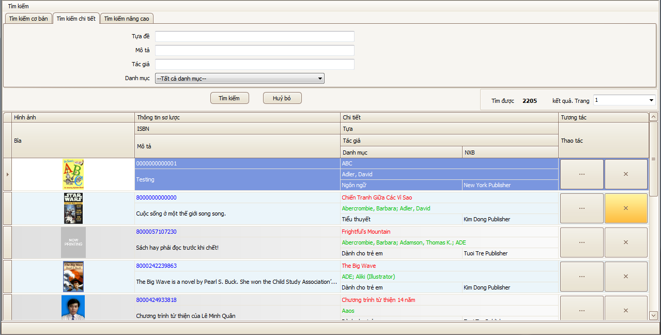

Figure : Sample of Detail Search feature

#### Hardware Interfaces

N/A

#### Software Interfaces

N/A

#### Communications Protocol

N/A

### System Overview:

The System required users to login to be able to use some of the managing features. As of the administrator can be able to manage the users, the librarian can only manage the catalogue and normal user can only send request to the library.

The main features of the LIB can be described as the below diagram:

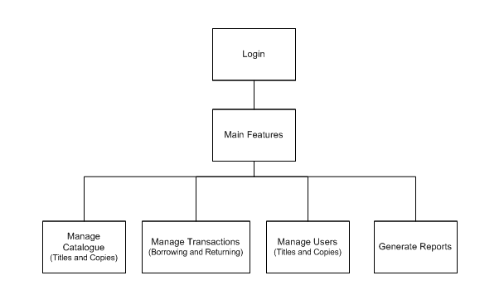

Figure : LIB System Overview

Type of the users in the LIB system:

* **Admin**: the **Administrator** of the system, admin has the primitive privilege on the system features and database. Only one admin is available in the system.
* **Librarian**: the **Librarian** of the Library, librarians can manage the titles and copies of the books in the library, the transaction between readers and library, but not the users’ information. Every business and document works must be performed by one of the librarians.
* **Normal User**: the **Normal Reader** of the system, login functionality is provided for the reader to order the copies of books only. Normal Reader cannot perform any managing activity.

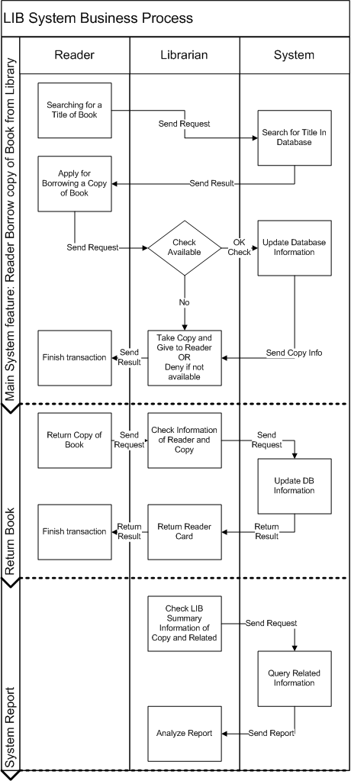

Figure : LIB System Business Functional Flowchart

### System Features

#### Manage Catalogue (Titles and Copies)

##### Use Case-A Diagram

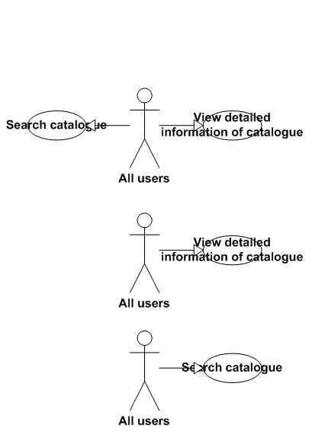

Figure : Searching & Viewing detailed Information

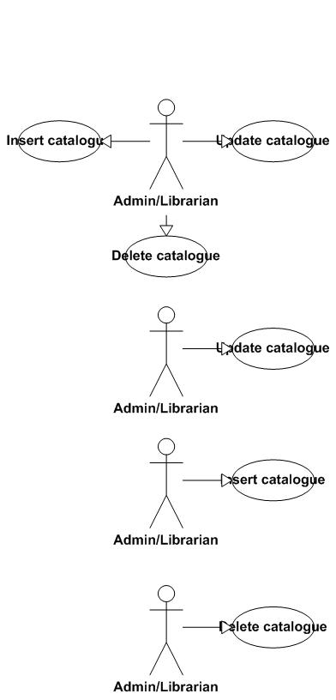

Figure : Catalogues management features

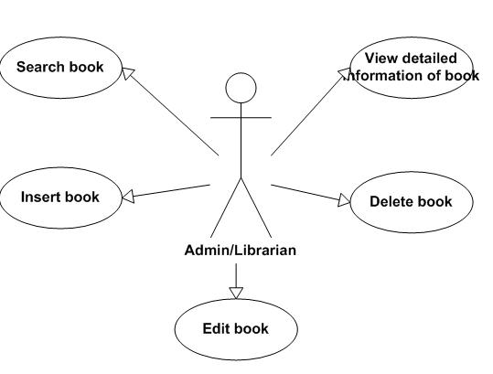

Figure : Copies management features

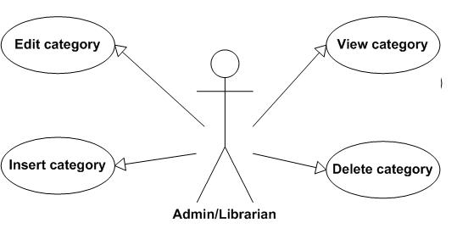

Figure : Categories management features

##### Use Case-A Specification

###### Use Case : Search Catalogue

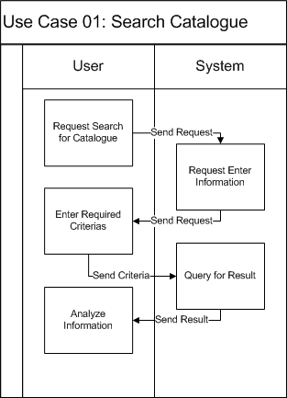

|  |  |  |
| --- | --- | --- |
| Use Case Name | Search catalogue of books | |
| Actors | All users | |
| Description | Search for some catalogues of books that are needed by users | |
| Requirement | Fields/Attributes must have validations on it | |
| Pre-conditions | Users must input keyword | |
| Post-conditions | A list of result will be display | |
| Basic Flow | *Actor Actions:*  *1. Click “Search catalogue” button*  *3. User types keywords*  *4. Click "Search" button* | *System Response:*  *2. Display a search window form (in librarian management form) or a search page (in web form for readers)*  *5. A list of result will be displayed in users’ screens. If there is no result, will display “Sorry we can’t find the books you want.”* |
| Exception Flow | N/A | |

###### Use Case : View Detail Information of Catalogue

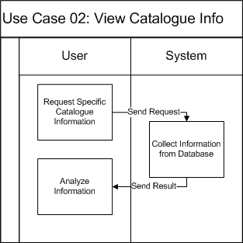

|  |  |  |
| --- | --- | --- |
| Use Case Name | View detailed information of the catalogue of books | |
| Actors | All users | |
| Description | View detailed information of the catalogue of books | |
| Requirement | N/A | |
| Pre-conditions | User choose the catalogue which they want to view detailed information | |
| Post-conditions | Detailed information of catalogue will be displayed | |
| Basic Flow | *Actor Actions:*  *1. In the result form of search page. User clicks “View detailed information” button* | *System Response:*  *2. Display a new window form (in win form mode) or new web page (in web mode) that includes the detailed information of the catalogue.* |
| Exception Flow | N/A | |

###### 

###### Use Case : Insert a Catalogue of Book

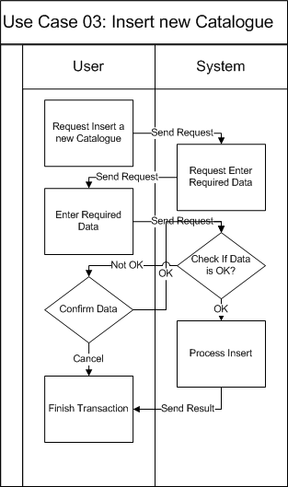

|  |  |  |
| --- | --- | --- |
| Use Case Name | Insert catalogue of books | |
| Actors | Admin/Librarian | |
| Description | Insert a catalogue of books to the database | |
| Requirement | Fields/Attributes must have validations on it | |
| Pre-conditions | User must log in with role “Admin” or “Librarian” | |
| Post-conditions | New catalogue of books is added to database | |
| Basic Flow | *Actor Actions:*  *1. Click “Add catalogue” button*  *3. User types required attributes*  *4. Click "Insert" button*  *6. User click “Yes” button* | *System Response:*  *2. Display a form and request to enter the attributes that will be processed.*  *5. Message box confirms "Are you sure to insert this catalogue?“.*  *7. Data will be checked and insert to the database.* |
| Alternative Flow 1 | *Actor actions:*  *1. Click “No” button* | *System Response:*  *2. Stay in the current window form.* |
| Exception Flow | N/A | |

###### Use Case : Delete a Catalogue of Book

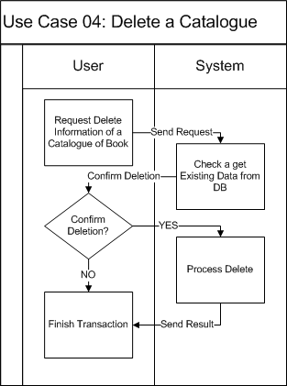

|  |  |  |
| --- | --- | --- |
| Use Case Name | Delete catalogue of books | |
| Actors | Admin/Librarian | |
| Description | Delete a catalogue of books to the database | |
| Requirement | Fields/Attributes must have validations on it | |
| Pre-conditions | User must log in with role “Admin” or “Librarian” | |
| Post-conditions | The data of catalogue of books and all the books in the same catalogue will be deleted from the database | |
| *Basic Flow* | *Actor Actions:*  *1. In the result of search form or in the view detailed information form, user click “Delete” button.*  *6. User click “Yes” button* | *System Response:*  *2. Message box confirms "Are you sure to delete this catalogue and all the books belong to it? “.*  *7. The available book field in the database will set to 0 and all the books belong to it will be deleted from the database* |
| *Alternative Flow 1* | *Actor actions:*  *1. Click “No” button* | *System Response:*  *2. Stay in the current window form.* |
| *Exception Flow* | *N/A* | |

###### Use Case : Update Catalogue of Book

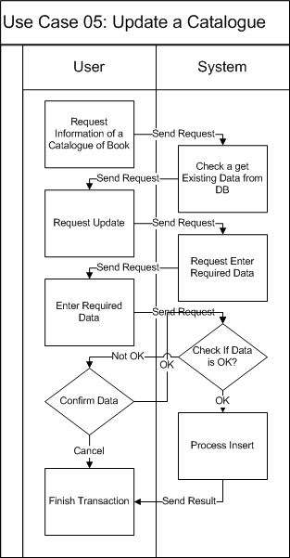

|  |  |  |
| --- | --- | --- |
| Use Case Name | Update catalogue of books | |
| Actors | Admin/Librarian | |
| Description | Update a catalogue of books to the database | |
| Requirement | Fields/Attributes must have validations on it | |
| Pre-conditions | User must log in with role “Admin” or “Librarian” | |
| Post-conditions | New data of catalogue is modified to database | |
| Basic Flow | *Actor Actions:*  *1. In the result of search form or in the view detailed information form, user click “Edit” button.*  *3. User change the fields that they want to modify*  *4. Click "Edit" button*  *6. User click “Yes” button* | *System Response:*  *2. Display a form that has detailed information of catalogue and all the information appear in text box.*  *5. Message box confirms "Are you sure to change the information of this catalogue? “.*  *7. Data will be checked and updated to the database.* |
| Alternative Flow 1 | *Actor actions:*  *1. Click “No” button* | *System Response:*  *2. Stay in the current window form.* |
| Exception Flow | N/A | |

###### Use Case : Searching a Books & Copies

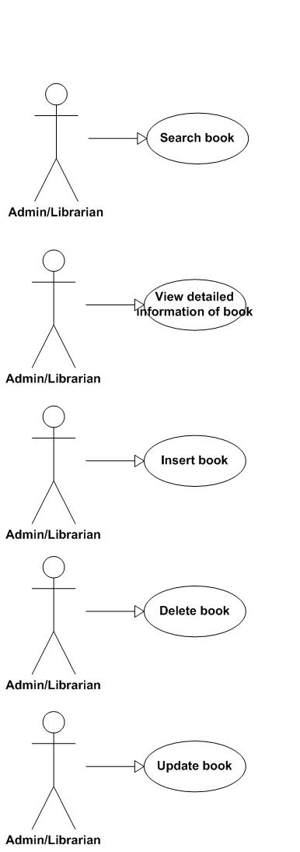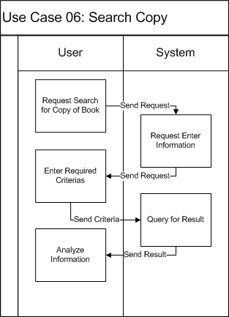

|  |  |  |
| --- | --- | --- |
| Use Case Name | Search book | |
| Actors | Librarian/Admin | |
| Description | Search for some catalogues of books that are needed by users | |
| Requirement | Fields/Attributes must have validations on it | |
| Pre-conditions | Users must input keyword | |
| Post-conditions | A list of result will be display | |
| Basic Flow | *Actor Actions:*  *1. Click “Search book” button*  *3. User types keywords*  *4. Click "Search" button* | *System Response:*  *2. Display a search window form*  *5. A list of result will be displayed in users’ screens. If there is no result, will display “Sorry we can’t find the book you want.”* |
| Exception Flow | N/A | |

###### Use Case : View Information of Copies

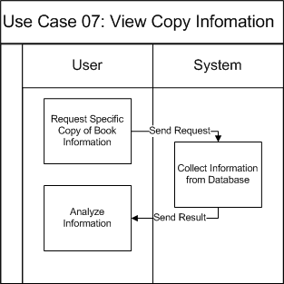

|  |  |  |
| --- | --- | --- |
| Use Case Name | View detailed information of book | |
| Actors | All users | |
| Description | View detailed information of the book | |
| Requirement | N/A | |
| Pre-conditions | User choose the book which they want to view detailed information | |
| Post-conditions | Detailed information of book will be displayed | |
| Basic Flow | *Actor Actions:*  *1. In the result form of search page. User clicks “View detailed information” button* | *System Response:*  *2. Display a new window form that includes the detailed information of the book.* |
| Exception Flow | N/A | |

###### Use Case : Insert Copies to a Catalogue

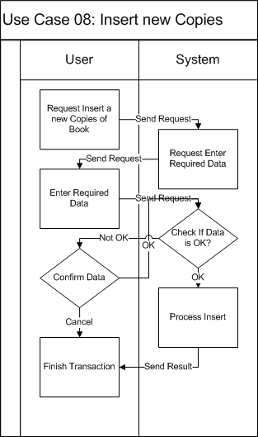

|  |  |  |
| --- | --- | --- |
| Use Case Name | Insert book | |
| Actors | Admin/Librarian | |
| Description | Insert books to the database | |
| Requirement | Fields/Attributes must have validations on it | |
| Pre-conditions | User must log in with role “Admin” or “Librarian” | |
| Post-conditions | New books is added to database | |
| Basic Flow | *Actor Actions:*  *1. In the detailed catalogue information page, user click “Add book” button*  *3. User types required attributes or choose the number of books*  *4. Click "Insert" button*  *6. User click “Yes” button* | *System Response:*  *2. Display a form and request to enter the attributes that will be processed (with separate book) or the number of books that they want to add to the catalogue.*  *5. Message box confirms "Are you sure to insert book? “.*  *7. Data will be checked and insert to the database.* |
| Alternative Flow 1 | *Actor actions:*  *1. Click “No” button* | *System Response:*  *2. Stay in the current window form.* |
| Exception Flow | N/A | |

###### Use Case : Delete a number of Copies in Database

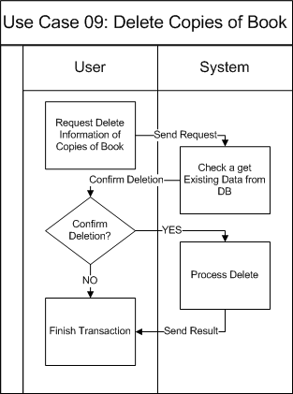

|  |  |  |
| --- | --- | --- |
| Use Case Name | Delete book | |
| Actors | Admin/Librarian | |
| Description | Delete a book from the database | |
| Requirement | Fields/Attributes must have validations on it | |
| Pre-conditions | User must log in with role “Admin” or “Librarian” | |
| Post-conditions | book will be deleted from the database | |
| Basic Flow | *Actor Actions:*  *1. In the result of search form or in the view detailed information form, user click “Delete” button.*  *6. User click “Yes” button* | *System Response:*  *2. Message box confirms "Are you sure to delete this book? “.*  *7. The selected book will be deleted from the database* |
| Alternative Flow 1 | *Actor actions:*  *1. Click “No” button* | *System Response:*  *2. Stay in the current window form.* |
| Exception Flow | N/A | |

###### Use Case : Update Copies information

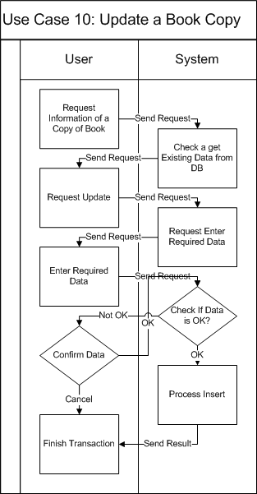

|  |  |  |
| --- | --- | --- |
| Use Case Name | Update a book | |
| Actors | Admin/Librarian | |
| Description | Update an information of a book to the database | |
| Requirement | Fields/Attributes must have validations on it | |
| Pre-conditions | User must log in with role “Admin” or “Librarian” | |
| Post-conditions | New data of book is modified to database | |
| Basic Flow | *Actor Actions:*  *1. In the result of search form or in the view detailed information form, user click “Edit” button.*  *3. User change the fields that they want to modify*  *4. Click "Edit" button*  *6. User click “Yes” button* | *System Response:*  *2. Display a form that has detailed information of book and all the information which user can modify is appeared in text box.*  *5. Message box confirms "Are you sure to change the information of this catalogue?”.*  *7. Data will be checked and updated to the database.* |
| Alternative Flow 1 | *Actor actions:*  *1. Click “No” button* | *System Response:*  *2. Stay in the current window form.* |
| Exception Flow | N/A | |

###### 

###### Use Case : View Category information

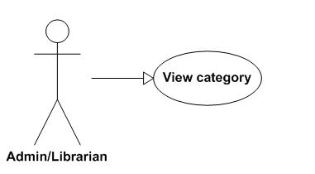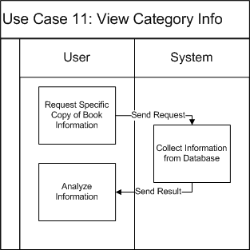

|  |  |  |
| --- | --- | --- |
| Use Case Name | View category | |
| Actors | Admin/Librarian | |
| Description | View detailed information of category | |
| Requirement | N/A | |
| Pre-conditions | User choose the category which they want to view detailed information | |
| Post-conditions | Detailed information of category will be displayed | |
| Basic Flow | *Actor Actions:*  *1. In the result form of search page. User clicks “View detailed information” button* | *System Response:*  *2. Display a new window form that includes the detailed information of the category.* |
| Exception Flow | N/A | |

###### 

###### Use Case : Insert a new Category

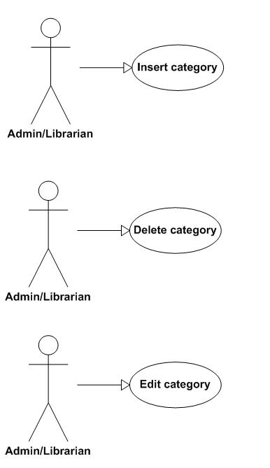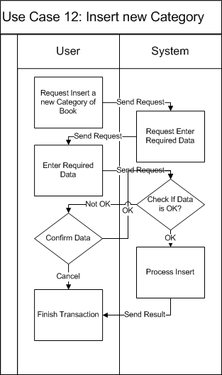

|  |  |  |
| --- | --- | --- |
| Use Case Name | Insert category of books | |
| Actors | Admin/Librarian | |
| Description | Insert a category of books to the database | |
| Requirement | Fields/Attributes must have validations on it | |
| Pre-conditions | User must log in with role “Admin” or “Librarian” | |
| Post-conditions | New category of books is added to database | |
| Basic Flow | *Actor Actions:*  *1. Click “Add category” button*  *3. User types required attributes*  *4. Click "Insert" button*  *6. User click “Yes” button* | *System Response:*  *2. Display a form and request to enter the attributes that will be processed.*  *5. Message box confirms "Are you sure to insert this category? “.*  *7. Data will be checked and insert to the database.* |
| Alternative Flow 1 | *Actor actions:*  *1. Click “No” button* | *System Response:*  *2. Stay in the current window form.* |
| Exception Flow | N/A | |

###### Use Case : Delete a Category

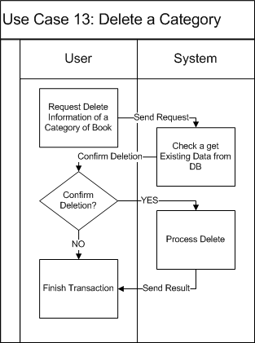

|  |  |  |
| --- | --- | --- |
| Use Case Name | Delete category of books | |
| Actors | Admin/Librarian | |
| Description | Delete a category of books from the database | |
| Requirement | Fields/Attributes must have validations on it | |
| Pre-conditions | User must log in with role “Admin” or “Librarian” | |
| Post-conditions | The category will be delete from the database and all the catalogue that referenced to this category will be referenced to the parent category or set to uncategorized | |
| Basic Flow | *Actor Actions:*  *1. In the result of search form or in the view detailed information form, user click “Delete” button.*  *3. User click “Yes” button* | *System Response:*  *2. Message box confirms "Are you sure to delete this category? “.*  *7. The category will be delete from the database and all the catalogue that referenced to this category will be referenced to the parent category or set to uncategorized* |
| Alternative Flow 1 | *Actor actions:*  *1. Click “No” button* | *System Response:*  *2. Stay in the current window form.* |
| Exception Flow | N/A | |

###### Use Case : Edit a Category

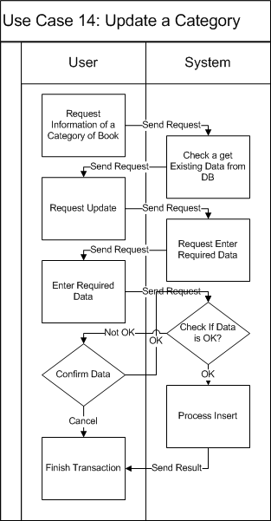

|  |  |  |
| --- | --- | --- |
| Use Case Name | Update category of books | |
| Actors | Admin/Librarian | |
| Description | Update a category of books to the database | |
| Requirement | Fields/Attributes must have validations on it | |
| Pre-conditions | User must log in with role “Admin” or “Librarian” | |
| Post-conditions | New data of category is modified to database | |
| Basic Flow | *Actor Actions:*  *1. In the result of search form or in the view detailed information form, user click “Edit” button.*  *3. User change the fields that they want to modify*  *4. Click "Edit" button*  *6. User click “Yes” button* | *System Response:*  *2. Display a form that has detailed information of category and all the information appear in text box.*  *5. Message box confirms "Are you sure to change the information of this category? “.*  *7. Data will be checked and updated to the database.* |
| Alternative Flow 1 | *Actor actions:*  *1. Click “No” button* | *System Response:*  *2. Stay in the current window form.* |
| Exception Flow | N/A | |

#### Manage Transactions (Borrowing and Returning)

##### Use Case-B Diagram



Figure : Reader’s related features



Figure : Internal User’s related features

##### Use Case-B Specification

###### Use Case : Register a Book online



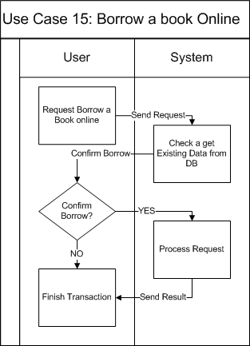

|  |  |  |
| --- | --- | --- |
| Use Case Name | Register book online | |
| Actors | Reader | |
| Description | Register book online | |
| Requirement | User is available to borrow book | |
| Pre-conditions | User must log in as a reader | |
| Post-conditions | New register record is inserted into database | |
| Basic Flow | *Actor Actions:*  *1. Click Register icon on a book*  *4. Click OK*  *[Alternative Flow 1]* | *System Response:*  *3. Display confirm message*  *5. Save register info to database.*  *6. Display info message*  *7. Back to book list page* |
| Alternative Flow 1 | *Actor actions:*  *1. Click “Cancel”* | *System Response:*  *2. Back to book list page* |
| Exception Flow | N/A | |

###### Use Case : View Register information



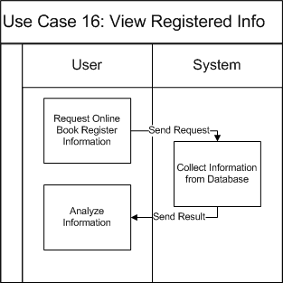

|  |  |  |
| --- | --- | --- |
| Use Case Name | View register info | |
| Actors | Reader | |
| Description | View register info | |
| Requirement | N/A | |
| Pre-conditions | User must log in as a reader | |
| Post-conditions | Register info is displayed | |
| Basic Flow | *Actor Actions:*  *1. Click “View Register Info”* | *System Response:*  *2. Display all register of the logged in user* |
| Exception Flow | N/A | |

###### Use Case : Confirm Registers



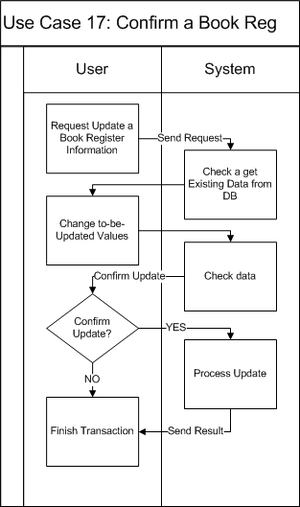

|  |  |  |
| --- | --- | --- |
| Use Case Name | Confirm register | |
| Actors | Librarian | |
| Description | Confirm register | |
| Requirement | N/A | |
| Pre-conditions | User must log in as a librarian | |
| Post-conditions | New borrowing record is inserted into database | |
| Basic Flow | *Actor Actions:*  *1. Click “View Register”*  *3. Select a register*  *4. Click “Confirm”*  *[Alternative Flow 1]*  *6. Click “OK”*  *[Alternative Flow 2]* | *System Response:*  *2. Display all available registers*  *5. Display confirm message box*  *7. Update register info*  *8. Back to register list page* |
| Alternative Flow 1 | *Actor actions:*  *1. Click “Deny”*  *3. Click “OK”*  *[Alternative Flow 2]* | *System Response:*  *2. Display confirm message box*  *4. Update register info*  *5. Back to register list page* |
| Alternative Flow 2 | *Actor actions:*  *1. Click “Cancel”* | *System Response:*  *2. Back to register list page* |
| Exception Flow | N/A | |

###### Use Case : Update after Reader take Copy of Book



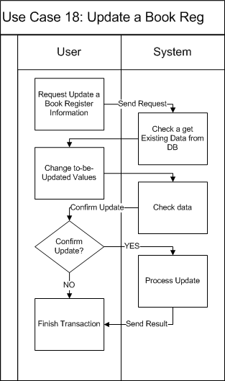

|  |  |  |
| --- | --- | --- |
| Use Case Name | Take registered book | |
| Actors | Librarian | |
| Description | Reader takes registered book | |
| Requirement | Reader info is available | |
| Pre-conditions | User must log in as a librarian | |
| Post-conditions | New borrowing record is inserted into database  Register record is updated | |
| Basic Flow | *Actor Actions:*  *1. User input Reader ID*  *3. Click “Take Book” button*  *5. Select the required book*  *6. Click “Take”*  *8. Click “OK”*  *[Alternative Flow 1]* | *System Response:*  *2. Display reader info*  *4. Display a list of registered book*  *7. Display confirm message*  *9. Save borrowing info to database*  *10. Update register info*  *11. Display info message* |
| Alternative Flow 1 | *Actor actions:*  *1. Click “Cancel”* | *System Response:*  *2. Back to list book page* |
| Exception Flow | N/A | |

###### Use Case : Borrow Copy of Book offline



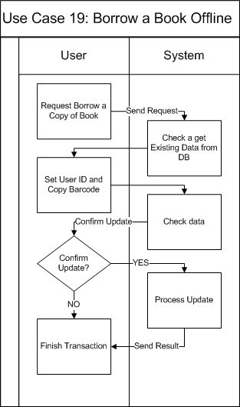

|  |  |  |
| --- | --- | --- |
| Use Case Name | Borrow book offline | |
| Actors | Librarian | |
| Description | Borrow book offline | |
| Requirement | Reader info is available | |
| Pre-conditions | User must log in as a librarian | |
| Post-conditions | New borrowing record is inserted into database | |
| Basic Flow | *Actor Actions:*  *1. User input Reader ID*  *3. Click “Borrow Book” button*  *5. Select the required book*  *6. Click “Borrow”*  *8. Click “OK”*  *[Alternative Flow 1]* | *System Response:*  *2. Display reader info*  *4. Display list book page*  *7. Display confirm message*  *9. Save borrowing info to database*  *10. Display info message* |
| Alternative Flow 1 | *Actor actions:*  *1. Click “Cancel”* | *System Response:*  *2. Return to list book page* |
| Exception Flow | N/A | |

###### Use Case : Return Copy of Book



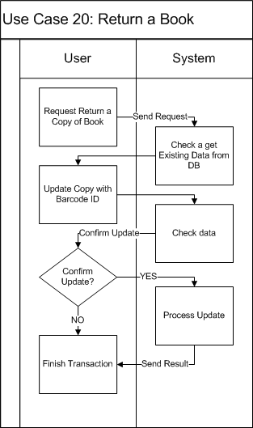

|  |  |  |
| --- | --- | --- |
| Use Case Name | Return book | |
| Actors | Reader | |
| Description | Reader returns book | |
| Requirement | Reader info is available | |
| Pre-conditions | User must log in as a librarian | |
| Post-conditions | Borrowing record is updated | |
| Basic Flow | *Actor Actions:*  *1. User input Reader ID*  *3. Click “Return Book” button*  *5. Select the required book*  *6. Click “Return”*  *8. Click “OK”*  *[Alternative Flow 1]* | *System Response:*  *2. Display reader info*  *4. Display list of currently borrowed books*  *7. Display confirm message*  *9. Save borrowing info to database* |
| Alternative Flow 1 | *Actor actions:*  *1. Click “Cancel”* | *System Response:*  *2. Return to list book page* |
| Exception Flow | N/A | |

###### Use Case : Expand a Borrow Time of a Copy



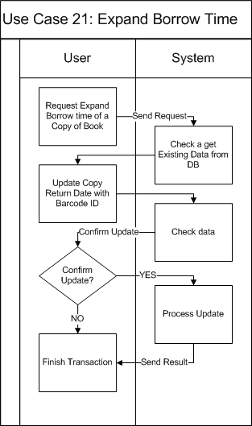

|  |  |  |
| --- | --- | --- |
| Use Case Name | Expand borrowing time | |
| Actors | Librarian | |
| Description | Expand borrowing time | |
| Requirement | Reader info is available | |
| Pre-conditions | User must log in as a librarian | |
| Post-conditions | Borrowing record is updated | |
| Basic Flow | *Actor Actions:*  *1. User input Reader ID*  *2. Click “Expand time”*  *3. Select a borrowing record*  *5. Choose a date to expand to*  *6. Click “OK”*  *[Alternative Flow 1]* | *System Response:*  *3. Display list of borrowing records*  *4. Display a form and let user modify its info*  *Form includes:*   * *Date to expand to*   *7. Save borrowing info to database*  *8. Display info message* |
| Alternative Flow 1 | *Actor actions:*  *1. Click “Cancel”* | *System Response:*  *2. Return to borrowing records list* |
| Exception Flow | N/A | |

#### Searching features of the system.

##### Use Case-C Diagram

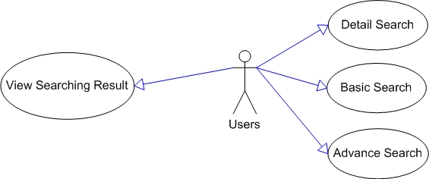

Figure : Searching features of the LIB System

##### Use Case-C Specification

###### Use Case : Basic Search

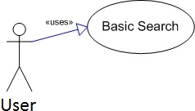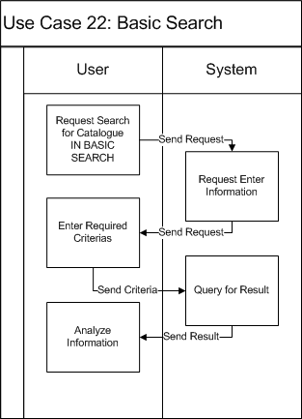

|  |  |  |
| --- | --- | --- |
| Use Case Name | Book Basic Search Use Case | |
| Actors | Librarian/Admin/Normal users | |
| Description |  | |
| Requirement | For authorized users only | |
| Pre-conditions | User must log in the system | |
| Post-conditions |  | |
| Basic Flow | *Actor Actions:*  *1. Click “Search for books” (button)*  *3. User types required attributes*  *4. Click "Search" button*  *[Alternative Flow 1]* | *System Response:*  *2. Display a form and request to enter the attributes that will be processed.*  *Form includes:*   * *Title: String, Textbox (Required)* * *Author: String, Textbox (Required)* * *Publisher: String. Textbox (Required)*   *5. Data will be checked then show searching result* |
| Alternative Flow 1 | *Actor actions:*  *1. Click “Reset” button*  *3. Click "Yes"*  *[Alternative Flow 2]* | *System Response:*  *2. Message box confirms "Do you want to reset your searching data?"*  *4. Erase data in textboxes* |
| Alternative Flow 2 | *Actor Actions:*  *1. Click "No" button* | *System Response:*  *2. Stay at current state.* |
| Exception Flow | N/A | |

###### Use Case : Detail Search

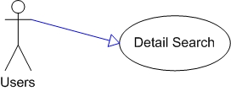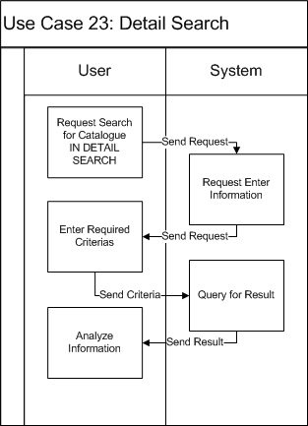

|  |  |  |
| --- | --- | --- |
| Use Case Name | Book Detail Search Use Case | |
| Actors | Librarian/Admin/Normal users | |
| Description |  | |
| Requirement | For authorized users only | |
| Pre-conditions | User must log in the system | |
| Post-conditions |  | |
| Basic Flow | *Actor Actions:*  *1. Click “Search for books” (button)*  *3. User types required attributes*  *4. Click "Search" button*  *[Alternative Flow 1]* | *System Response:*  *2. Display a form and request to enter the attributes that will be processed.*  *Form includes:*   * *Title: String, Textbox (Required)* * *Author: String, Textbox (Required)* * *Publisher: String. Textbox (Required)*   *5. Data will be checked then show searching result* |
| Alternative Flow 1 | *Actor actions:*  *1. Click “Reset” button*  *3. Click "Yes"*  *[Alternative Flow 2]* | *System Response:*  *2. Message box confirms "Do you want to reset your searching data?"*  *4. Erase data in textboxes* |
| Exception Flow | N/A |  |

###### Use Case : Advanced Search

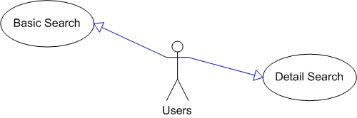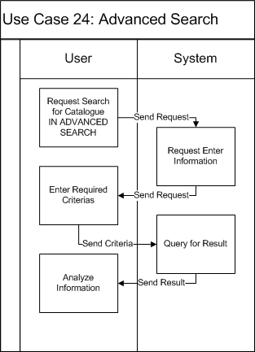

|  |  |  |
| --- | --- | --- |
| Use Case Name | Book Advance Search Use Case | |
| Actors | Librarian/Admin/Normal users | |
| Description |  | |
| Requirement | For authorized users only | |
| Pre-conditions | User must log in the system | |
| Post-conditions |  | |
| Basic Flow | *Actor Actions:*  *1. Click “Search for books” (button)*  *3. User types required attributes*  *4. Click "Search" button*  *[Alternative Flow 1]* | *System Response:*  *2. Display a form and request to enter the attributes that will be processed.*  *Form includes:*   * *Title: String, Textbox (Required)* * *Author: String, Textbox (Required)* * *Publisher: String. Textbox (Required)*   *5. Data will be checked then show searching result* |
| Alternative Flow 1 | *Actor actions:*  *1. Click “Reset” button*  *3. Click "Yes"*  *[Alternative Flow 2]* | *System Response:*  *2. Message box confirms "Do you want to reset your searching data?"*  *4. Erase data in textboxes* |
| Exception Flow | N/A |  |

#### Manage Users’ Information

##### Use Case-D Diagram

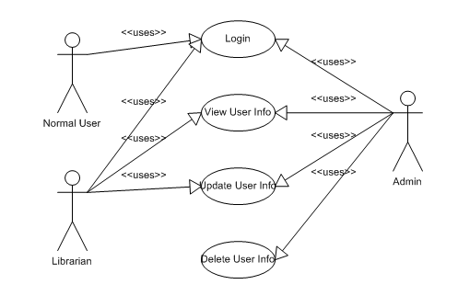

Figure : User Management features

##### Use Case-D Specification

###### Use Case : Login

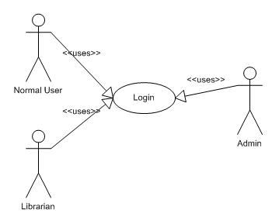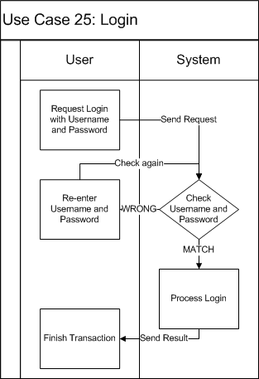

|  |  |  |
| --- | --- | --- |
| Use Case Name | Login Use Case | |
| Actors | Admin/Librarian/Normal User | |
| Description | Log a user into LIB System | |
| Requirement | N/A | |
| Pre-conditions | N/A | |
| Post-conditions | User will be logged into LIB System. New working session will be created | |
| Basic Flow | *Actor Actions:*  *1. In the Login form of the Win-form application or the Login page of the OOPAC, user will have to enter the username and password and then click “Login” button.* | *System Response:*  *2. The system will check the username and password from user and if the user name password are right. [Alternative Flow 2]*  *Else [Alternative Flow 1]* |
| Alternative Flow 1 | *Actor Actions:*  *2. The User will enter again username and password* | *System Response:*  *1. The system alert user about “wrong username or password and request enter again.”*  *3. Check username and password, if username and password are right. [Alternative Flow 2]*  *Else [Alternative Flow 1]* |
| Alternative Flow 1 | *Actor Actions:* | *System Response:*  *1. Log the user into the system and create a new working session.* |
| Exception Flow | N/A | |

###### Use Case : View User Information

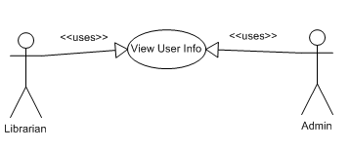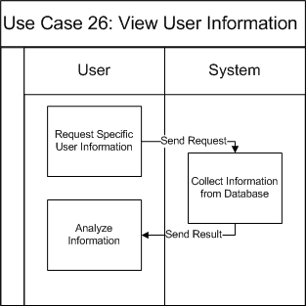

|  |  |  |
| --- | --- | --- |
| Use Case Name | View User Information Use Case | |
| Actors | Admin/Librarian | |
| Description | View an User Information | |
| Requirement | N/A | |
| Pre-conditions | User must log in with role “Admin”/“Librarian” | |
| Post-conditions | Detail information of selected user will be shown | |
| Basic Flow | *Actor Actions:*  *1. In the user list view, the librarian or admin click on one user to view the detailed information of that user.* | *System Response:*  *2. The detailed Information of that user will be shown in a User Detail Form.* |
| Exception Flow | N/A | |

###### Use Case : Update User Information

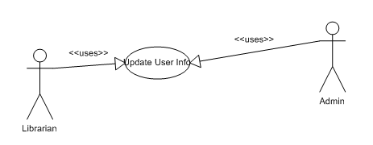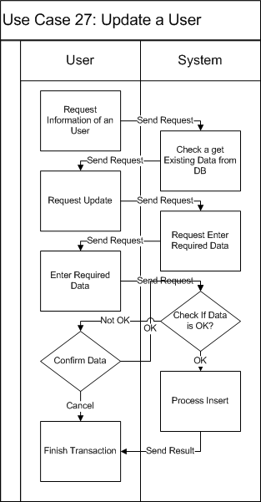

|  |  |  |
| --- | --- | --- |
| Use Case Name | Update User Information Use Case | |
| Actors | Admin/Librarian | |
| Description | Update an User Information | |
| Requirement | Fields/Attributes must have validations on it | |
| Pre-conditions | User must log in with role “Admin”/“Librarian” | |
| Post-conditions | Detail information of selected user will be updated | |
| Basic Flow | *Actor Actions:*  *1. In the user Detail Information, the librarian or admin edit the detailed information of that user.*  *2. Click on “Save” button.*  *4. Click on “Yes”.*  *6. Click on “No”*  *[Alternative Flow 1]* | *System Response:*  *3. Show message “Are you sure want to update this user information?”*  *5. The detailed Information of that user will be updated in the DB.* |
| Alternative Flow 1 | *Actor Actions:*  *1. User click on “No” button of confirm message.* | *System Response:*  *2. The user information remains unchanged.* |
| Exception Flow | N/A | |

###### Use Case : Delete an User

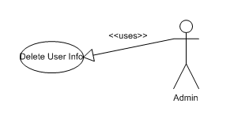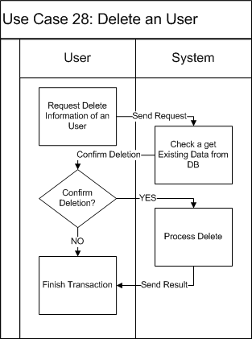

|  |  |  |
| --- | --- | --- |
| Use Case Name | Delete User Information Use Case | |
| Actors | Admin | |
| Description | Delete an User Information | |
| Requirement | Fields/Attributes must have validations on it | |
| Pre-conditions | User must log in with role “Admin” | |
| Post-conditions | Detail information of selected user will be deleted | |
| Basic Flow | *Actor Actions:*  *1. In the user Detail Information, the librarian or admin click on “Delete” button.*  *4. Click on “Yes”.*  *6. Click on “No”*  *[Alternative Flow 1]* | *System Response:*  *3. Show message “Are you sure want to delete this user?”*  *5. The detailed Information of that user will be deleted in the DB.* |
| Alternative Flow 1 | *Actor Actions:*  *1. User click on “No” button of confirm message.* | *System Response:*  *2. The user information remains unchanged.* |
| Exception Flow | N/A | |

#### Generate Reports

##### Use Case-E Diagram

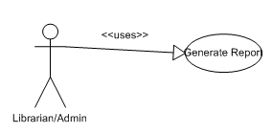

Figure : Generate Report

##### Use Case-E Specification

###### Use Case : Generate Report

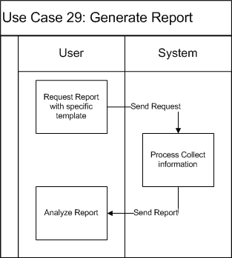

|  |  |  |
| --- | --- | --- |
| Use Case Name | Generate Report Use Case | |
| Actors | Admin/Librarian | |
| Description | Generate Report based on the report template. | |
| Requirement | N/A | |
| Pre-conditions | User must log in with role “Admin”/“Librarian” | |
| Post-conditions | The Report will be generated and shown. | |
| Basic Flow | *Actor Actions:*  *1. In the Report Menu, User will have to choose the type of report to be generated and click Create Report.* | *System Response:*  *2. LIB will send request to DB system to collect information then create and show the report.* |
| Exception Flow | N/A | |

### Software System Attributes

#### Reliability

* The system can be used like “always on” system.
* There is no requirement for system maintenance task from the user.
* Mean Time Between Failures (MTBF): more than 6 months.
* Mean Time To Repair (MTTR): less than 72 hours.
* Accuracy: 100%
* Maximum Bugs and Defect Rate: 0.3 bugs per thousand lines of code (0.3 bugs/KLOC).
* Critical bugs:
* Loss of data: not any
* Unable to use part of the system’s functionality: not any

#### Availability

It should be available as a minimum 99.99% when any one of these subsystems is available.

#### Security: there are 3 types of the users in the LIB System

* **Admin:** the **Administrator** of the system, admin has the primitive privilege on the system features and database. Only one admin is available in the system.
* **Librarian:** the **Librarian** of the Library, librarians can manage the titles and copies of the books in the library, the transaction between readers and library, but not the users’ information. Every business and document works must be performed by one of the librarians.
* **Normal User:** the **Normal Reader** of the system, login functionality is provided for the reader to order the copies of books only. Normal Reader cannot perform any managing activity.

#### Maintainability

The LIB should have the ability to auto-update without hiatus the system.

#### Portability

The LIB shall enable users to use the following environments (e.g., platform and operating system) to interact with the LIB:

* User Personal Computer:
  + PC with minimum of Pentium IV chip, 512MB of RAM, and a 56 K modem
  + Dot NET Environment
* Operating System:
  + Microsoft Windows XP or above
  + Mac OS X 10.0 or above
  + Linux 3.5 or above
* Connection:
  + 56 kbps or other type of connection.

#### Performance

* Response time for a search:
  + Average: 100 millisecond/search
  + Maximum: 250 millisecond/search
* Maximum number of concurrent users:
  + 1000 concurrent users
* Disk:
  + Database: depends on the number of publication records.
  + Hard drive space to install application on each computer: 150 megabytes.

## Entity Relationship Diagram or Data Structures

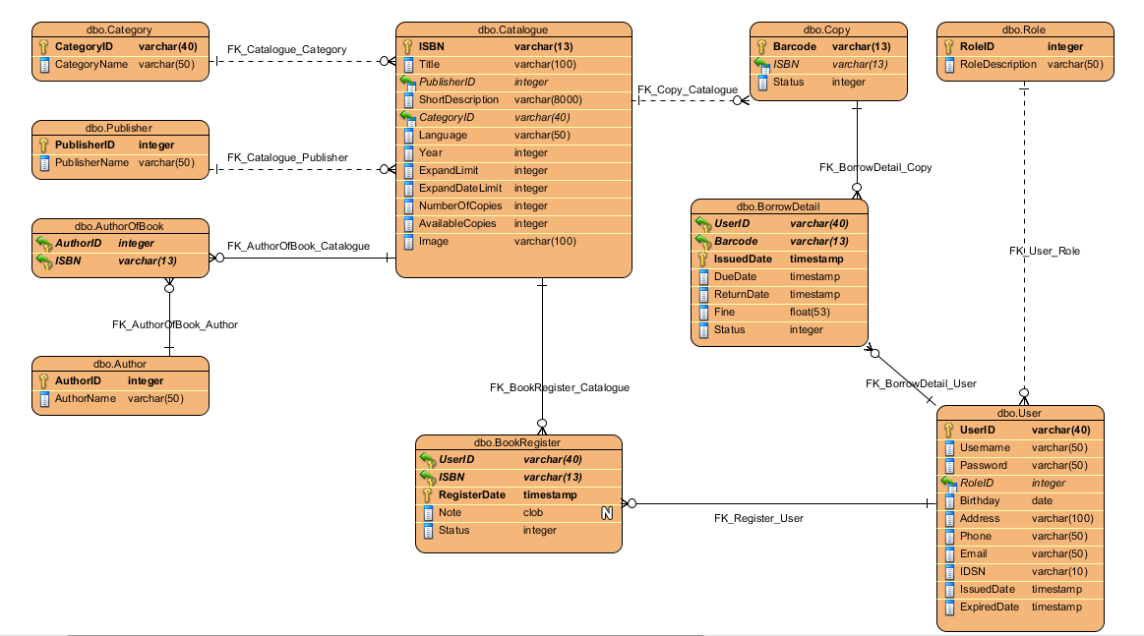

## Other material (if any)

N/A

# Software Detail Design

## Design Overview

The document is aimed to show the detail design of the LIB system design, from architecture design to high level design of logical.

LIB system consists of 2 parts: one is windows-form based application software, and one is a web-based application.

* Windows-form based application: is the application for the librarian to manage the information of the library and information about user and the copies of book. With the windows-form application, the user can perform most of the features of the LIB System.
* Web-based application: is the application that has been deployed to an open server for the users to connect and searching or ordering the copies of book that they want.

The architecture of LIB:

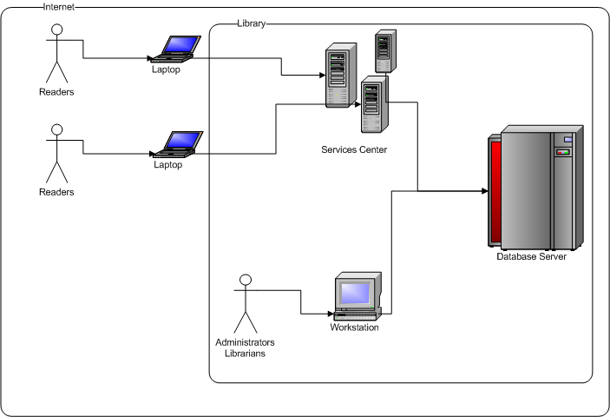

Figure a: System architecture of LIB



Figure b: Network architecture of LIB

## System Architectural Design

### Choice of System Architecture

Because of consisting 2 types of application in one system, the LIB system will be implemented on the type of system architecture:

* For the windows-form based application:
  + C# with .NET framework.
  + Microsoft SQL Server 2008.
* For the web-based application:
  + C# with .NET framework.
  + Microsoft SQL Server 2008.
  + Internet Information Service (IIS) 7.0

### Discussion of Alternative Designs

In the alternative design of LIB system, there are 2 discussions of the system tools that had been used for developing the system:

* Microsoft Light-switch Technology: one of the Technology of Microsoft that support communication between database and application.
  + - Cons: the Light-switch work at very low efficiency.
* XAMPP Server: one of the light-weight servers that has been designed for hosting application online.
  + - Cons: low security.

### Description of System Interface

N/A

## Component Diagram

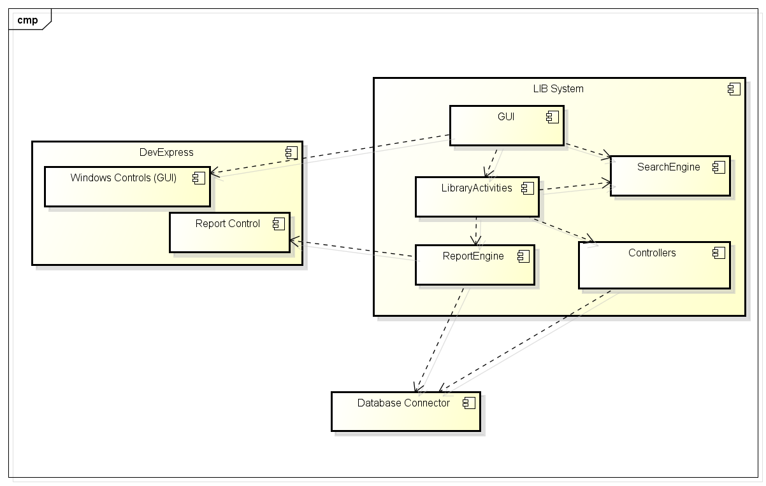

Figure : LIB Components Diagram

## Detailed Description of Components

### CRC Cards (Class-Responsibility-Collaborators)

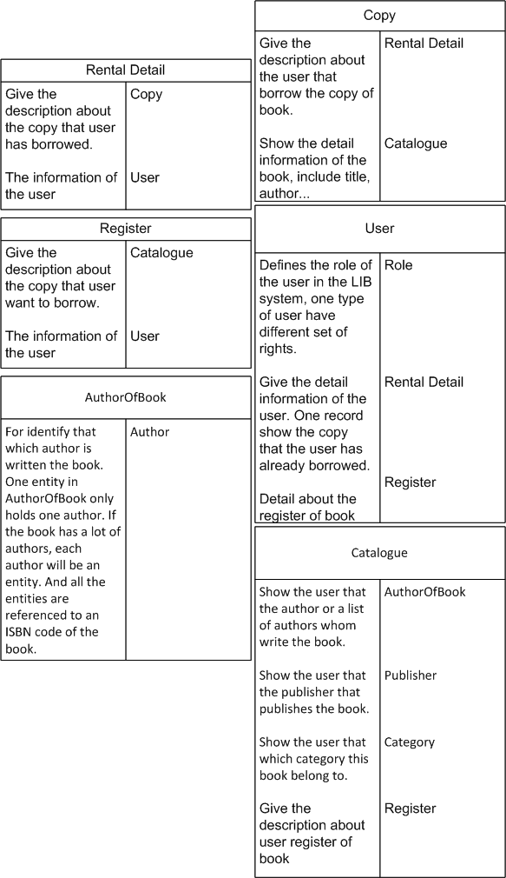

Figure : CRC Cards

### Class Diagram

Figure 18: Class Diagram of LIB

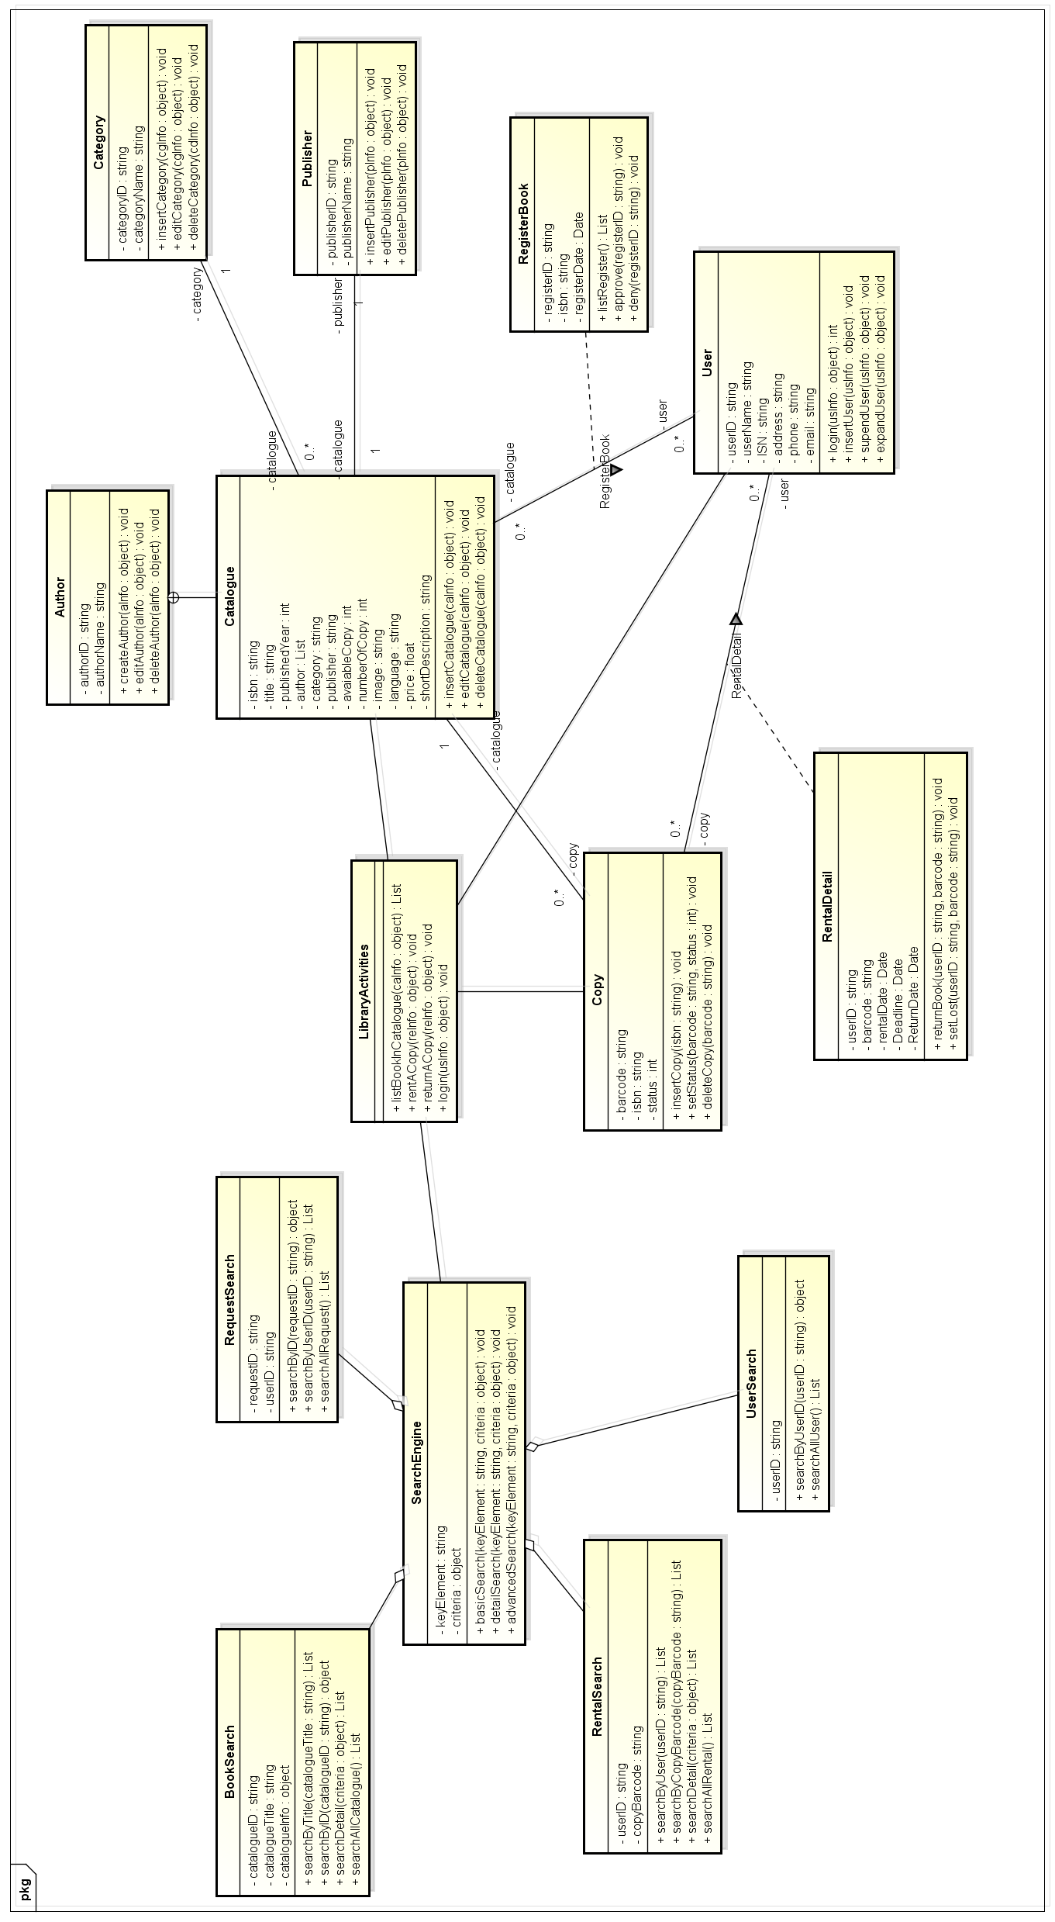

### Class Diagram Explanation

* There are 2 parts of the classes divided by class responsibility.
* In the right side are the classes that project the project master data:
  + Each Catalogue consist several Authors.
  + Each Catalogue belongs to one and only one Category.
  + Each Catalogue published by one and only one Publisher.
  + Each Catalogue consist several Copies of that title.
  + Each User can register to rent some copies of Catalogues.
  + Each User can rent some copies of Catalogues.
* The left side are the classes that represent the functionalities of the Library:
  + LibraryActivity provides the basic activities of the LIB and have relationship to Catalogue, Copy, User and SearchEngine.
  + SearchEngine provides the search abilities of LIB, contains the Book, Request, Rental and User search-ability.

### System Layers Overview

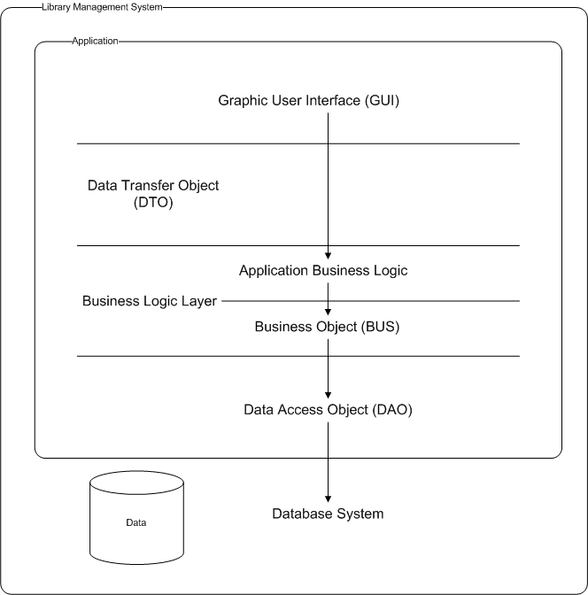

Figure : System Layers Overview

|  |  |
| --- | --- |
| **Name** | **Description** |
| **Data Transfer Object** | This object for containing data which will interact with user |
| **Business Object** | Execute system business logic |
| **Data Access Object** | Directly interacting with system’s database. |

### System Layers Explanation

* Our system consists of an application system and a database server.
* The application system divided into 3 layers based on the functionality of object.
  + The Data Access Object (DAO) layer acts as a middle class to connect to the database server and perform the query and advance functional of database system.
  + The Business Logic Layer (BUS) is the class consist all the business functionalities of the system. In this layer, we have divide into 2 section:
    - First is the BUS, that performs the data validation and integration, including all the basic functionalities of the database system.
    - Second is the higher class, used for representing the functionalities of the LIB system, containing the business function of the LIB.
  + Data Transfer Object (DTO) projecting the database to be used as the data container for the LIB to communicate with the DB system.
* Graphic User Interface (GUI) is the interface that used to interact with the users.

## Sequence Diagram

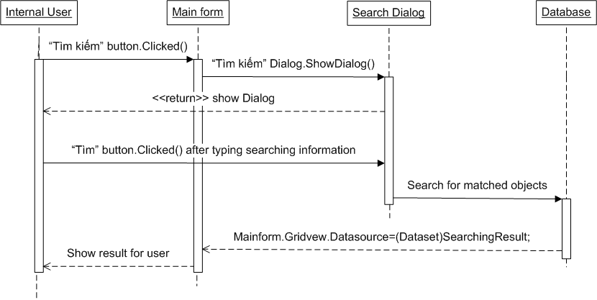

Figure : Search for catalogue (Basic/Detail/Advance)

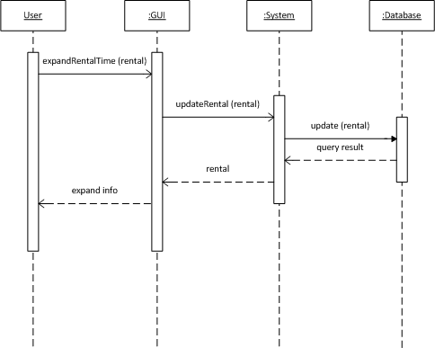

Figure : Expand Rental Time of a copy

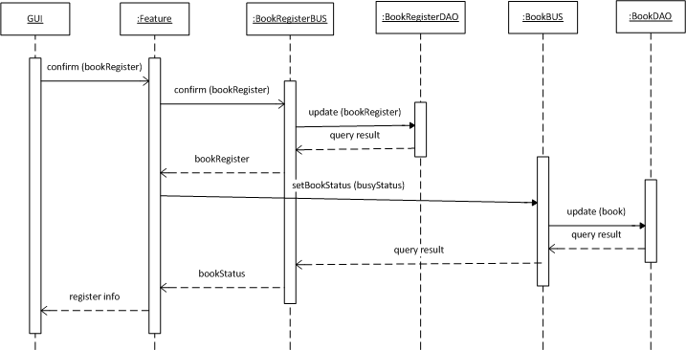

Figure : Confirm the registered order of copies

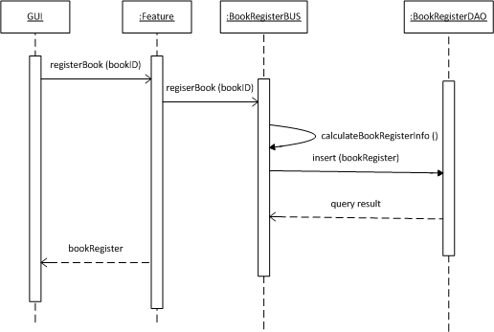

Figure : Register a copy of catalogue

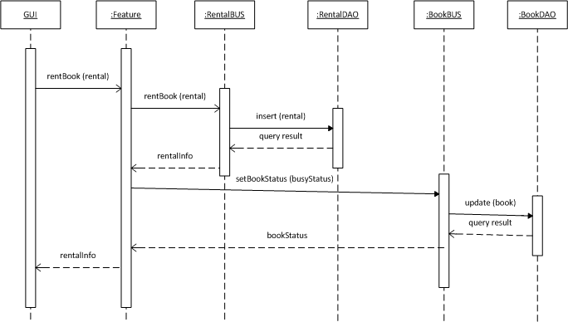

Figure : Rent a copy of book

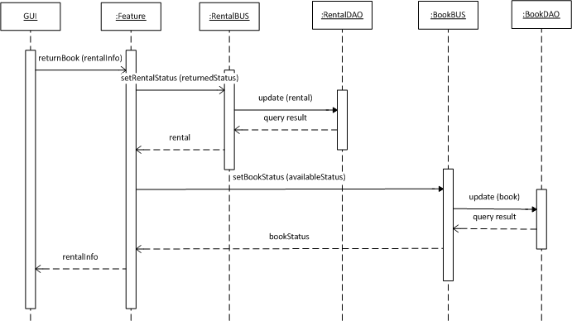

Figure : Return a copy of book

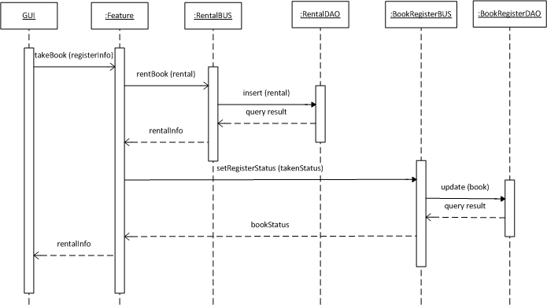

Figure : Take a registered copy of book

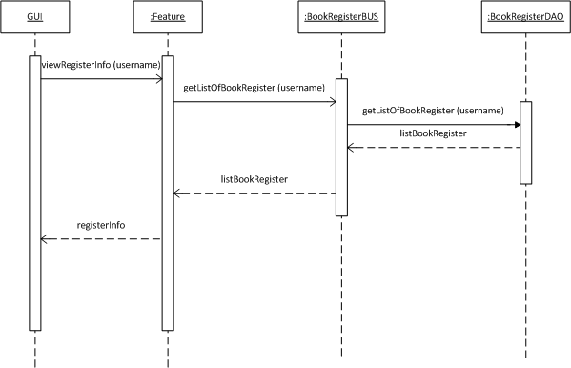

Figure : View a registered Information

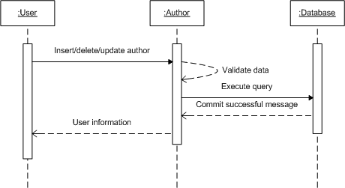

Figure : Insert/Delete/Update an author

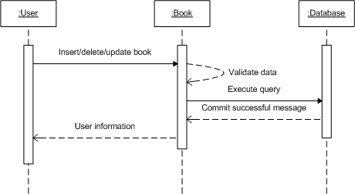

Figure : Insert/Delete/Update a copy of book

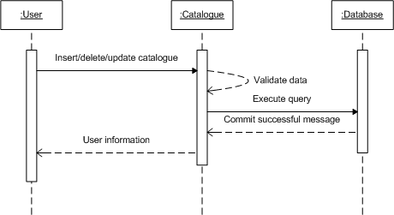

Figure : Insert/Delete/Update a catalogue

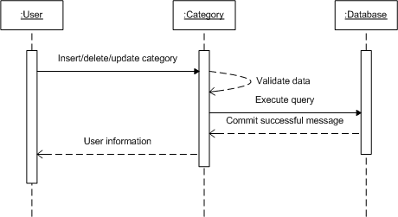

Figure : Insert/Delete/Update a category

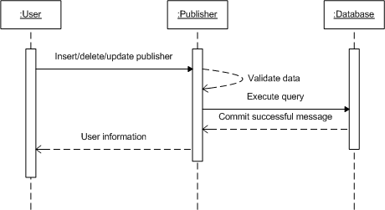

Figure : Insert/Delete/Update a publisher

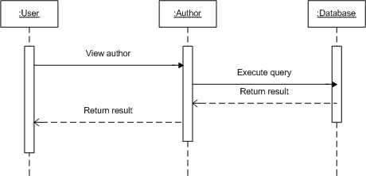

Figure : View Author Information

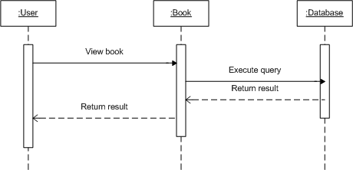

Figure : View copy of book Information

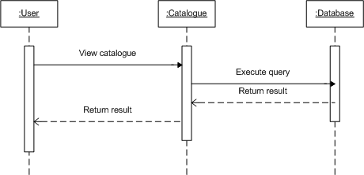

Figure : View Catalogue Information

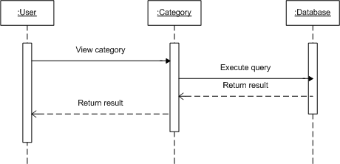

Figure : View Category Information

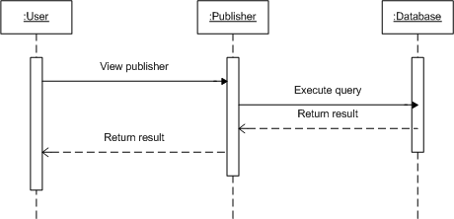

Figure : View Publisher Information

## User Interface Design

### Description of the User Interface

#### Screen Images

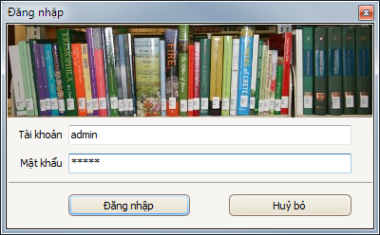

Figure : Login Screen

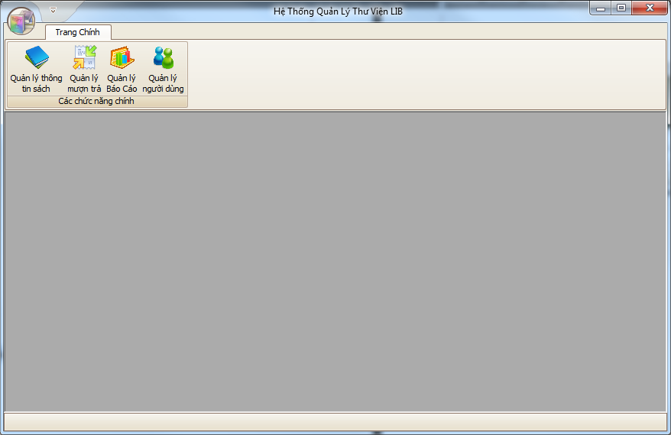

Figure : Main Menu

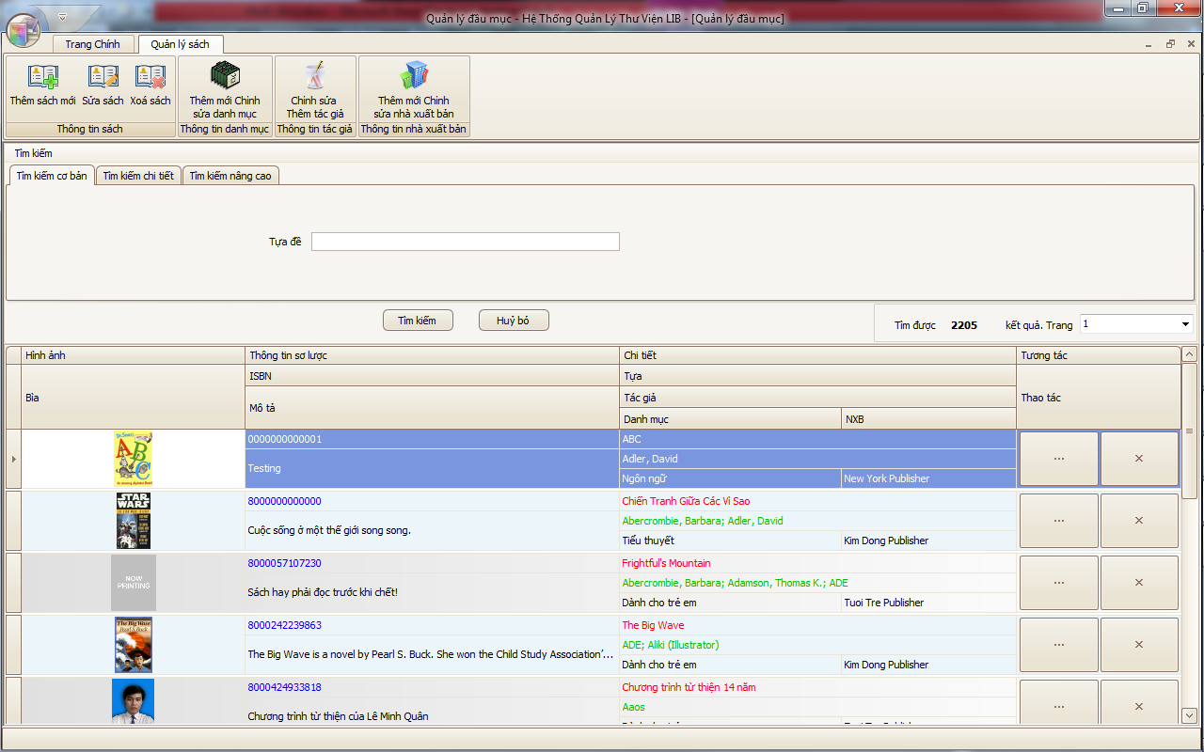

Figure : Book Management

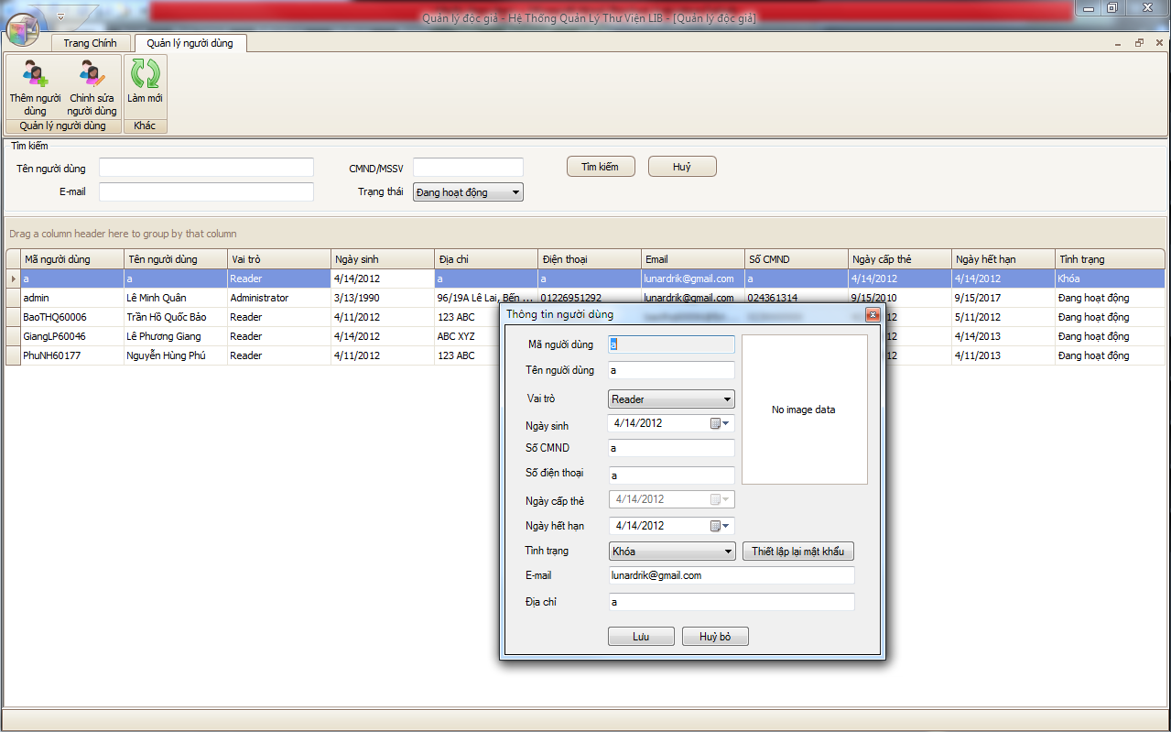

Figure : User Management

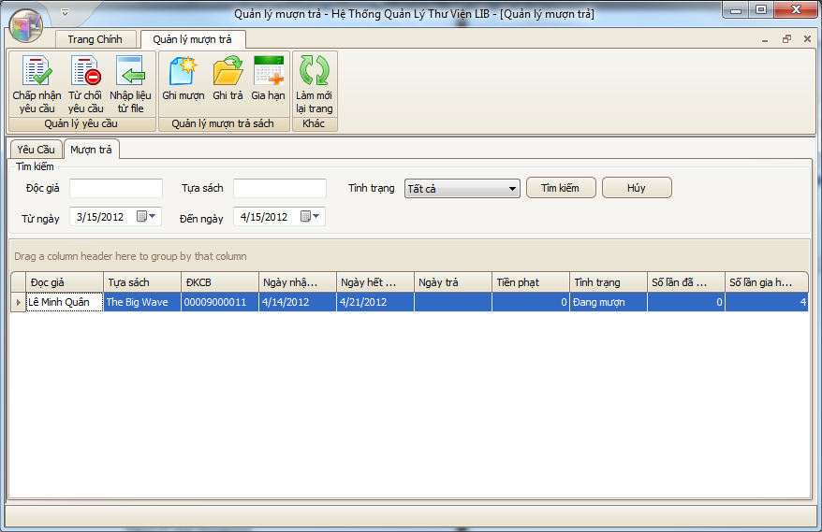

Figure : Book Rental Management

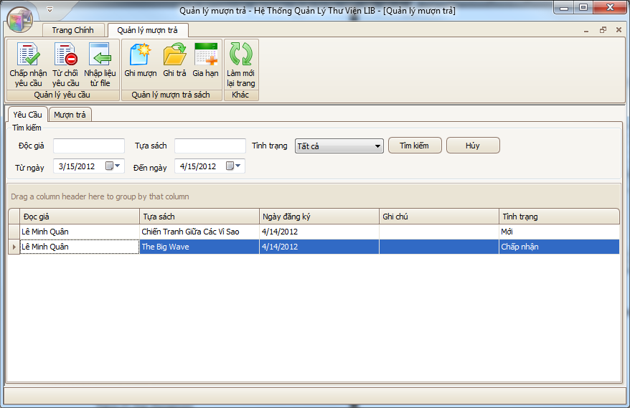

Figure : Request Management

#### Objects and Actions

Refer SRS

## Database Design or Data Structures

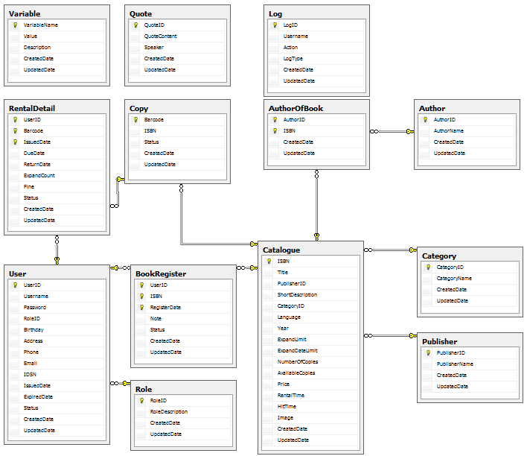

Figure : Database design

### Database Schema

| **No.** | **Column Name** | **Data Type** | **Default** | **NULL** | **Size** | **Key** |
| --- | --- | --- | --- | --- | --- | --- |
| **Variable** | | | | | | |
| 1 | VariableName | nvarchar |  | NO | 40 | PK |
| 2 | Value | nvarchar |  | NO | 50 |  |
| 3 | Description | nvarchar |  | YES | 100 |  |
| 4 | CreatedDate | datetime | (getdate()) | NO |  |  |
| 5 | UpdatedDate | datetime | (getdate()) | NO |  |  |
| **Role** | | | | | | |
| 1 | RoleID | int |  | NO |  | PK |
| 2 | RoleDescription | nvarchar |  | NO | 50 |  |
| 3 | CreatedDate | datetime | (getdate()) | NO |  |  |
| 4 | UpdatedDate | datetime | (getdate()) | NO |  |  |
| **Quote** | | | | | | |
| 1 | QuoteID | int |  | NO |  | PK |
| 2 | QuoteContent | nvarchar |  | NO | MAX |  |
| 3 | Speaker | nvarchar |  | NO | 100 |  |
| 4 | CreatedDate | datetime | (getdate()) | NO |  |  |
| 5 | UpdatedDate | datetime | (getdate()) | NO |  |  |
| **Publisher** | | | | | | |
| 1 | PublisherID | int |  | NO |  | PK |
| 2 | PublisherName | nvarchar |  | NO | 50 |  |
| 3 | CreatedDate | datetime | (getdate()) | NO |  |  |
| 4 | UpdatedDate | datetime | (getdate()) | NO |  |  |
| **Category** | | | | | | |
| 1 | CategoryID | nvarchar |  | NO | 40 | PK |
| 2 | CategoryName | nvarchar |  | NO | 50 |  |
| 3 | CreatedDate | datetime | (getdate()) | NO |  |  |
| 4 | UpdatedDate | datetime | (getdate()) | NO |  |  |
| **Catalogue** | | | | | | |
| 1 | ISBN | nvarchar |  | NO | 13 | PK |
| 2 | Title | nvarchar |  | NO | 100 |  |
| 3 | PublisherID | int | ((0)) | NO |  | FK |
| 4 | ShortDescription | nvarchar |  | NO | MAX |  |
| 5 | CategoryID | nvarchar | ((0)) | NO | 40 | FK |
| 6 | Language | nvarchar |  | NO | 50 |  |
| 7 | Year | int |  | NO |  |  |
| 8 | ExpandLimit | int |  | NO |  |  |
| 9 | ExpandDateLimit | int |  | NO |  |  |
| 10 | NumberOfCopies | int |  | NO |  |  |
| 11 | AvailableCopies | int |  | NO |  |  |
| 12 | Price | float |  | YES |  |  |
| 13 | RentalTime | int | ((0)) | NO |  |  |
| 14 | HitTime | int | ((0)) | NO |  |  |
| 15 | Image | nvarchar |  | NO | 100 |  |
| 16 | CreatedDate | datetime | (getdate()) | NO |  |  |
| 17 | UpdatedDate | datetime | (getdate()) | NO |  |  |
| **User** | | | | | | |
| 1 | UserID | nvarchar |  | NO | 40 | PK |
| 2 | Username | nvarchar |  | NO | 50 |  |
| 3 | Password | nvarchar |  | NO | 50 |  |
| 4 | RoleID | int |  | NO |  | FK |
| 5 | Birthday | date |  | NO |  |  |
| 6 | Address | nvarchar |  | NO | 100 |  |
| 7 | Phone | nvarchar |  | NO | 50 |  |
| 8 | Email | nvarchar |  | NO | 50 |  |
| 9 | IDSN | nvarchar |  | NO | 10 |  |
| 10 | IssuedDate | datetime |  | NO |  |  |
| 11 | ExpiredDate | datetime |  | NO |  |  |
| 12 | Status | int | ((1)) | NO |  |  |
| 13 | CreatedDate | datetime | (getdate()) | NO |  |  |
| 14 | UpdatedDate | datetime | (getdate()) | NO |  |  |
| **Log** | | | | | | |
| 1 | LogID | int |  | NO |  | PK |
| 2 | Username | nvarchar |  | NO | 50 |  |
| 3 | Action | nvarchar |  | NO | MAX |  |
| 4 | LogType | nvarchar |  | NO | 50 |  |
| 5 | CreatedDate | datetime |  | NO |  |  |
| 6 | UpdatedDate | datetime |  | NO |  |  |
| **BookRegister** | | | | | | |
| 1 | UserID | nvarchar |  | NO | 40 | PK, FK |
| 2 | ISBN | nvarchar |  | NO | 13 | PK, FK |
| 3 | RegisterDate | datetime |  | NO |  | PK |
| 4 | Note | ntext |  | YES | 1073741823 |  |
| 5 | Status | int |  | NO |  |  |
| 6 | CreatedDate | datetime | (getdate()) | NO |  |  |
| 7 | UpdatedDate | datetime | (getdate()) | NO |  |  |
| **AuthorOfBook** | | | | | | |
| 1 | AuthorID | int |  | NO |  | PK, FK |
| 2 | ISBN | nvarchar |  | NO | 13 | PK, FK |
| 3 | CreatedDate | datetime | (getdate()) | NO |  |  |
| 4 | UpdatedDate | datetime | (getdate()) | NO |  |  |
| **Copy** | | | | | | |
| 1 | Barcode | nvarchar |  | NO | 13 | PK |
| 2 | ISBN | nvarchar |  | NO | 13 | FK |
| 3 | Status | int |  | NO |  |  |
| 4 | CreatedDate | datetime | (getdate()) | NO |  |  |
| 5 | UpdatedDate | datetime | (getdate()) | NO |  |  |
| **RentalDetail** | | | | | | |
| 1 | UserID | nvarchar |  | NO | 40 | PK, FK |
| 2 | Barcode | nvarchar |  | NO | 13 | PK, FK |
| 3 | IssuedDate | datetime |  | NO |  | PK |
| 4 | DueDate | datetime |  | NO |  |  |
| 5 | ReturnDate | datetime |  | YES |  |  |
| 6 | ExpandCount | int | ((0)) | NO |  |  |
| 7 | Fine | float | ((0.0)) | NO |  |  |
| 8 | Status | int |  | NO |  |  |
| 9 | CreatedDate | datetime | (getdate()) | NO |  |  |
| 10 | UpdatedDate | datetime | (getdate()) | NO |  |  |
| **Author** | | | | | | |
| 1 | AuthorID | int |  | NO |  | PK |
| 2 | AuthorName | nvarchar |  | NO | 50 |  |
| 3 | CreatedDate | datetime | (getdate()) | NO |  |  |
| 4 | UpdatedDate | datetime | (getdate()) | NO |  |  |

### Database Partitioning

The software is intended for using with high workload of transactions. Due to that, the database design must support the application to work in the high level of flexibility.

Due to that, the database will be divided to series of file groups and files in file group. Each of them will be place in separate data center to improve the accessibility of the system in mean time.

|  |
| --- |
| **Physical Files**  **n**  **3**  **2**  **1**  **Logical Database** |

**Division of one file to n-files in one file group:** help to increase the accessibility of the application. Each file place onto one separate hard-disk, each hard-disk has its own reader-head, so in mean time, if the application wants to access a large data portion, the application can make use of all the hard-disk readability to provide that data portion.

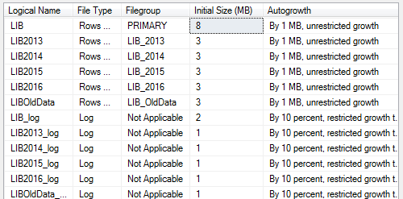

Files in database

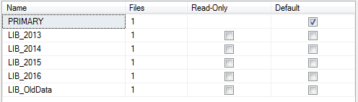

File groups in database

## Other material (if any)

N/A

# Software Test Documentation

## Introduction

### System Overview

The LIB system allows users to perform the following actions:

* + - Manage Catalogue (Titles and Copies): add, edit or remove one of the titles and copies in the system.
    - Manage User Information: add, edit or remove users from the system.
    - Manage Borrowing and Returning Transaction: approve and modify the transaction between users and library.
    - Generate Reports: generate reports bases on the information from the library.

### Test Approach

Testing procedure of PTS will be based on the use cases listed in the requirement specifications document.

## Test Plan

### Features to be tested

### Features not to be tested

N/A

### Testing Tools and Environment

* + Windows 7 operating system
  + dotNET Framework 3.5
  + MSSQL 2008
  + IE 9.0 & Google Chrome
  + Windows Internet Information Service (IIS) 7.0

## Test Cases

### Case 1: Insert Author

#### Purpose

Test if the Insert Author function correctly works or not.

#### Inputs

##### Normal

Name: Mark Twain

##### Abnormal

Name: The author name is too longggggggggggggggggggggggggggggggggggggggggggggggggggggg

##### Null

Name: (leave blank)

#### Expected Outputs & Pass/Fail criteria

##### Normal

###### Expected Output

A new Author with name “Mark Twain” will be inserted into database.

###### Pass/Fail criteria

After the procedure if the new Author is created: Pass

Or else: Fail

##### Abnormal

###### Expected Output

A message will be shown remind the user about the length of author name.

No new Author will be inserted into database.

###### Pass/Fail criteria

After the procedure if the new Author is not created: Pass

Or else: Fail

##### Null

###### Expected Output

A message will be shown remind the user about leaving information blank.

No new Author will be inserted into database.

###### Pass/Fail criteria

After the procedure if the new Author is not created: Pass

Or else: Fail

#### Test Procedure

* User logged in as a Librarian
* Select the “QuảnlýTácgiả” feature from the Main menu.
* Click on the [Tạomới] button to create a new Author.
* Type in the Inputs.
* Click on [Lưu]

### Case 2: Edit Author

#### Purpose

Test if the Edit Author function correctly works or not.

#### Inputs

##### Normal

Name: Mark Twain

##### Abnormal

Name: The author name is too longggggggggggggggggggggggggggggggggggggggggggggggggggggg

##### Null

Name: (leave blank)

#### Expected Outputs & Pass/Fail criteria

##### Normal

###### Expected Output

An Author will be updated with new name “Mark Twain” in database.

###### Pass/Fail criteria

After the procedure if the Author is updated: Pass

Or else: Fail

##### Abnormal

###### Expected Output

A message will be shown remind the user about the length of author name.

No new Author will be updated into database.

###### Pass/Fail criteria

After the procedure if the Author is not updated: Pass

Or else: Fail

##### Null

###### Expected Output

A message will be shown remind the user about leaving information blank.

No Author will be updated in database.

###### Pass/Fail criteria

After the procedure if the Author is not updated: Pass

Or else: Fail

#### Test Procedure

* User logged in as a Librarian
* Select the “QuảnlýTácgiả” feature from the Main menu.
* Click on a record to be edit and change the information in the right of the Management form.
* Type in the Inputs.
* Click on [Lưu]

### Case 3: Insert Category

#### Purpose

Test if the Insert Category function correctly works or not.

#### Inputs

##### Normal

Name: Science

##### Abnormal

Name: The Category name is too longggggggggggggggggggggggggggggggggggggggggggggggggggggg

##### Null

Name: (leave blank)

#### Expected Outputs & Pass/Fail criteria

##### Normal

###### Expected Output

A new Category with name “Science” will be inserted into database.

###### Pass/Fail criteria

After the procedure if the new Category is created: Pass

Or else: Fail

##### Abnormal

###### Expected Output

A message will be shown remind the user about the length of Category name.

No new Category will be inserted into database.

###### Pass/Fail criteria

After the procedure if the new Category is not created: Pass

Or else: Fail

##### Null

###### Expected Output

A message will be shown remind the user about leaving information blank.

No new Category will be inserted into database.

###### Pass/Fail criteria

After the procedure if the new Category is not created: Pass

Or else: Fail

#### Test Procedure

* User logged in as a Librarian
* Select the “Quản lý danh mục” feature from the Main menu.
* Click on the [Tạo mới] button to create a new Category.
* Type in the Inputs.
* Click on [Lưu]

### Case 4: Edit Category

#### Purpose

Test if the Edit Category function correctly works or not.

#### Inputs

##### Normal

Name: Science

##### Abnormal

Name: The Category name is too longggggggggggggggggggggggggggggggggggggggggggggggggggggg

##### Null

Name: (leave blank)

#### Expected Outputs & Pass/Fail criteria

##### Normal

###### Expected Output

A Category will be updated with new name “Science” in database.

###### Pass/Fail criteria

After the procedure if the Category is updated: Pass

Or else: Fail

##### Abnormal

###### Expected Output

A message will be shown remind the user about the length of Category name.

No new Category will be updated into database.

###### Pass/Fail criteria

After the procedure if the Category is not updated: Pass

Or else: Fail

##### Null

###### Expected Output

A message will be shown remind the user about leaving information blank.

No Category will be updated in database.

###### Pass/Fail criteria

After the procedure if the new Category is not updated: Pass

Or else: Fail

#### Test Procedure

* User logged in as a Librarian
* Select the “Quản lý danh mục” feature from the Main menu.
* Click on a record to be edit and change the information in the right of the Management form.
* Type in the Inputs.
* Click on [Lưu]

### Case 5: Insert Publisher

#### Purpose

Test if the Insert Publisher function correctly works or not.

#### Inputs

##### Normal

Name: NXB Trẻ

##### Abnormal

Name: The Publisher name is too longggggggggggggggggggggggggggggggggggggggggggggggggggggg

##### Null

Name: (leave blank)

#### Expected Outputs & Pass/Fail criteria

##### Normal

###### Expected Output

A new Publisher with name “NXB Trẻ” will be inserted into database.

###### Pass/Fail criteria

After the procedure if the new Publisher is created: Pass

Or else: Fail

##### Abnormal

###### Expected Output

A message will be shown remind the user about the length of Publisher name.

No new Publisher will be inserted into database.

###### Pass/Fail criteria

After the procedure if the new Publisher is not created: Pass

Or else: Fail

##### Null

###### Expected Output

A message will be shown remind the user about leaving information blank.

No new Publisher will be inserted into database.

###### Pass/Fail criteria

After the procedure if the new Publisher is not created: Pass

Or else: Fail

#### Test Procedure

* User logged in as a Librarian
* Select the “Quản lý NXB” feature from the Main menu.
* Click on the [Tạo mới] button to create a new Publisher.
* Type in the Inputs.
* Click on [Lưu]

### Case 6: Edit Publisher

#### Purpose

Test if the Edit Publisher function correctly works or not.

#### Inputs

##### Normal

Name: NXB Trẻ

##### Abnormal

Name: The Publisher name is too longggggggggggggggggggggggggggggggggggggggggggggggggggggg

##### Null

Name: (leave blank)

#### Expected Outputs & Pass/Fail criteria

##### Normal

###### Expected Output

A Publisher will be updated with new name “NXB Trẻ” in database.

###### Pass/Fail criteria

After the procedure if the Publisher is updated: Pass

Or else: Fail

##### Abnormal

###### Expected Output

A message will be shown remind the user about the length of Publisher name.

No Publisher will be updated into database.

###### Pass/Fail criteria

After the procedure if the new Publisher is not created: Pass

Or else: Fail

##### Null

###### Expected Output

A message will be shown remind the user about leaving information blank.

No Publisher will be updated in database.

###### Pass/Fail criteria

After the procedure if the new Publisher is not updated: Pass

Or else: Fail

#### Test Procedure

* User logged in as a Librarian
* Select the “Quản lý NXB” feature from the Main menu.
* Click on a record to be edit and change the information in the right of the Management form.
* Type in the Inputs.
* Click on [Lưu]

### Case 7: Insert Catalogue

#### Purpose

Test if the Insert Catalogue function correctly works or not.

#### Inputs

##### Normal

ISBN: 0000000000001

Tựa: Tây du ký

Nhà xuất bản: NXB Trẻ

Thuộc danh mục: Văn học

Năm: 2011

Giá: 50000

Số lượng bản sao: 10

Tác giả: Ngô Thừa Ân

Số lần gia hạn cho phép: 1

Trong vòng: 7 ngày

Mô tả chi tiết: truyện thần thoại

##### Abnormal

ISBN: 01

Tựa: Tây du ký zzzzzzzzzzzzzzzzzzzzzzzzzzzzzzzzzzzzzzzzzzzzzzzzzzzzzzzzzzzzzzzzzzzzzzzzzzzzzzzzzzzzzzz

Nhà xuất bản: NXB Trẻ

Thuộc danh mục: Văn học

Năm: 2011

Giá: 50000

Số lượng bản sao: 10

Tác giả: Ngô Thừa Ân

Số lần gia hạn cho phép: 1

Trong vòng: 7 ngày

Mô tả chi tiết: truyện thần thoại

##### Null

ISBN: (leave blank)

Tựa: (leave blank)

Nhà xuất bản: [None]

Thuộc danh mục: [None]

Năm: 2012

Giá: 0

Số lượng bản sao: 0

Tác giả: [None]

Số lần gia hạn cho phép: 0

Trong vòng: 7 ngày

Mô tả chi tiết: (leave blank)

#### Expected Outputs & Pass/Fail criteria

##### Normal

###### Expected Output

A new Catalogue with name the above information will be inserted into database.

###### Pass/Fail criteria

After the procedure if the new Catalogue is created: Pass

Or else: Fail

##### Abnormal

###### Expected Output

A message will be shown remind the user about the errors of Catalogue.

No new Catalogue will be inserted into database.

###### Pass/Fail criteria

After the procedure if the new Catalogue is not created: Pass

Or else: Fail

##### Null

###### Expected Output

A message will be shown remind the user about leaving information blank.

No new Catalogue will be inserted into database.

###### Pass/Fail criteria

After the procedure if the new Catalogue is not created: Pass

Or else: Fail

#### Test Procedure

* User logged in as a Librarian
* Select the “Quản lý đầu mục” feature from the Main menu.
* Click on the [Tạo mới] button to create a new Catalogue.
* Type in the Inputs.
* Click on [Lưu]

### Case 8: Edit Catalogue

#### Purpose

Test if the Edit Catalogue function correctly works or not.

#### Inputs

##### Normal

ISBN: 0000000000001

Tựa: Tây du ký

Nhà xuất bản: NXB Trẻ

Thuộc danh mục: Văn học

Năm: 2011

Giá: 50000

Số lượng bản sao: 10

Tác giả: Ngô Thừa Ân

Số lần gia hạn cho phép: 1

Trong vòng: 7 ngày

Mô tả chi tiết: truyện thần thoại

##### Abnormal

ISBN: 0000000000001

Tựa: Tây du ký zzzzzzzzzzzzzzzzzzzzzzzzzzzzzzzzzzzzzzzzzzzzzzzzzzzzzzzzzzzzzzzzzzzzzzzzzzzzzzzzzzzzzzz

Nhà xuất bản: NXB Trẻ

Thuộc danh mục: Văn học

Năm: 2011

Giá: 50000

Số lượng bản sao: 10

Tác giả: Ngô Thừa Ân

Số lần gia hạn cho phép: 1

Trong vòng: 7 ngày

Mô tả chi tiết: truyện thần thoại

##### Null

ISBN: (leave blank)

Tựa: (leave blank)

Nhà xuất bản: [None]

Thuộc danh mục: [None]

Năm: 2012

Giá: 0

Số lượng bản sao: 0

Tác giả: [None]

Số lần gia hạn cho phép: 0

Trong vòng: 7 ngày

Mô tả chi tiết: (leave blank)

#### Expected Outputs & Pass/Fail criteria

##### Normal

###### Expected Output

A Catalogue with the specific ISBN will be updated with the above information to the database.

###### Pass/Fail criteria

After the procedure if the Catalogue is updated: Pass

Or else: Fail

##### Abnormal

###### Expected Output

A message will be shown remind the user about the errors of the Catalogue.

No Catalogue will be updated into database.

###### Pass/Fail criteria

After the procedure if the Catalogue is not updated: Pass

Or else: Fail

##### Null

###### Expected Output

A message will be shown remind the user about leaving information blank.

No Catalogue will be updated in database.

###### Pass/Fail criteria

After the procedure if the new Catalogue is not updated: Pass

Or else: Fail

#### Test Procedure

* User logged in as a Librarian
* Select the “Quản lý đầu mục” feature from the Main menu.
* Click on a record to be edit and change the information in the right of the Management form.
* Type in the Inputs.
* Click on [Lưu]

### Case 9: Insert Copy

#### Purpose

Test if the Insert Copy function correctly works or not.

#### Inputs

##### Normal

Number of copy: 8

##### Abnormal

Number of copy: 0

#### Expected Outputs & Pass/Fail criteria

##### Normal

###### Expected Output

A numbers of Copies with generated barcodes will be inserted into database.

###### Pass/Fail criteria

After the procedure if the new Copy is created: Pass

Or else: Fail

##### Abnormal

###### Expected Output

No new Copy will be inserted into database.

###### Pass/Fail criteria

After the procedure if the new Copy is not created: Pass

Or else: Fail

#### Test Procedure

* User logged in as a Librarian
* Select the “Quản lý danh mục” feature from the Main menu.
* Select a catalogue to edit or add new catalogue
* Navigate to “Danh sách bản sao chi tiết” or enter a number of copies on the “insert page”
* Click on the [Thêm sách] button to create new Copies.
* Enter the number of copies on the “Thêm sách” page.
* Click “Đồng ý”
* Click on [Lưu]

### Case 10: Delete Copy

#### Purpose

Test if the Delete Copy function correctly works or not.

#### Inputs

N/A

#### Expected Outputs & Pass/Fail criteria

##### Expected Output

A Copy with specific barcode will be deleted for the database.

##### Pass/Fail criteria

After the procedure if the Copy is updated: Pass

Or else: Fail

#### Test Procedure

* User logged in as a Librarian
* Select the “Quản lý danh mục” feature from the Main menu.
* Select a catalogue to edit.
* Navigate to “Danh sách bản sao chi tiết” or enter a number of copies on the “insert page”
* Click on the on a specific barcode.
* Clck “Xóa” button.
* Click “Đồng ý”.

### Case 11: Insert Rental

#### Purpose

Test if the Insert Rental function correctly works or not.

#### Inputs

##### Normal

Mã độc giả: PhuNH60177

Mã sách: 00001000013

Ngày mượn: 19/03/2012

Ngày trả: 26/03/2012

##### Abnormal

Mã độc giả: PhuN

Mã sách: 01

Ngày mượn: 19/03/2012

Ngày trả: 12/03/2012

##### Null

Mã độc giả: (blank)

Mã sách: (blank)

Ngày mượn: 19/03/2012

Ngày trả: 26/03/2012

#### Expected Outputs & Pass/Fail criteria

##### Normal

###### Expected Output

A new Rental with above information will be inserted into database.

###### Pass/Fail criteria

After the procedure if the new Rental is created: Pass

Or else: Fail

##### Abnormal

###### Expected Output

A message will be shown remind the user about the errors of Rental information.

No new Rental will be inserted into database.

###### Pass/Fail criteria

After the procedure if the new Rental is not created: Pass

Or else: Fail

##### Null

###### Expected Output

A message will be shown remind the user about the errors of Rental information.

No new Rental will be inserted into database.

###### Pass/Fail criteria

After the procedure if the new Rental is not created: Pass

Or else: Fail

#### Test Procedure

* User logged in as a Librarian
* Select the “Quản lý mượn trả” feature from the Main menu.
* Click on the tab [Mượn trả].
* Click on the button [Ghi mượn].
* Type in the Inputs.
* Click on [Ghi mượn]

### Case 12: Expand Rental

#### Purpose

Test if the Expand Rental function correctly works or not.

#### Inputs

##### Normal

Ngày hết hạn mới: 26/03/2012

##### Abnormal

Ngày hết hạn mới: 12/03/2012

#### Expected Outputs & Pass/Fail criteria

##### Normal

###### Expected Output

A Rental will be updated with new return date to database.

###### Pass/Fail criteria

After the procedure if the Rental is updated: Pass

Or else: Fail

##### Abnormal

###### Expected Output

A message will be shown remind the user about the error of return date of Rental.

No Rental will be updated into database.

###### Pass/Fail criteria

After the procedure if the new Rental is not created: Pass

Or else: Fail

#### Test Procedure

* User logged in as a Librarian
* Select the “Quản lý mượn trả” feature from the Main menu.
* Click on the tab [Mượn trả].
* Select a rental to be expanded.
* Click on the button [Gia hạn].
* Choose the new return date.
* Click on [Gia hạn]

### Case 13: Finish Rental

#### Purpose

Test if the Finish Rental function correctly works or not.

#### Inputs

##### Normal

Ngày trả: 19/03/2012

Tình trạng: đã trả

##### Abnormal

Ngày trả: 12/03/2012

Tình trạng: đã trả

#### Expected Outputs & Pass/Fail criteria

##### Normal

###### Expected Output

A Rental will be updated with return date and status to database.

###### Pass/Fail criteria

After the procedure if the Rental is updated: Pass

Or else: Fail

##### Abnormal

###### Expected Output

A message will be shown remind the user about the errors of Rental information.

Rental will not be updated into database.

###### Pass/Fail criteria

After the procedure if the Rental is not updated: Pass

Or else: Fail

#### Test Procedure

* User logged in as a Librarian
* Select the “Quản lý mượn trả” feature from the Main menu.
* Click on the tab [Mượn trả].
* Select a rental to be finished.
* Click on the button [Ghi trả].
* Choose the return date and status.
* Click on [Ghi trả]

### Case 14: Insert User

#### Purpose

Test if the Insert User function correctly works or not.

#### Inputs

##### Normal

Mã người dùng: PhuNH60177

Tên người dùng: Phú đẹp trai

Vai trò: Độc giả

Ngày sinh: 01/09/1988

Số CMND: 025511422

Số điện thoại: 01696433444

Ngày cấp thẻ: 19/03/2012

Ngày hết hạn: 20/03/2012

Tình trạng: Đang hoạt động

Email: [phunh60177@fpt.edu.vn](mailto:phunh60177@fpt.edu.vn)

Địa chỉ: QTSC, đường Tô Ký, Quận 12, TP.HCM

##### Abnormal

Mã người dùng: PhuNH60177handsomeeeeeeeeeeeeeeeeeeeeeeeeeeeeee

Tên người dùng: Phú đẹp traiiiiiiiiiiiiiiiiiiiiiiiiiiiiiiiiiiiiiiiiiiiiiiiiiiiiiiiiiiiiiiiiiiiiii

Vai trò: Độc giả

Ngày sinh: 01/09/2012

Số CMND: 02551142222222222222222222222222222222222222222

Số điện thoại: 016964334444444444444444444444444444444444444

Ngày cấp thẻ: 20/03/2012

Ngày hết hạn: 18/03/2012

Tình trạng: Đang hoạt động

Email: phunh60177

Địa chỉ: QTSC, đường Tô Ký, Quận 12, TP.HCMmmmmmmmmmmmmmmmmmmmmmmmmmmmmmmmmmmmmmmmmmmmmmmmmmmmmmmmmmmmmmmmmmmmmmmm

##### Null

Mã người dùng: (blank)

Tên người dùng: (blank)

Vai trò: Độc giả

Ngày sinh: 01/09/1988

Số CMND: (blank)

Số điện thoại: (blank)

Ngày cấp thẻ: 19/03/2012

Ngày hết hạn: 20/03/2012

Tình trạng: Đang hoạt động

Email: (blank)

Địa chỉ: (blank)

#### Expected Outputs & Pass/Fail criteria

##### Normal

###### Expected Output

A new User with id PhuNH60177 will be inserted into database.

###### Pass/Fail criteria

After the procedure if the new User is created: Pass

Or else: Fail

##### Abnormal

###### Expected Output

A message will be shown remind the user about the errors of User information.

No new User will be inserted into database.

###### Pass/Fail criteria

After the procedure if the new User is not created: Pass

Or else: Fail

##### Null

###### Expected Output

A message will be shown remind the user about the errors of User information.

No new User will be inserted into database.

###### Pass/Fail criteria

After the procedure if the new User is not created: Pass

Or else: Fail

#### Test Procedure

* User logged in as a Librarian
* Select the “Quảnlý người dùng” feature from the Main menu.
* Click on the [Tạomới người dùng] button to create a new User.
* Type in the Inputs.
* Click on [Lưu]

### Case 15: Edit User

#### Purpose

Test if the Edit User function correctly works or not.

#### Inputs

##### Normal

Tên người dùng: Phú đẹp trai

Vai trò: Độc giả

Ngày sinh: 01/09/1988

Số CMND: 025511422

Số điện thoại: 01696433444

Ngày cấp thẻ: 19/03/2012

Ngày hết hạn: 20/03/2012

Tình trạng: Đang hoạt động

Email: [phunh60177@fpt.edu.vn](mailto:phunh60177@fpt.edu.vn)

Địa chỉ: QTSC, đường Tô Ký, Quận 12, TP.HCM

##### Abnormal

Tên người dùng: Phú đẹp traiiiiiiiiiiiiiiiiiiiiiiiiiiiiiiiiiiiiiiiiiiiiiiiiiiiiiiiiiiiiiiiiiiiiii

Vai trò: Độc giả

Ngày sinh: 01/09/2012

Số CMND: 02551142222222222222222222222222222222222222222

Số điện thoại: 016964334444444444444444444444444444444444444

Ngày cấp thẻ: 20/03/2012

Ngày hết hạn: 18/03/2012

Tình trạng: Đang hoạt động

Email: phunh60177

Địa chỉ: QTSC, đường Tô Ký, Quận 12, TP.HCMmmmmmmmmmmmmmmmmmmmmmmmmmmmmmmmmmmmmmmmmmmmmmmmmmmmmmmmmmmmmmmmmmmmmmmm

##### Null

Tên người dùng: (blank)

Vai trò: Độc giả

Ngày sinh: 01/09/1988

Số CMND: (blank)

Số điện thoại: (blank)

Ngày cấp thẻ: 19/03/2012

Ngày hết hạn: 20/03/2012

Tình trạng: Đang hoạt động

Email: (blank)

Địa chỉ: (blank)

#### Expected Outputs & Pass/Fail criteria

##### Normal

###### Expected Output

The user PhuNH60177’s information will be updated to database.

###### Pass/Fail criteria

After the procedure if the new User is created: Pass

Or else: Fail

##### Abnormal

###### Expected Output

A message will be shown remind the user about the errors of User information.

User will not be updated into database.

###### Pass/Fail criteria

After the procedure if the User is not updated: Pass

Or else: Fail

##### Null

###### Expected Output

A message will be shown remind the user about the errors of User information.

User will not be updated into database.

###### Pass/Fail criteria

After the procedure if the new User is not created: Pass

Or else: Fail

#### Test Procedure

* User logged in as a Librarian
* Select the “Quảnlý người dùng” feature from the Main menu.
* Click on the [chỉnh sửa thông tin người dùng] button to edit user.
* Type in the Inputs.
* Click on [Lưu]

## Checklists

### Checklist of Validation

| **No.** | **Check item** | **Check result** | **Reviewer** |
| --- | --- | --- | --- |
| 1 | Are exceptions used to indicate error rather than returning status or error codes? | □OK　□NG　□None-correspondence |  |
| 2 | Are all classes and public methods commented with .NET style comments?  Note that <summary> comments should discuss the "what" of public methods.  Discussion of "how" should be in <remarks> blocks or in-line with the code in question. | □OK　□NG　□None-correspondence |  |
| 3 | Are method arguments validated and rejected with an exception if they are invalid? | □OK　□NG　□None-correspondence |  |
| 4 | Are Debug.Asserts used to verify assumptions about the functioning of the code?  Comments like, "j will be positive" should be rewritten as Asserts. | □OK　□NG　□None-correspondence |  |
| 5 | Do classes that should not be instantiated have a private constructor? | □OK　□NG　□None-correspondence |  |
| 6 | Are classes declared as value types only infrequently used as method parameters, returned from methods or stored in Collections? | □OK　□NG　□None-correspondence |  |
| 7 | Are classes, methods and events that are specific to an assembly marked as internal? | □OK　□NG　□None-correspondence |  |
| 8 | Are singletons that may be accessed by multiple threads instantiated correctly?  See the Enterprise Solution Patterns book, p. 263. | □OK　□NG　□None-correspondence |  |
| 9 | Are methods that must be overriden by derived classes marked as abstract? | □OK　□NG　□None-correspondence |  |
| 10 | Are classes that should not be overriden marked as sealed? | □OK　□NG　□None-correspondence |  |
| 11 | Is "as" used for possibly incorrect downcasts? | □OK　□NG　□None-correspondence |  |
| 12 | Do classes override ToString instead of defining a Dump method for outputting the object's state? | □OK　□NG　□None-correspondence |  |
| 13 | Are log messages sent to the logging component instead of Console? | □OK　□NG　□None-correspondence |  |
| 14 | Are finally blocks used for code that must execute following a try? | □OK　□NG　□None-correspondence |  |
| 15 | Is foreach used in preference to the for(int i...) construct? | □OK　□NG　□None-correspondence |  |
| 16 | Are properties used instead of implementing getter and setter methods? | □OK　□NG　□None-correspondence |  |
| 17 | Are readonly variables used in preference to properties without setters? | □OK　□NG　□None-correspondence |  |
| 18 | Is the override keyword used on all methods that are overriden by derived classes? | □OK　□NG　□None-correspondence |  |
| 19 | Are interface classes used in preference to abstract classes? | □OK　□NG　□None-correspondence |  |
| 20 | Is code written against an interface rather than an implementing class? | □OK　□NG　□None-correspondence |  |
| 21 | Do all objects that represent "real-world" or expensive resources implement the IDisposable pattern? | □OK　□NG　□None-correspondence |  |
| 22 | Are all objects that implement IDisposable instantiated in a using block? | □OK　□NG　□None-correspondence |  |
| 23 | Is the lock keyword used in preference to the Monitor.Enter construct? | □OK　□NG　□None-correspondence |  |
| 24 | Are threads awakened from wait states by events or the Pulse construct, rather than "active" waiting such as Sleep()? | □OK　□NG　□None-correspondence |  |
| 25 | If equals is overridden, is it done correctly?  The rules for overriding equals are complex, see Richter p153-160 for details. | □OK　□NG　□None-correspondence |  |
| 26 | If == and != are overridden, so they redirect to Equals? | □OK　□NG　□None-correspondence |  |
| 27 | Do all objects that override Equals also provide an overloaded version of GetHashCode that provides the same semantics as Equals?  Note that overrides to GetHashCode should takeadvantage of the object's member variables, and must return an unchanging hash code. | □OK　□NG　□None-correspondence |  |
| 28 | Do all exception classes have a constructor that takes a string and and another constructor that takes a string and an exception? | □OK　□NG　□None-correspondence |  |
| 29 | Do all exception classes derive from the base Matrix exceptions and fit correctly into the exception hierarchy? | □OK　□NG　□None-correspondence |  |
| 30 | Are all classes that will be marshaled or remoted marked with the Serializable attribute? | □OK　□NG　□None-correspondence |  |
| 31 | Do all classes marked with the Serializable attribute have a default constructor?  This includes Exception and EventArgs classes. | □OK　□NG　□None-correspondence |  |
| 32 | Do all classes that explicitly implement ISerializable provide both the required GetObjectData and the implied constructor that takes a SerializationInfo and a StreamingContext? | □OK　□NG　□None-correspondence |  |
| 33 | When doing floating point calculations, are all constants doubles rather than integers? | □OK　□NG　□None-correspondence |  |
| 34 | Do all delegates have a void return type and avoid using output or ref parameters? | □OK　□NG　□None-correspondence |  |
| 35 | Do all delegates send the sender (publisher) as the first argument?  This allows the subscriber to tell which publisher fired the event. | □OK　□NG　□None-correspondence |  |
| 36 | Are all members of derived EventArg classes read-only?  This prevents one subscriber from modifying the EventArgs, which would affect the other subscribers. | □OK　□NG　□None-correspondence |  |
| 37 | Are delegates published as events?  This prevents the subscribers from firing the event, see Lowy, p. 102 for details. | □OK　□NG　□None-correspondence |  |
| 38 | Is common setup and teardown nUnit code isolated in Setup and Teardown methods that are marked with the appropriate attribute? | □OK　□NG　□None-correspondence |  |
| 39 | Do negative nUnit tests use the ExpectedException attribute to indicate that an exception must be thrown? | □OK　□NG　□None-correspondence |  |

### Submission Checklist

N/A

## Other material (if any)

### Test log

Refer to test log Excel file attached to this submission.

# Software User’s Manual

## Catalogue management

### Insert catalogue

1. Click “Quản lý sách thông tin” menu

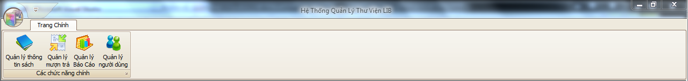

1. Choose “Thêm sách mới” button

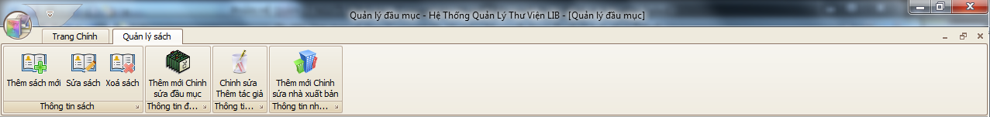

1. Enter required fields.

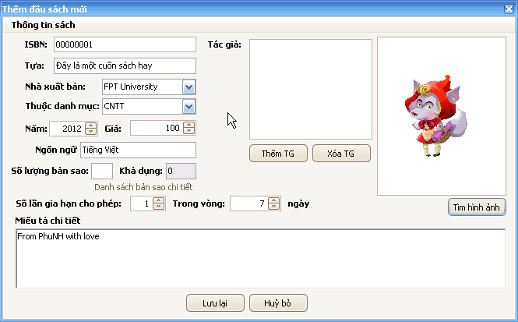

* If you enter a number to “Số lượng bản sao” textbox so the system will automatic generate barcode for this number of books to the database (default is 0)
* Choose author for the book by click “Thêm TG” button. Then a new form will appear. And you choose the appropriate author and click “Thêm TG” then the information of the author will be included in the catalogue’s information.

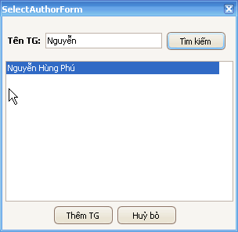

If you want to remove the author from the list author of book, click the author’s name and then press the “Xóa TG” button.

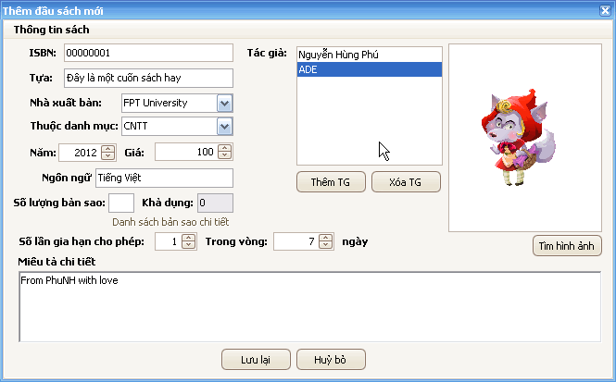

If you want to add a picture for the catalogue, click “Tìm hình ảnh” button then choose the appropriate picture and click “Open”

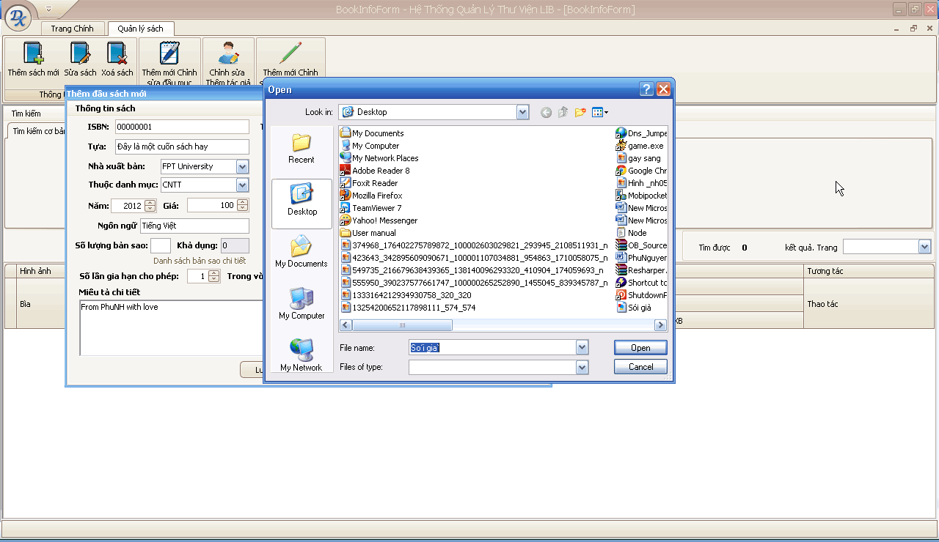

1. After finished to fill in the catalogue’s information, click “Lưu lại” button

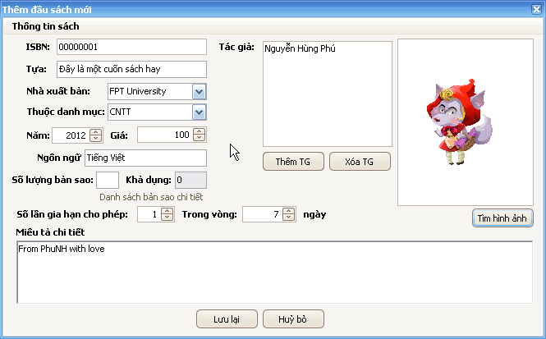

Then the catalogue will be inserted to the database

### Edit a catalogue’s information

1. Choose the catalogue which you want to edit then double click to it or you can also click to the button “…” in the right side of the catalogue list’s grid

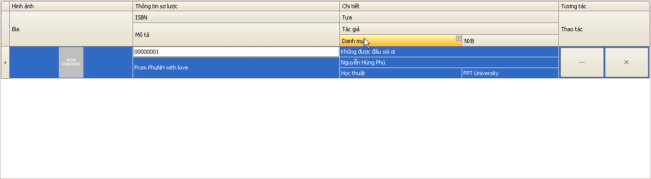

1. Edit the fields which you want to edit

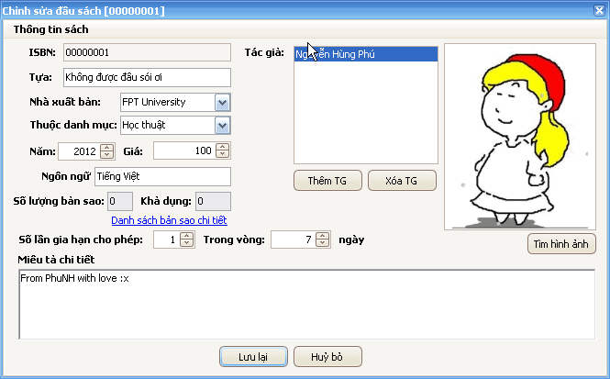

1. Click “Lưu lại” button



1. Click “Yes” button

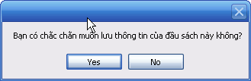

1. Click “OK” button

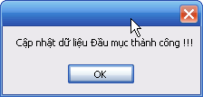

### Delete a catalogue

1. Choose the catalogue which you want to delete by click to the button “x” in the right side of the catalogue list’s grid

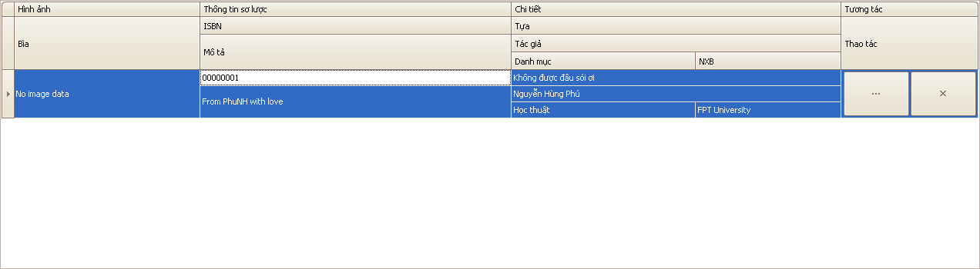

1. Click “Yes” button

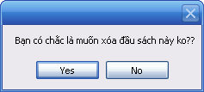

## Author management

### Insert an author

1. On the main form click on “Quản lý thông tin sách” button



1. Click “Chỉnh sửa thêm tác giả” button



1. Click on “Thêm tác giả mới” button

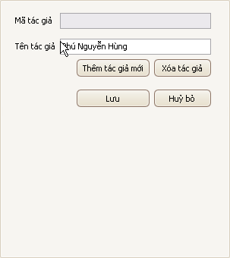

1. Enter the author’s name and click “Lưu lại” button

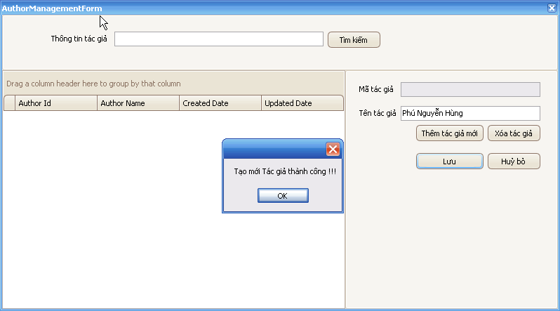

### Edit an author’s information

1. On the main form click on “Quản lý thông tin sách” button



1. Click “Chỉnh sửa thêm tác giả” button



1. Choose the author which you want to edit information

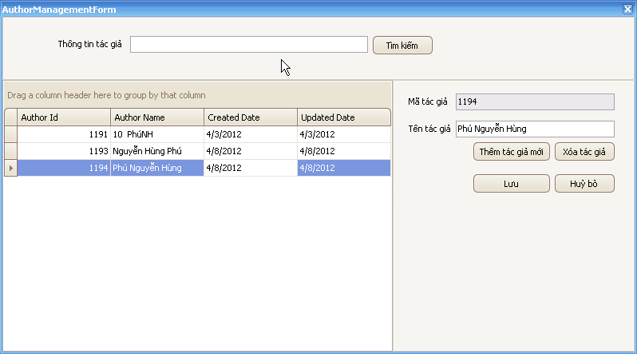

1. Edit the author’s name

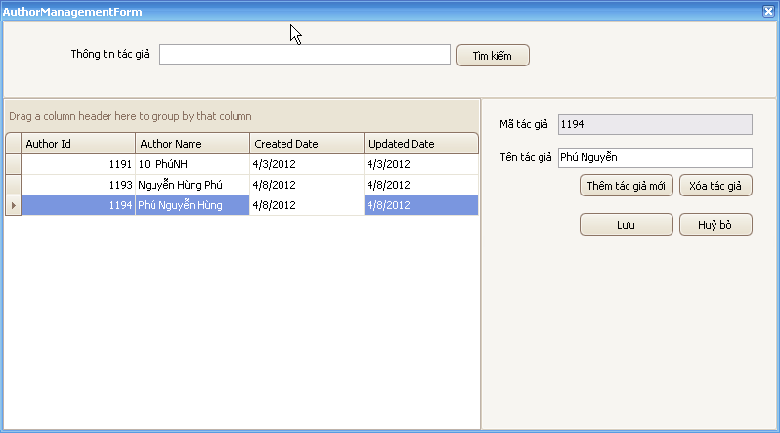

1. Click “Lưu” button

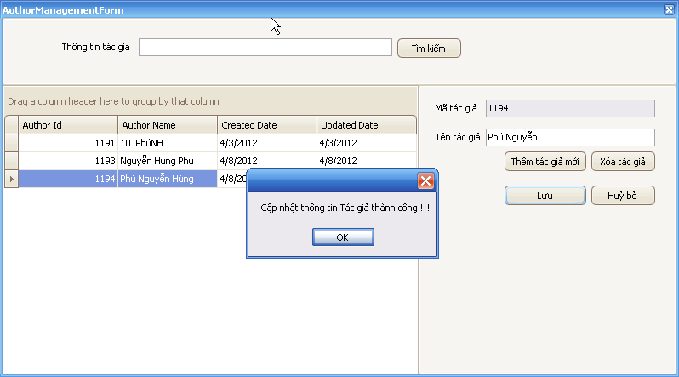

### Delete an author

1. On the main form click on “Quản lý thông tin sách” button



1. Click “Chỉnh sửa thêm tác giả” button



1. Choose the author which you want to delete



1. Click “Xóa tác giả” button

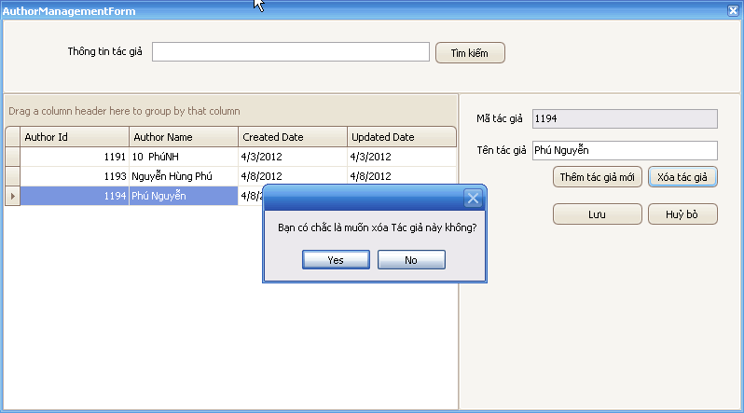

1. Click “Yes” button

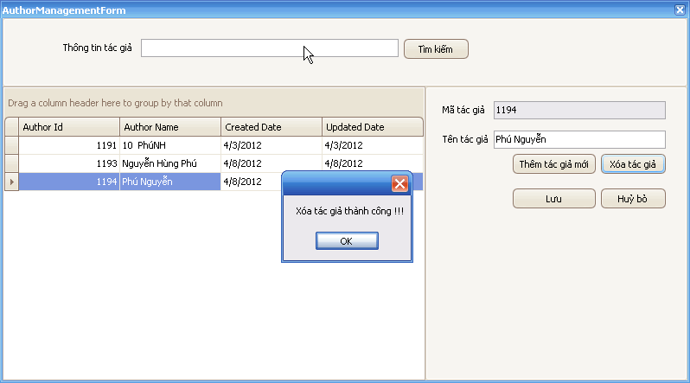

## Publisher management

### Insert a publisher

1. Click “Quản lý thông tin sách” button



1. Click “Thêm mới Chỉnh sửa nhà xuất bản” button



1. Click “Thêm mới” button

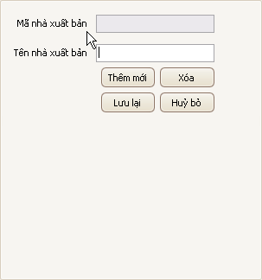

1. Fill in the publisher’s name and click “Lưu” button

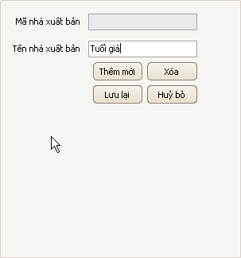

1. Click “OK” button

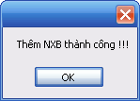

### Edit a publisher’s information

1. Click “Quản lý thông tin sách” button



1. Click “Thêm mới Chỉnh sửa nhà xuất bản” button



1. Choose the appropriate publisher

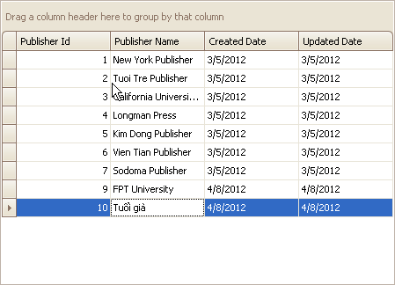

1. Edit the publisher’s information and click “Lưu lại” button

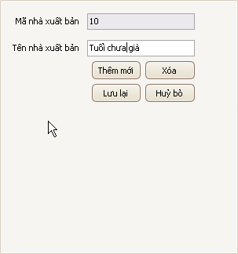

1. Click “OK”

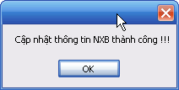

### Delete a publisher

1. Enter the author’s name



1. Enter the author’s name



1. Enter the author’s name



1. Enter the author’s name

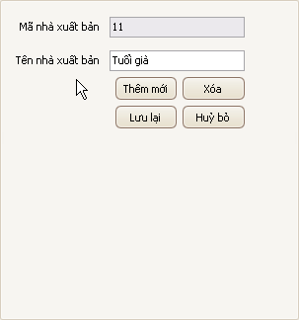

1. Enter the author’s name

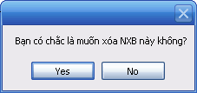

1. Enter the author’s name

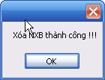

## Category management

### Insert a category

1. Click “Quản lý thông tin sách” button



1. Click “Thêm mới Chỉnh sửa nhà xuất bản” button



1. Click “Thêm mới” button

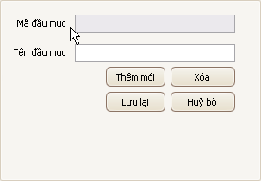

1. Fill in the category’s information and click “Lưu lại” button

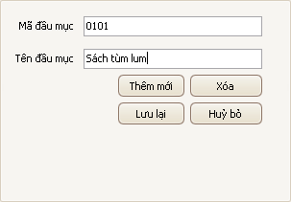

1. Click “OK” button

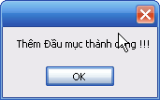

### Edit a category’s information

1. Click “Quản lý thông tin sách” button



1. Click “Thêm mới Chỉnh sửa đầu mục” button



1. Choose the appropriate category

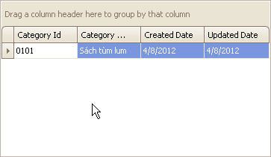

1. Edit the category’s information and click “Lưu lại” button

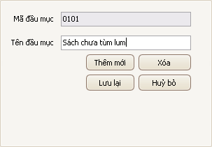

1. Click “OK” button

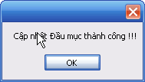

### Delete a category

1. Click “Quản lý thông tin sách” button



1. Click “Thêm mới Chỉnh sửa đầu mục” button



1. Choose the appropriate category



1. Click “Xóa” button

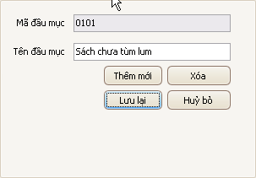

1. Click “Yes” button

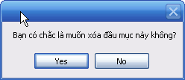

1. Click “OK” button

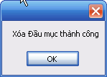

## Copies management

### Insert copies

1. Click “Quản lý sách thông tin” menu



1. Choose the catalogue which you want to add copies then double click to it or you can also click to the button “…” in the right side of the catalogue list’s grid



1. Click “Danh sách bản sao chi tiết” link

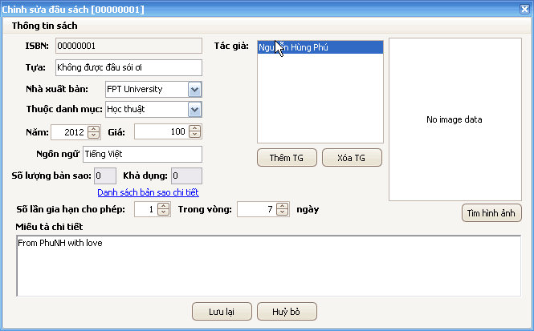

1. Click “Thêm sách” button

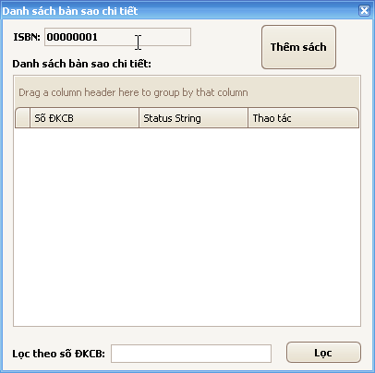

1. Enter the number of copies you want to insert. Then click “Tạo ĐKCB” button. Then click “Đồng ý” button

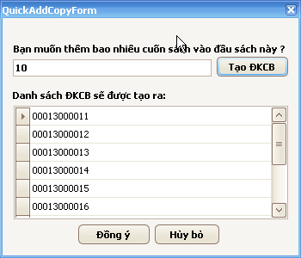

### Delete copy

1. Click “Quản lý sách thông tin” menu



1. Choose the catalogue which you want to add copies then double click to it or you can also click to the button “…” in the right side of the catalogue list’s grid



1. Click “Danh sách bản sao chi tiết” link



1. Click the “X” button to delete copy with the specific barcode in the same line

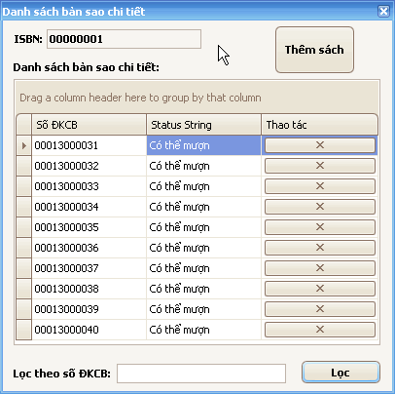

1. Click “OK” button

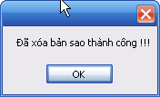

## BOOK REGISTER AND RENTAL MANAGEMENT

### Purpose

Book register and rental module functions to manage the traffic between reader community and library and to ensure the implementation of policies related to library activities.

### Usage

To open the "Rental and Register Management" module, user must select the button "Rental and Register Management" in the tab "Main Page".

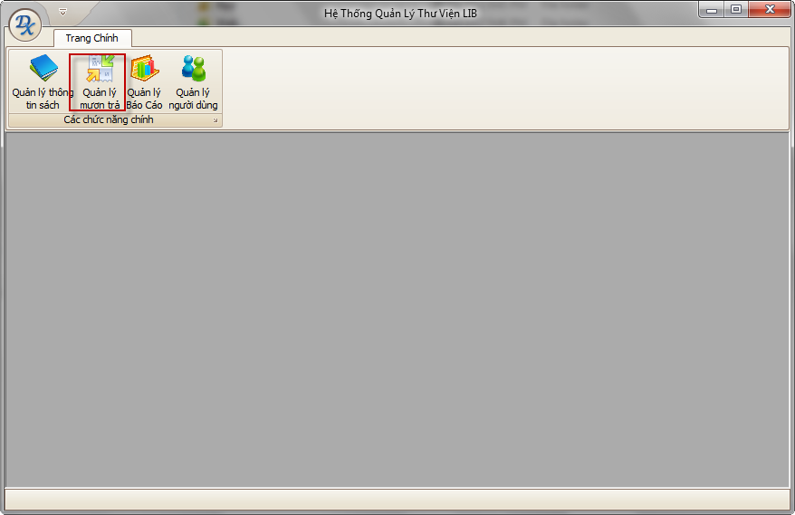

### ****Main Interface****

Includes two main tabs:

* Request: Managing the borrowing requirements of the books you read.
* Borrowing to pay: Managing information about repayment of the books you read.

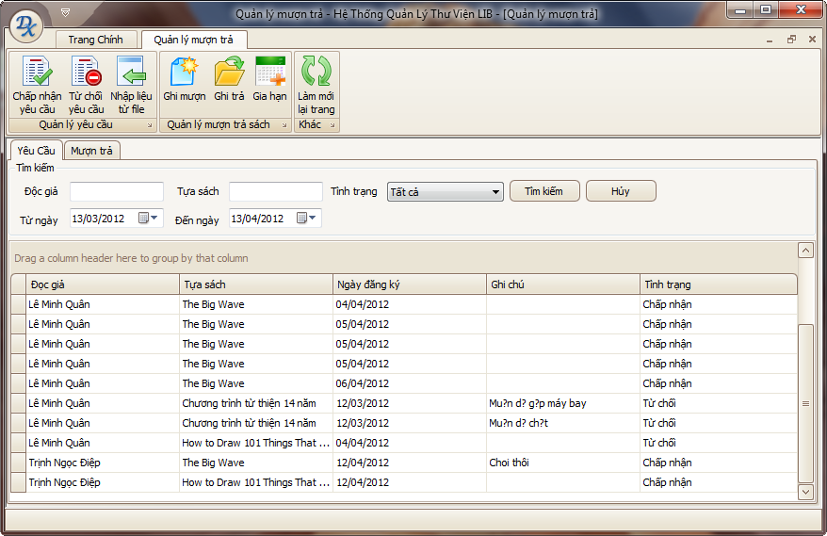

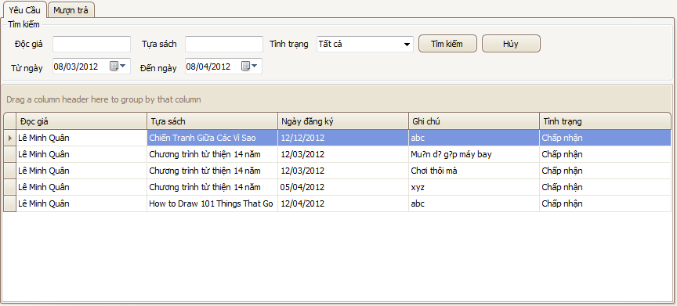

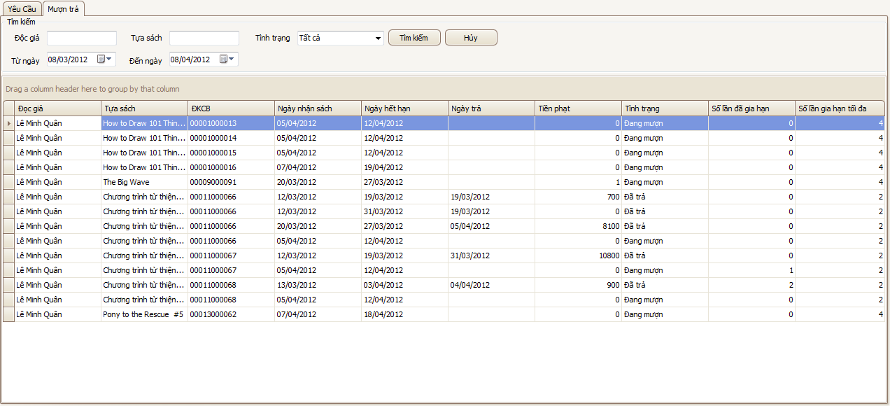

### ****Main Functions****

#### Accept a request

##### **Purpose**

This function is used to accept a specific request is selected from the list on the screen.

##### **Usage**

* **Choose a request with status “New” from the list below the tab “Request”.**
* **Click button “Accept Request”.**
* **A confirm dialog will appear.**

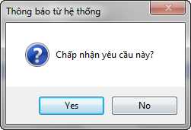

* **Choose “Yes” to perform, “No” to cancel.**

##### **Effect**

After the user selects "Yes", the system will automatically perform the following actions:

* The status of this request will be revised to "Accepted"
* A rental record is added to the tab “**Rental**".
* An email is sent to inform the reader to receive the book.

#### **Reject a request**

##### **Purpose**

This function is used to deny a specific request selected from the list on the screen.

##### **Usage**

* Choose a request with the condition as "New" from the list below the tab "Request".
* Click the button "Reject Request".
* A confirmation dialog will appear.

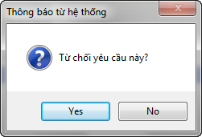

* **Choose “Yes” to perform, “No” to cancel.**

##### **Effect**

After the user selects "Yes", the system will automatically perform the following actions:

* The status of this request will be revised to "Denied".
* An email was sent to inform reader about the request being denied.

#### **Record a rental**

##### **Purpose**

This function is used to record information on borrowing books or other publications in the library of the readers. It also allows the user to check the status of a borrow books you read.

##### **Usage**

* **Click button “Record Rental”.**
* **A dialog will appear with the following information:**

**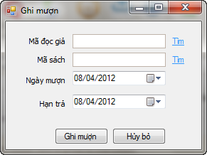**

* + Reader ID: ID of the reader to borrow books. User can click on the link "Find" on the right to seek information about readers.

**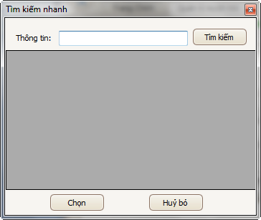**

* + Book ISBN: The ISBN of the publication is being borrowed. User can click on the word "Find" on the right to search for information on publications.

****

* + **Borrowing Date: The date of borrowing books.**
  + **Expiry Date: The date when the rental is expired. If the reader returns books after this date, there will be a penalty.**
* **User clicks “Record Rental” to perform or “Cancel” to cancel.**

##### **Effect**

After users select **“Record Rental**", the system will automatically perform the following actions:

* A rental record is written to the database.
* A new line is added to the list in the tab "Rental".

#### **Record a return**

##### **Purpose**

This function is used to record information about the payment policy. It also has the task to save the log of the borrow books you read.

##### **Usage**

* Select a record with the situation "is borrowed" in the tab "Borrowing to pay".
* Click the button "Remember to pay".
* A dialog box will appear

**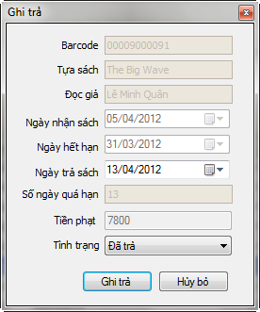**

* User must enter the following information
  + **Return Date: When the reader return the book to library.** Based on the payment date and expiration policies that the system will calculate the number of days overdue and fines respectively**.**
  + **Status:** The state of the returned books. There are three types of status: Returned (the book is the same as when borrowed), Damaged (the book is damaged) and Lost. Corresponding to each state where the system will automatically calculate the cost of the fine print**.**
* Librarian collects fines (if any) from readers.
* User click on the button "Register Rental" to keep the information or button "Cancel" to cancel the operation**.**

##### **Effect**

After users select "Remember to pay", the system will automatically perform the following actions:

* The state of the record will be corrected corresponding to the above condition is selected.
* A rental record is written to the database.

#### **Expand a rental**

##### **Purpose**

This function allows extended borrowed period.

##### **Usage**

* Select a record with the status "Borrowing” in the tab "Rental".
* Click the button "Expand Rental".
* A dialog box will appear

**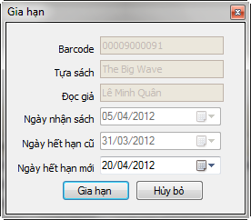**

* Users must enter the following information
  + New expiration date: The specific date to be expanded to. This date must be after the old expiration date**.**
* User click on the "Expand Rental" to save the information, select "Cancel" to cancel the operation.

##### **Effect**

After users select "Expand Rental", the system will automatically perform the following actions:

* On the extension of the repayment record revised expiration date**.**

#### **Refresh**

##### **Purpose**

This function is used to get the latest information from the database**.**

##### **Usage**

**Click button “Refresh”.**

##### **Effect**

After users select "Refresh", the system will automatically perform the following actions:

* Information on the screen is refreshed.

#### **Import data from file**

##### **Purpose**

This function is used to enter information on the registration from an excel file in the format provided. Intended for batch registering.

##### **Usage**

* **Click button “Import data from file”.**
* **A dialog will appear**

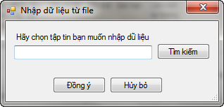

* **User click button “Browse” to choose the excel file containing data.**

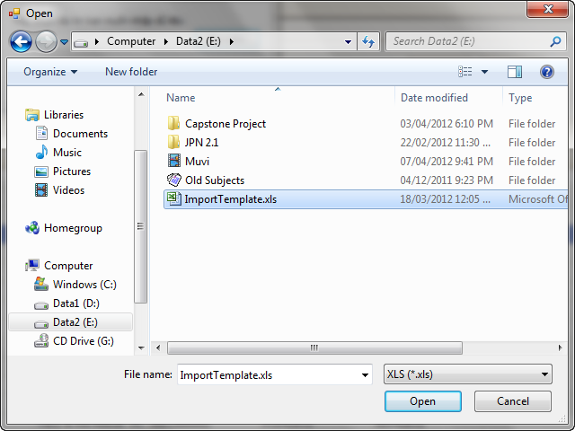

* **Choose “OK” to perform or “Cancel” to cancel.**

##### **Effect**

After the user selects "Yes", the system will automatically perform the following actions:

* Data from the selected file is read out, check, and then written to the database.
* The tab "Request" refreshed with the newly input record.

## USER MANAGEMENT

### Purpose

The User Management module functions to manage the information of readers and users of LIB system.

### Usage

To open “User Management” module, user must select button “User Management” in the tab “Main Page”.

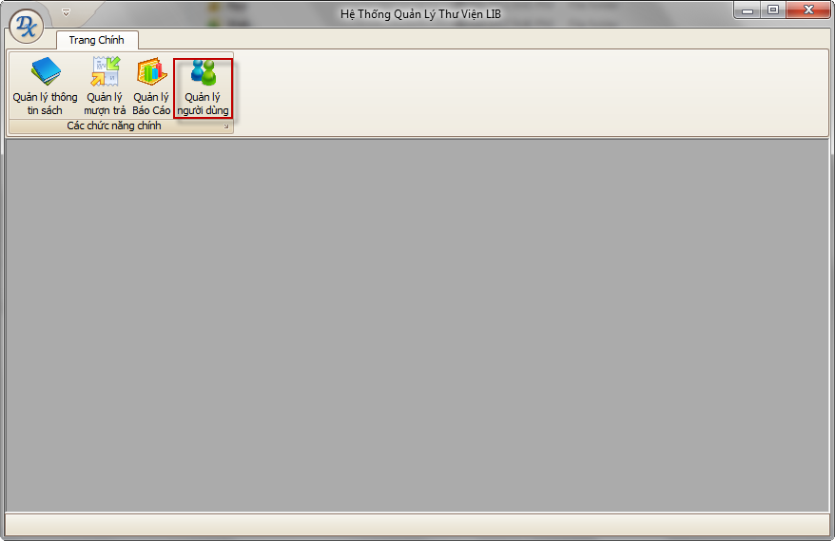

### Main Interface

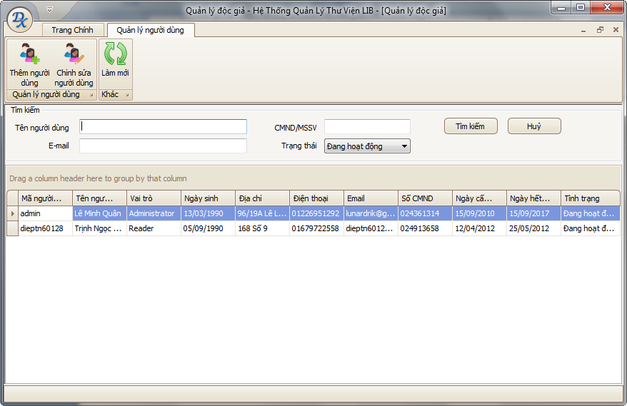

### Main Functions

#### Add User

##### Purpose

This function is used to add a new user into the system. The added users may be librarians or readers but not Administrator.

##### Usage

* Click button “Add User”.
* A dialog will appear with the following information

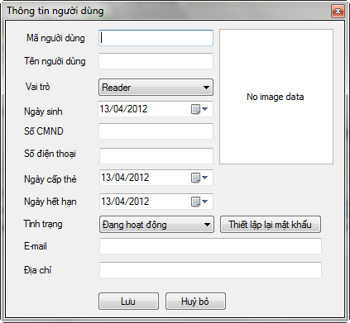

* Users must enter complete information in the dialog box. If any information is invalid, the system will display the message specific.
* Click "Save" to save the reader information, "Cancel" to cancel operation.

##### Effect

After the user selects "Save" button, the system will perform the following operations

* A new reader is inserted into database.
* A new record is added to the current list.

#### Edit User

##### Purpose

This function allows to edit information of users in the system. The edited users can be librarians or readers but not administrator.

##### Usage

* Double-click a user in the list below or select a user in the list below, then click "Edit User".
* A dialog box will appear.

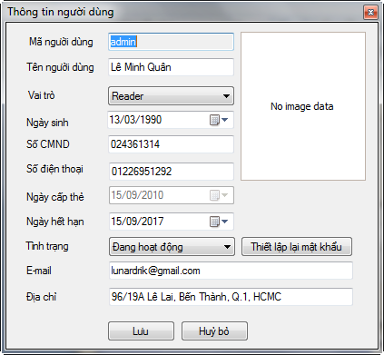

* Users must enter complete information in the dialog box. If any information is invalid, the system will display the message specific.
* Click "Save" to save the reader information, "Cancel" to cancel operation.

##### Effect

After the user selects "Save" button, the system will perform the following operations:

* The new user information is saved to the database and be displayed on the current user list.

## SEARCH FUNCTIONS

### Search of Catalogue:

#### Basic Search Function:

##### Capture:

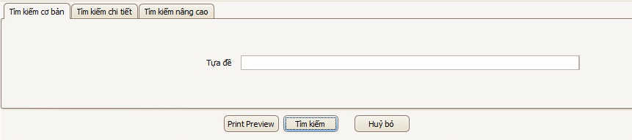

##### Purpose:

* This kind of function helps librarian search books quickly by using their titles.

##### Step by step:

* Typing the whole or one part of the title into textbox will be the first step.
* Click to activate the function.



* Searching results will be listed in the below grid-control. (View “List of Result” for more detail).
* If button is clicked, information in textbox will be erased.



#### Detail Search Function:

##### Capture:

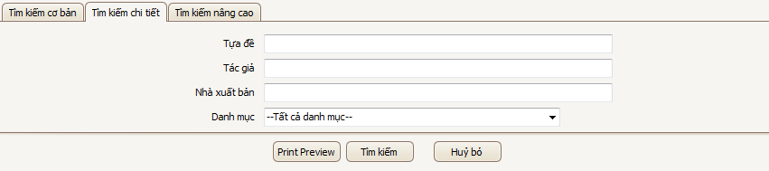

##### Purpose:

* This feature supports users looking for a more detailed items based on the information of the title, author, publisher, or type of book lists

##### .Step by step:

* Users will enter search information into one or more of the input text boxes to get close to the search results most desired.
* Next, pick a book list that you belong to. If the list is selected as "All categories", the search results will include all the books in the book under the category of systems.
* Click to activate the function.



* Searching results will be listed in the below grid-control. (View “List of Result” for more detail).
* If button is clicked, information in textbox will be erased.



#### Advance Search Function:

##### Capture:

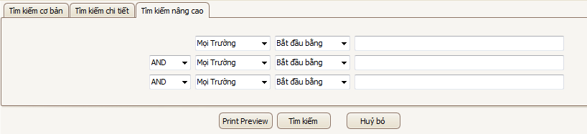

##### Purpose:

* This is the search function the most detailed books of the system. It supportsuser searches in a row in many different fields of information and to book morethan two choices on the search function

##### **.**Notes:

* : three combo boxes lets you select one or many different information for your search



* + All cases: the system will find information on school policies, such as title, author, publisher, category, language ...
  + Book Title: find information on titles  
     Author: find detailed information on the author
  + Publisher: find information on publishers
  + Categories: find information based on categories
  + Languages​​: find detailed information on language
* : three combo box will be a choice about the type of search strings of users. There are four choices here, including:



* + Start with: the system will perform functions based on the search string begins with the user information input into the right-hand text boxes.
  + End with: the system will perform functions based on search string ends withthe user information input into the right-hand text boxes.
  + Found in: the system will perform functions based on search string containingthe user information input into the right-hand text boxes.
  + Accuracy: will execute system functions based on the search string exactly whatthe user enters the text boxes on the right input.
* : This is the way chosen to append the search string 2nd and 3rd in command of the search system. There are 3 choices, respectively: AND (And), OR (OR) andNOT (not included)



* After all input is three text boxes. The user can fill in one or more arbitrary text boxes.

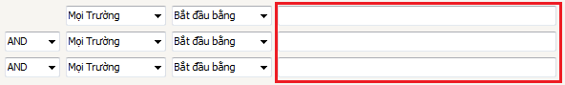

#### Step by step:

* The user will perform the function by entering into the third text boxes of the input required information.
* The corresponding value of the combo box to complete the search stringas you wish.
* Click to activate the function.



* Searching results will be listed in the below grid-control. (View “List of Result” for more detail).
* If button is clicked, information in textbox will be erased.



### List of Result:

#### Capture:

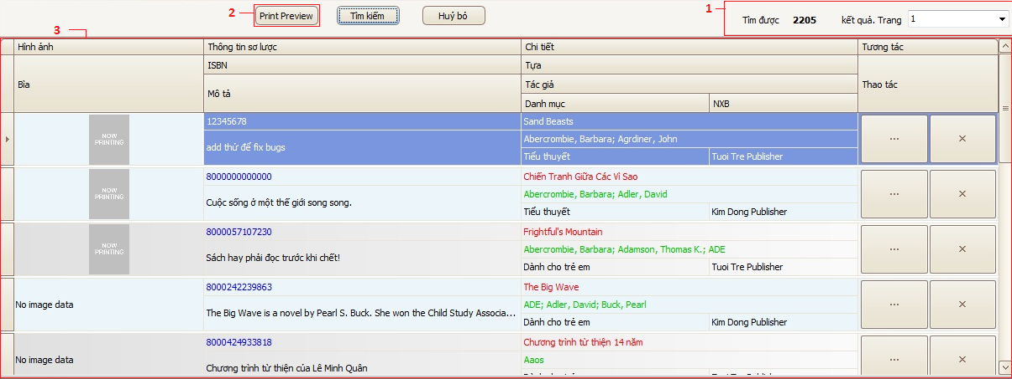

#### Notes:

* 1: This is where the total number of books display system found. Combo-Box helps users next to display the corresponding page titles (the system will automatically split page results found, top 10 books a page, if the number found is greater than 10).
* 2: This is a button to support the user to view the search results before printing.
* 3: This is a table showing most of the information systems found the book at the request of the user.

### Rental Register Search Function:

#### Capture:

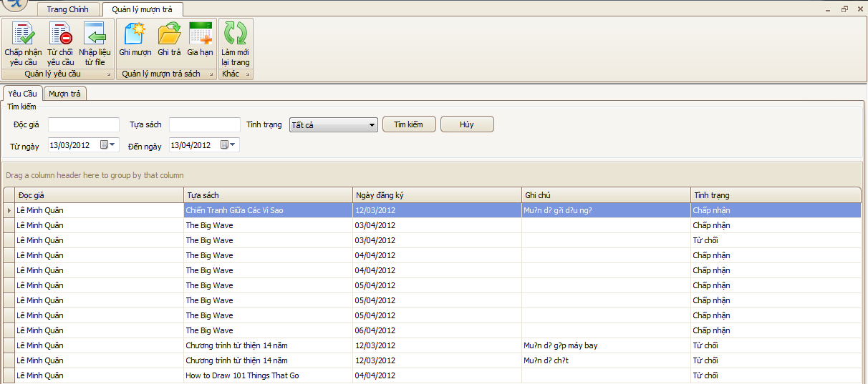

#### Step by Step:

* After opening the repayment Management screen, the user will select the tab"Request".
* There are two input text boxes, including "A Reader" and "Titles" to assist librarians who search by name or title registration borrow reserve books already.



* Just below the second text boxes and the date. The librarian will click on the second text boxes to select a time period of the registration requirements.



* Right is the combo-box allows selection of the state librarian's request should belooking for. There are three states of "New", "Accepted", "Deny". Also if the user selects "All", the system will find the requirements for all states.



* Click to activate the function.



* If button is clicked, information in textbox will be erased.



### Rental Detail Search Function:

#### Capture:

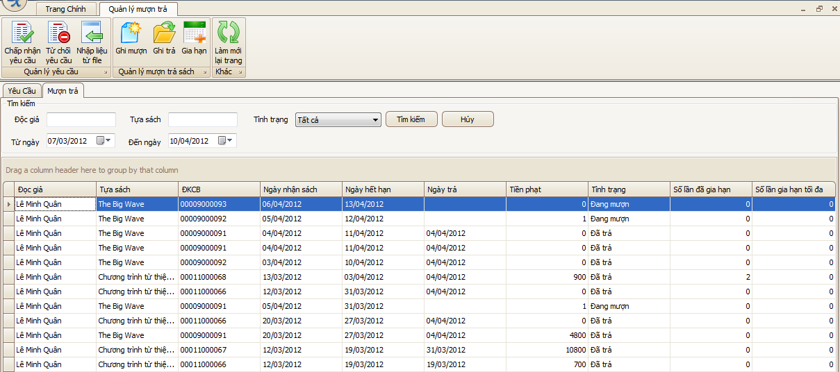

#### Step by Step:

* Also at repayment Management screen, users will need to switch to tab "Borrowing to pay" to perform this operation.
* The steps are similar to search function register borrow books, besides the twofollowing points:
  + Two text boxes received date will be filtered by date, but that details on the loanpayment systems.



* + Status details of the "Borrowing to pay" are three states: "Being on loan", "paid"and "Lost."



### Users Search Function:

#### Capture:

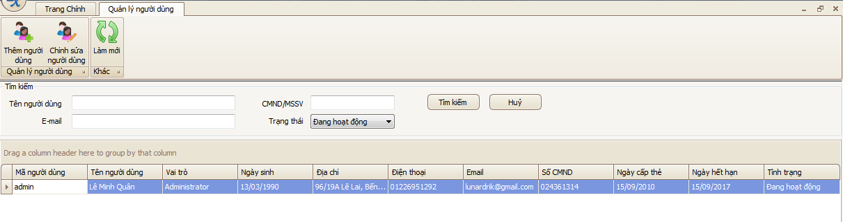

#### Step by Step:

* After the opening screen to manage users, users will see the text boxes combo-box to enter and search support.
* The input text boxes as, and get user information entered from the keyboard on the system's user name,identity card number (ID) or Student Identification Number (student ID) of the user...



* this is the user's state is saved in the system. There are two main status "In operation" and "Block".



* Click to activate the function. Results will be listed in the below grid-control.



* If button is clicked, information in textbox will be erased.



## LIB’s reports:

* This is one of the most important parts of LIB system.
* This feature supports users collecting and showing data of the system as reports.
* First of all, the librarian will start “Reports Management Feature” by clicking “Reports Management” button as ‘Image 1’.

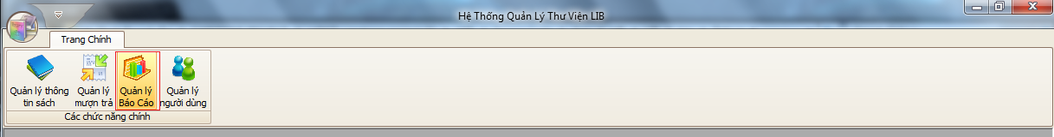

Image 1

* Right after that, user will see a form like ‘Image 2’:

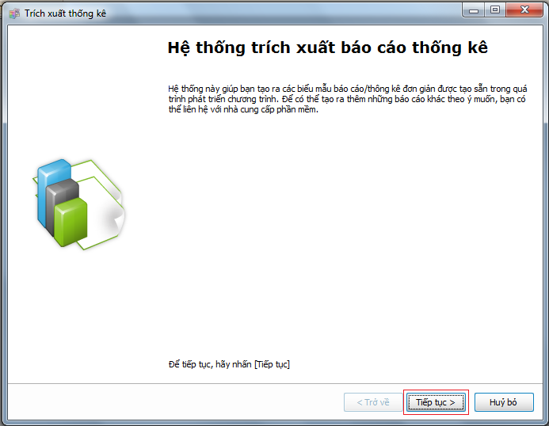

Image 2

* To continue, user just has to click “Next” button.
* Then, next window will be shown (Image 3):

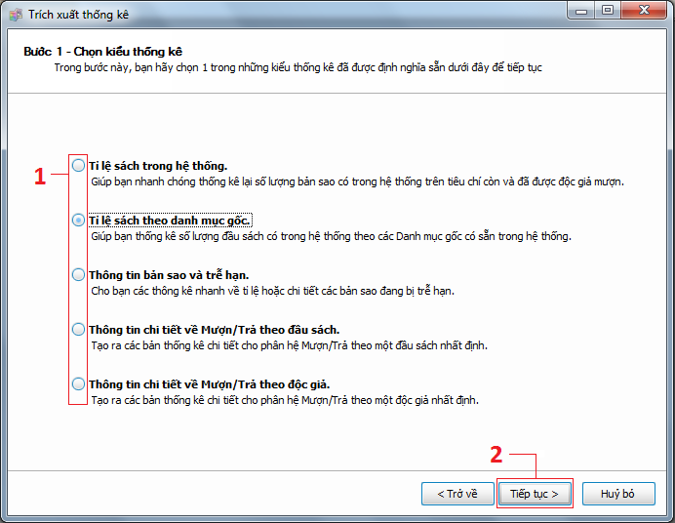

Image 3

* At this step, system requires user to choose one kind of report data. There are 5 kinds including:
  + The ratio of books in system.
  + The ratio of books based on categories.
  + Book copies information and expired rental detail.
  + Rental detail information based on catalogues.
  + Rental detail information based on readers.
* After that, “Next” button needs clicking.

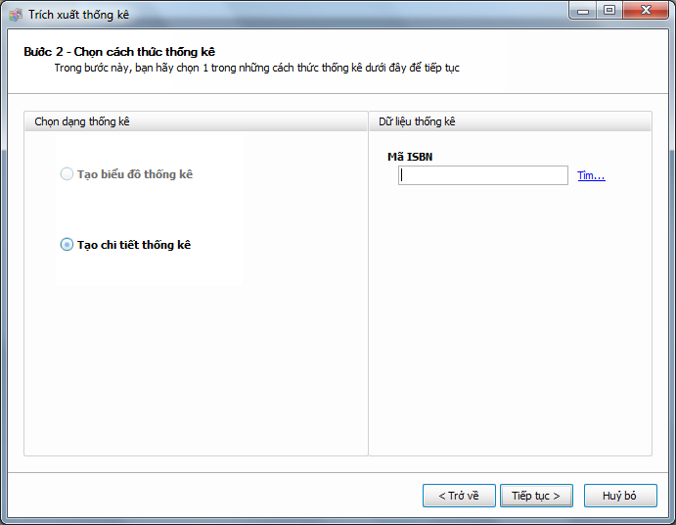

Image 4

* Depends on what kind of report data librarian needs and has chosen before, the out-put reports will have two types of template which she can see their names in the left panel:
  + Showing in detail.
  + Showing in graphs.
  + And in the right side panel, in some cases, user will be required to choose more conditions so that LIB system can find exact result.
* “Next” button clicking will move the current form to next step of this feature.

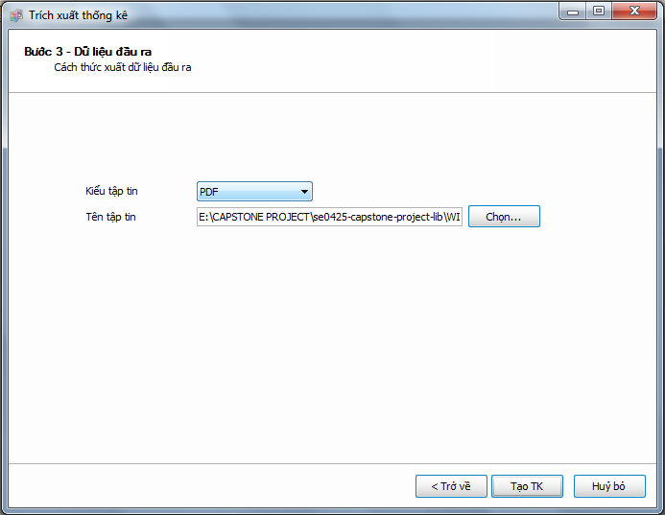

Image 5

* As you can see in ‘Image 5’, you have to choose the output file type for your report. It may be:
  + PDF file
  + Microsoft Excel File
  + An HTML file
* The last thing you must do is choose one place to save this report file to.
* Click at “Create Report” button will start create your report.

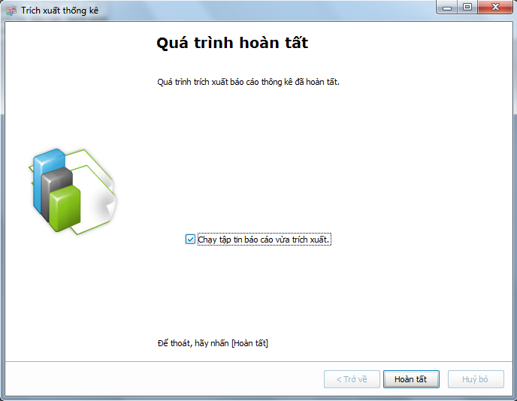

Image 5

* In case you want to view your report immediately, choose at “Run ‘just-created’ report” check-box and click “Finish” button.
* At the end, you will have your report like this if you choose ‘PDF file’.

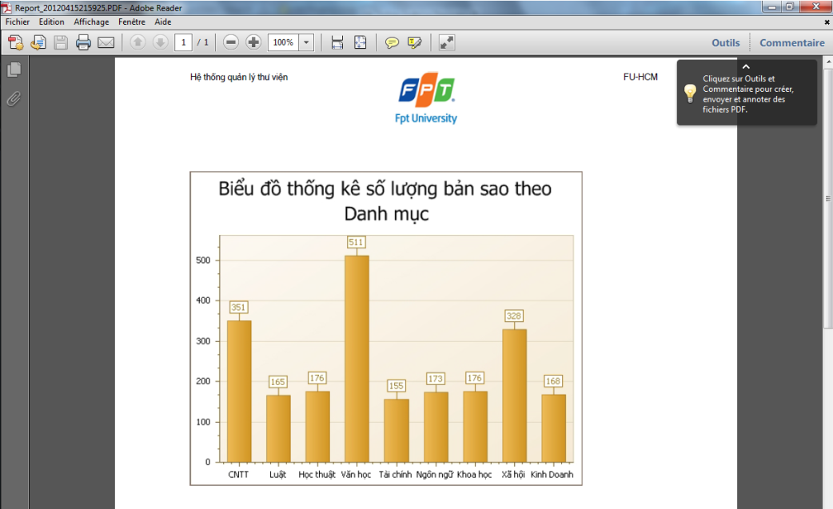

Sample Report

## Deployment Guide

### INSTALL SQL SERVER AND Run SQL Server ScriptS:

1. Install SQL Server 2008 R2 or later version.

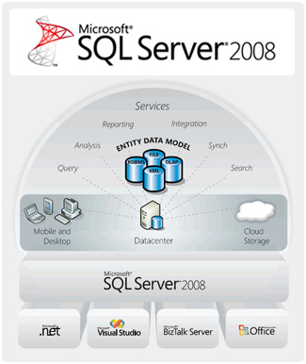

1. Navigate to CD-ROM:\Deliverable Package\Database Scripts\

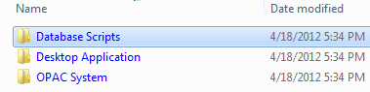

1. Take the scripts from the Database folder of the Deployment CD

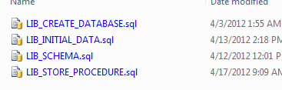

1. Run the scripts in order:
   1. LIB\_CREATE\_DATABASE.sql
   2. LIB\_SCHEMA.sql
   3. LIB\_STORE\_PROCEDURE.sql
   4. LIB\_INITIAL\_DATA.sql

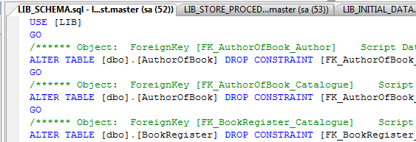

1. Double check the progress.

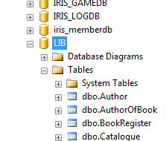

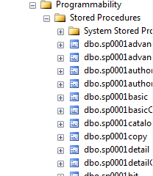

### Install LIB Desktop Application

1. Install the .NET Framework 3.5 SP 1 before continue to step 2.



1. Navigate to CD-ROM:\Deliverable Package\Desktop Application\

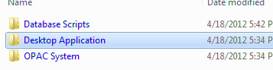

1. Run the Setup.exe.

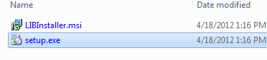

1. Specify the install location.

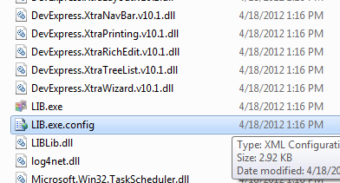

1. Re-configure the LIB.exe.config file from the [Install Location]

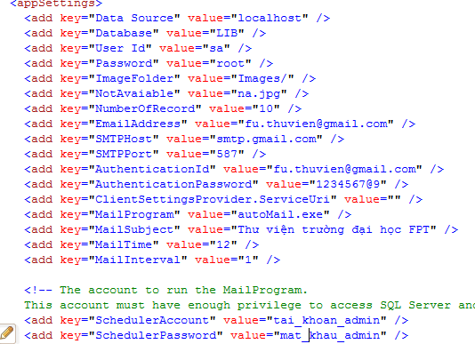

| Key | Description |
| --- | --- |
| Data Source | Name of the Database server |
| Database | Name of the Database registered in server |
| User Id | The user id of Database server |
| Password | The password of authenticate user |
| ImageFolder | The folder of cover images |
| NotAvaiable | The file to be used when a book has no cover |
| NumberOfRecord | Number of record to be shown on the result list |
| EmailAddress | The email address of the Library |
| SMTPHost | SMTP host of the email |
| SMTPPort | SMTP port for using SSL or not |
| AuthenticationId | The authentication id of SMTP host |
| AuthenticationPassword | The authentication password of SMTP host |
| MailProgram | The program’s file name used for auto mailing to send reader the remind about the expiration |
| MailSubject | The subject of the mail to be send to reader |
| MailTime | The mailing moment (24h) |
| MailInterval | The number of mailing times |
| SchedulerAccount | The administrator account used for running auto mailing application |
| SchedulerPassword | The administrator password used for running auto mailing application |

1. Run the LIB.exe from the [Install Location] or Library Management System from the [All Programs] in [Start Menu]



### Install the LIB OPAC System

1. Install the IIS (Internet Information Service) in your server before continue to step 2.
2. Install the .NET Framework 4.0 before continue to step 3.
3. Navigate to CD-ROM:\Deliverable Package\OPAC System\

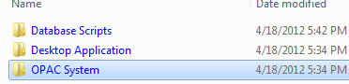

1. Copy all the script to specific location on your Server.
2. Create a new website in IIS.

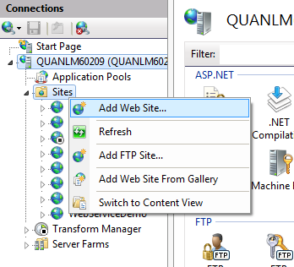

1. Point the Website Physical Path to the OPAC location on your server.

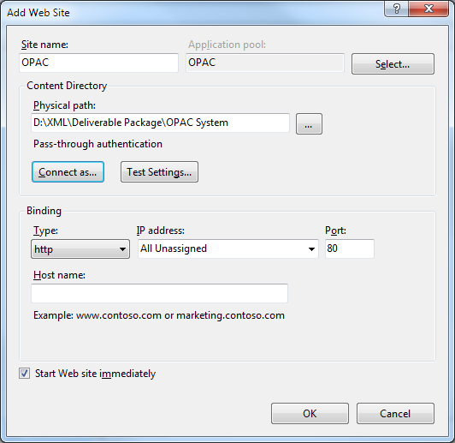

1. Change the Privilege of the account accessing to the website to allow modifying the web content.

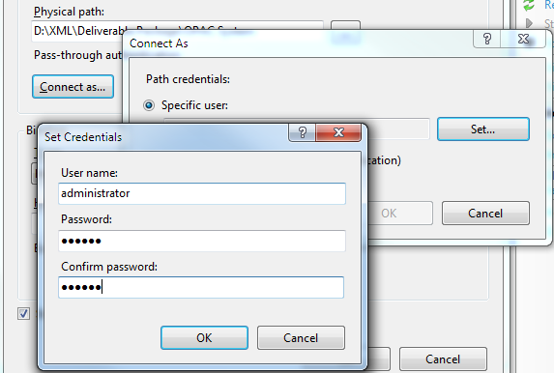

1. Share the Image folder and allow specific account accessing to the folder get the right to modify the folder content for uploading Cover images to server.

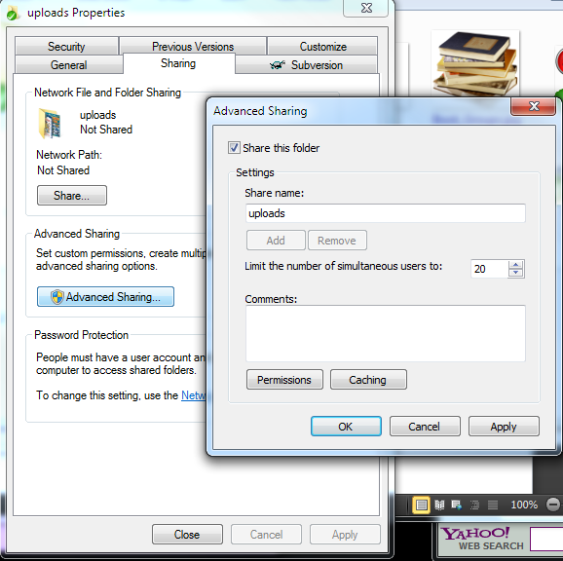

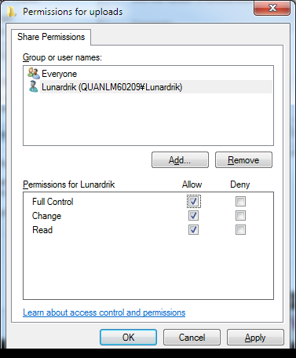

1. Re-configure the Web.config file



1. Start the web server

1. 1 man-month equals 25 man-day [↑](#footnote-ref-1)
2. These are type normally: staff, budget, equipment, schedule, infrastructure, business, ... [↑](#footnote-ref-2)
3. These are type normally: staff, budget, equipment, schedule, infrastructure, business, ... [↑](#footnote-ref-3)
4. This table and other tables in this project plan may be referred to appendixes. It’s permitted to replace tables by text but these information in table should be required. [↑](#footnote-ref-4)
5. Fill here any note about working time as % of total effort or how many hours per day or per week. [↑](#footnote-ref-5)
6. Including required deliverables and delivery time, if applicable [↑](#footnote-ref-6)
7. Including required deliverables and delivery time, if applicable [↑](#footnote-ref-7)